SDD Final Outline
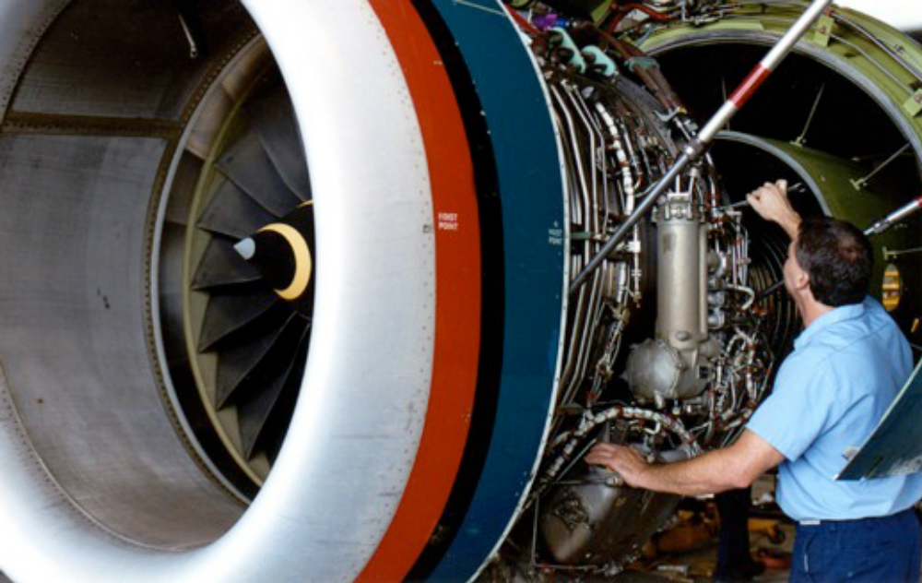

Maintenance System in iPhone

Team

• Taha Amdouni
• Sonila Dobi
• Benedikt Engeser
• Steffen Strobel
• Marcel Stuht
• Benjamin Ullrich

1. Introduction – To Do

  - Purpose of the system

The application is a demo for an Aircraft Maintenance Tool wich serve for communication, controlling, assistance and repairment in distance. This is a software of large dimension and integrates different components. The way it works is similar to the work the Linne Maintainers (LM) and Experts do in the Airports around the world. Basically it does the work of routine after flight inspection, planning for repairment, doing the actual repairment through given instructions, maintenance and job planning. All this is done electronically with the help of this tool which is being developed. Through video streaming the Expert does not have to leave his palace but can do it in distance through the use os wireless devices such as an iPhone. The LM can record everything and save it for later analisys. And the LM can also be instructed from the Expert by using just a phone.

- The software is user friendly with basic and enough functions. It has a step by step self explaining user interface. It solves the daily tasks related to the maintenance in the airport, and now the distance maintenance is made even easier.

- The information is saved in different data storage servers and they are all connected together at the same time to offer all the services. There is one server which will save the aircrafts scheleton, another one wich will save the attachments and another one which will do the streaming of the voice. All these are connectd together with some urls and the identification of the users can be done with a simple web page if not in the aircraft scheleton server.

- The workaload data is changeable depending on how many problems occur per day. But considering the maintenance outside the working place, this adds the works per day. The system should make the work easier for the users since they can access everything by clicking a “button”, therefore this software allows increasing the work and easening the job.

- The input of the program is aircraft models and parts with attachments such as picture, video, and notes made from the LMs and Experts.

- The output is made of different type of media such as voice, video, picture, text and is accessible at any time.

Decomposition in main functions:

Below are shown the main functionalities of the system:

- Register the users by categories.
- Store the aircraft types and their parts.
- Strore the attchments related to the aircraft types and parts.
- Register the sessions and their types.
- Register the users to the sessions.
- Enable Voice conference.
- Enable Video Streaming for distance help maintenance.
- Show status of sessions.

1.2 Design Goals (Optional)
1.3 Acronyms, synonyms, abbreviations (Optional)
1.4 References (Optional)

2. Current software architecture
The current system is a desktop based system. There is the schema of the emf store

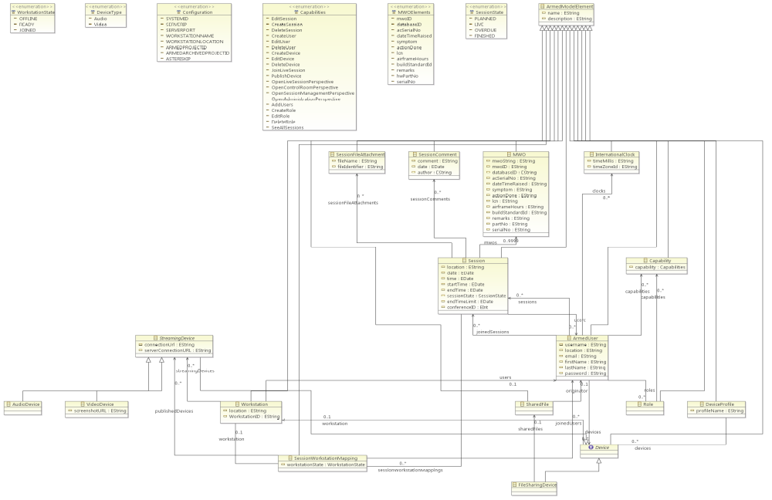

3. Proposed software architecture

ARCHITECTURAL MODELING

The model is the one named „Architecture with five levels“. The elements are as follow:

1. Presentation

The information which comes from the servers is presented in the client application.

2. User Interface

There are different user interfaces for the Experts and different for the Line Maintainers. The experts have also the interface on the iPad which the LM do not have at all.

3. Business Logic

The users of the system are mainly technician who know what to do. The only thing missing is accustoming to the use of iPhones and iPads. Basically we are dealing with trained users. The bussinesses focus in on making the application work and have good performance. The visual details are secondary.

4. Managing and Control

The communication should be syncronized so all the components of the system should communicate altogether at some point. The EMF models can be updated every some seconds on the client presentation, but we should make sure that all the updates are shown on time to each client. All the users shold be notified at the same time if some change occurs. The video and voice streaming might have some delays, but the users should be notified when the connection is estabilished. The other users should be notified when a new participants enters or leaves the conference room.

5. Data Storage

The storage is done in two different servers. One saves the EMF models and the other the attachments related to these models. The logic is different. In the EMF storage there is a tree model, while in the WebDav server which contains the attachments there is only a link and the link is referencing a model, so there is no specific structure.
3.1 Overview
SCD Diagram
The Figure. Shows the SCD diagram which shows the general overview of the all the tasks of the system and the way the user interacts with the system. The system is composed of five main parts which are:
- Input Data: The iput information is the user authenitcation and the EMF elements information. This part commuicates with the Data storage system through ID, name, description, username and passord. According to this input, the system generates the proper output. This output is then transferred to the graphical system.
- Communication Interfaces: There are two types of interfaces, the iPhone and the iPad. The information can be shown on both interfaces. The difference is that on iPad the user can see the video streaming which is sent from the iPhones.
- Output Data: This part generates the output information acording the input and the user requests. It can be the status of the user connected to a session, the infromation of a specific element of the EMF model, the infromation of a specific attachent etc.
- Maintenance and SelfTesting System: In this modul continuous requests and security controls are made. It makes sure the connection is established and there is no erroneous data. Also no interference from third parties should be allowed.
The main part of the diagram makes the information processing together with the device management system. This is the most important part of the system because this realizes the logic of the business.

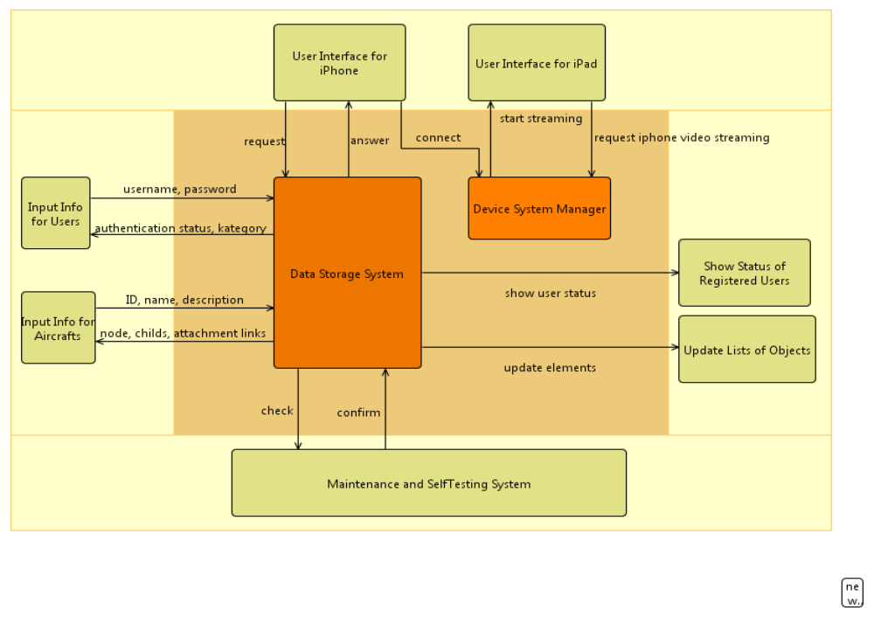

Figure: - to do the right number

3.2 Subsystem decomposition
SFD Diagram
In Figure, is shown the SFD diagram which shows the job flow in the system. As a beginning the User logs in the system with a username and a password and this will be checked in the EMF store. The connection to the EMF store is done throught the HTTP proxy server. After being identified, the user can make other requests such as browsing through the aircrafts types, adding attachments, joining a session, joining a voice conference, sending video streaming etc. Every modification is sent to the output and displayed either on the iPhones or iPads. All the time the information is checked in the testing subsystem, whether the connection is maintained, the format of the objects is the right one etc.

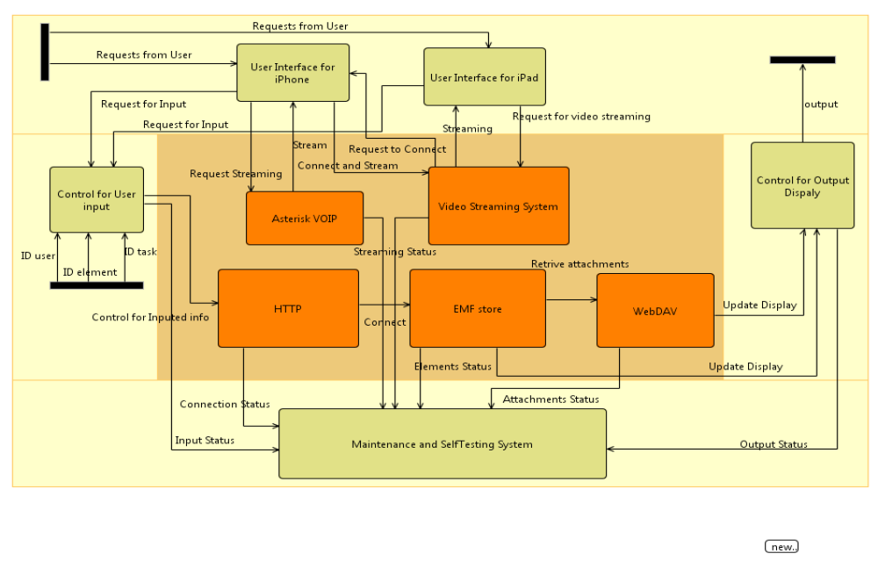
Figure.

3.3 Hardware/Software mapping– to do
The camera, the device for VOIP, the webdav, the Asterisc format, the tools used to the development of these hardwares such as for the iphone we use the cocoa and objective c, the platform is for apple, and things like this.

-To do

We might add here the code, or a part of it to show the implementation of each component, or we might show the code after the component diagram below, and refer the code to each component.
3.4 Persistent data management

DATA STORAGE MODELING – to do

EMF SCHEMA
The new schema should be placed here

3.5 Access control and security– to do
This should mainly be about the way users log in, and how their connection and their profile is loaded. When they log in, if there is some restriction such as the LM cannot see everything or do everything but the Experts can. Where do they connect to for accessing data, what they need to access the data.

3.6 Global software control

Software Testing and validation
During the testing of the product, we have concentrated in realizing the following main points:

  - The final product is the one the client wants
  - The final product fullfills all the functions the client requested
  - The final product is reliable and safe
  - The final product functions as a whole in a correct way

TESTING TECHNIQUES

For testing the software we have used Black-Box and White-Box techniques.

TEST CASES

- Assuring all the possible cases inside each module are tested atleast once.
- Proof of all the logical predicates either when the result is TRUE or FALSE.
- Executing all the cycles with the estreme values aswell as the ones within the extremities and checking the results.
- We have used the inner structures of the data storage to assure their validity.

Mainly the system has been tested from the graphical interface. During implementation of the modules, we have also tested them by setting input values within the allowed limits and also outside the limits to check the behaviour. WE have also checked the performance of each module in anycase and have changed parts of the code where errors have been identified. Besides this kind of testing, we have done a general testing to check how well the modules are integrated together. We have also tested the system from another aspect, that in case of malfunctioning of hardware or security threads. For the main functions we have followed all the path from the beginning till the end. We have fully ckecked the main scenarios. The followed technique is that of debugging.

DOCUMENTATION TESTING

This is a very important test for debugging. We will add as many information as possible during the whole development process and afterwards too.

CONCLUSSION – to do

3.7 Boundary condition – to do
There is something like, there cannot be more then 100 users online, and things like this. Technical restrictions.

4. Subsystem Services – to do
The VOIP device which offers the servise through the VOIP connector, the saving of attachments which is offered through the webdav connector, the loading of emf objects through the http connector.

Component Diagram

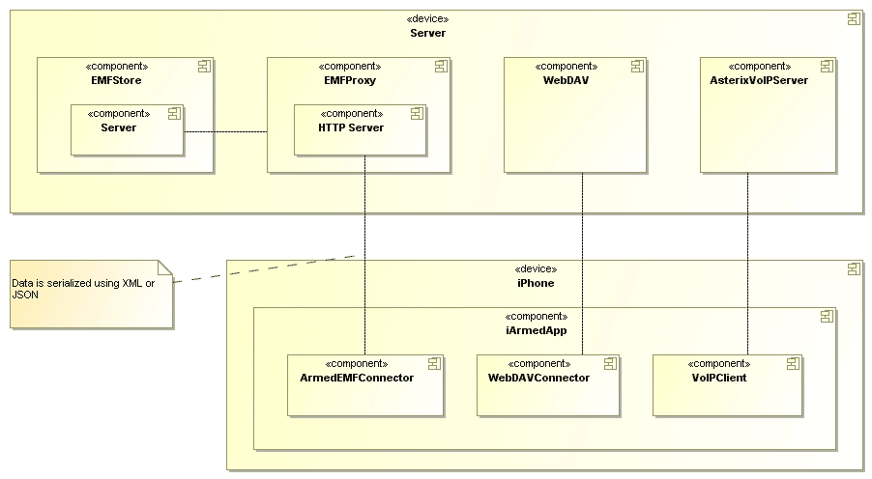
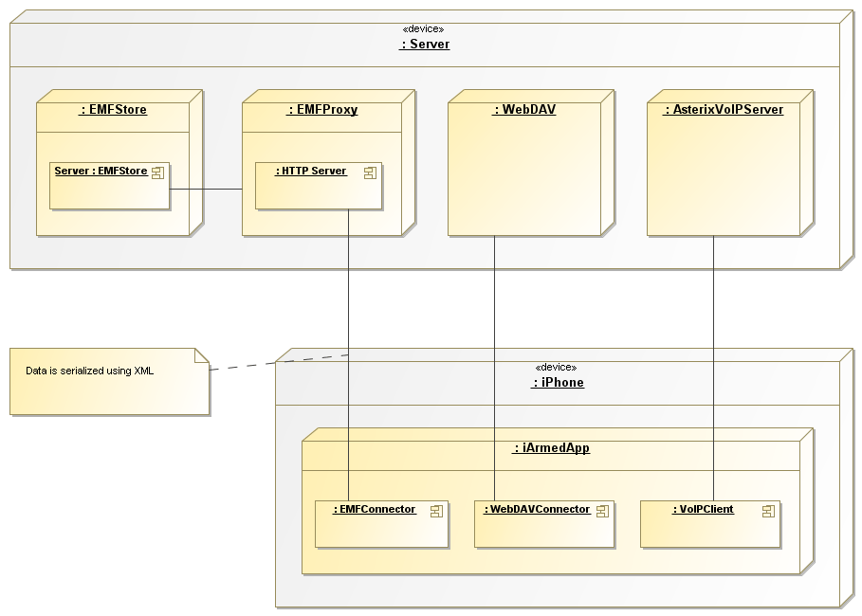

5. Glossary – to do

