**2015 SQL Database Development**

**Timothy DaMour**

**Description of Program**

The purpose of this program is keep a database of the small grocery store, Sweet Aunt May’s Fruits, keeping track of the store’s employee information, item information and equipment information. Each table will showcase information in regards to their subject matter as well as show relationships between selected tables as well as datatypes and keys. The goals of this database report is to give management a clear overview of the information organization and a readable yet in-depth look at the status of the business.

**Data Dictionary**

|  |  |  |  |  |  |
| --- | --- | --- | --- | --- | --- |
| Table | Attribute | DataType | Allow Nulls ? | Primary Key ? | Foreign Key ? |
| Items | item_id | int | 0 | 1 | 1 |
| Items | Item_description | Varchar | 0 | 0 | 0 |
| Items | company_name | Varchar | 0 | 0 | 0 |
| Items | Purchase_price | Decimal | 0 | 0 | 0 |
| Items | Sales_price | Decimal | 0 | 0 | 0 |
| Items | Stock | Int | 0 | 0 | 0 |
| Equipment | Equipment_id | Int | 0 | 1 | 1 |
| Equipment | Equp_description | Varchar | 0 | 0 | 0 |
| Equipment | Intial_cost | Decimal | 0 | 0 | 0 |
| Equipment | Age_months | Int | 0 | 0 | 0 |
| Personnel | Personnel_id | Int | 0 | 1 | 2 |
| Personnel | Job | Varchar | 0 | 0 | 0 |
| Personnel | Name | Varchar | 0 | 0 | 0 |
| Personnel | Works_for_id | Int | 0 | 0 | 0 |
| Personnel | Part_full_time | Char | 0 | 0 | 0 |
| Personnel | Salary | Decimal | 0 | 0 | 0 |
| Contact | Contact_id | Int | 0 | 0 | 0 |
| Contact | Address | Varchar | 0 | 0 | 0 |
| Contact | City | Varchar | 0 | 0 | 0 |
| Contact | State | Varchar | 0 | 0 | 0 |
| Contact | Email | Varchar | 1 | 0 | 0 |
| Contact | Phone_number | Int | 1 | 0 | 0 |

**Entity Relationship Diagram**

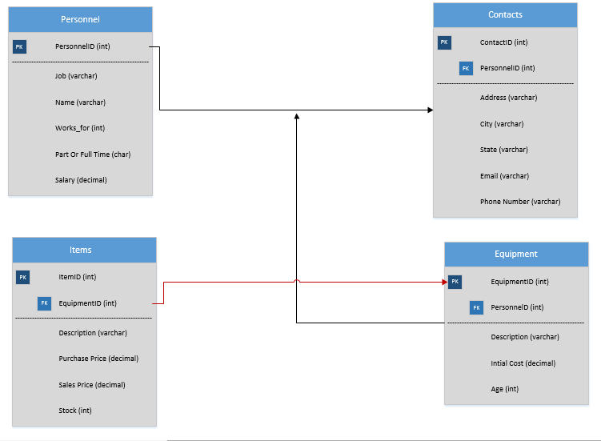

**Primary / Foreign Keys**

**ITEMS**

Primary Key – ItemID

Foreign Key – EquipmentID

**Equipment**

Primary Key- EquipmentID

Foreign Key- PersonnelID

**Personnel**

Primary Key- PID (PersonnelID)

**Contact**

Primary Key – ContactID

Foreign Key- PersonnelID

**Information**

The table Item is connect to Equipment table thru Equipment. The table Personnel connects to both the Contact table and the Equipment with the PersonnelID (PID in the Personnel Table). On the Item table, the stock is what is usually stocked in the store with the sell rate is how much each item sells per week.

**Tables**

**ITEMS**

|  |  |  |  |  |  |  |  |  |
| --- | --- | --- | --- | --- | --- | --- | --- | --- |
| ItemID | EquipmentID | Description | Company | Purchase Price | Sales Price | Stock | Sell Rate |  |
| 1 | 2 | Cheerios | General Mills | 1.50/box | 1.25/box | 50 | 20 |  |
| 2 | 4 | Ham | Big Thick Meats | 10.00/lb | 8.99/lb | 50 | 13 |  |
| 3 | 4 | Milk | Red Pill | 4.00/gal | 3.00/gal | 50 | 13 |  |
| 4 | 2 | Chili Beans | Hormel | 6.00/lb | 3.00/lb | 50 | 13 |  |
| 5 | 2 | White Bread | Dirty Joe's Bread | 0.49/loaf | 0.49/loaf | 50 | 13 |  |
| 6 | 2 | Cambell's Soup | Cambell | 2.00/can | 1.50/can | 50 | 11 |  |
| 7 | 5 | Apple | Grandma Smith's | 5.50/lb | 5.00/lb | 50 | 11 |  |
| 8 | 5 | Firewood | Dirty Joe's Wood | 7.00/log | 5.99/log | 50 | 11 |  |
| 9 | 5 | Bacon Bits | Hormel | 5.00/bag | 2.50/bag | 50 | 11 |  |
| 10 | 5 | Marshmellows | PuffPuff | 4.00/bag | 3.50/bag | 50 | 11 |  |

**Equipment**

|  |  |  |  |  |  |  |
| --- | --- | --- | --- | --- | --- | --- |
| Equipment ID | PersonnelID | Description | Initial Cost ($) | Age (months) | Deprecation | *Info* |
| 1 | 8 | Cash Register | 250 | 12 | 4 Years | Age-by month instead of year, weeks |
| 2 | 2 | Stock Shelf (3 each) | 2000 | 12 | 4 years | 3 shelves, $2000 each |
| 3 | 5 | Refrigerator | 1200 | 6 | 4.5 years |  |
| 4 | 4 | Crates ( 5 each) | 200 | 12 | 4 Years | 5 crates, each $200 |
| 5 | 10 | Cash Register | 250 | 12 | 4 Years |  |

**Personnel**

|  |  |  |  |  |  |
| --- | --- | --- | --- | --- | --- |
| PID | Job | Name | Works for ID | Part or Full Time | Salary |
| 1 | Owner | Tim |  | F |  |
| 2 | Shift 1 Supervisor | Will | 1 | F | $12 per hour |
| 3 | Shift 2 supervisor | Billybob | 1 | F | $11 per hour |
| 4 | Worker 1 | Mark | 2 | F | $8 per hour |
| 5 | Worker 2 | Andrea | 2 | F | $8 per hour |
| 6 | Accountant | Andre | 3 | P | $12 per hour |
|  | Add 4 more part time people |  |  |  | $7.50 per hour |
| 7 | Stock | Jared | 2 | P |  |
| 8 | Cashier | Janet | 3 | P |  |
| 9 | Butcher | Waldo | 2 | P |  |
| 10 | Cashier | Emily | 3 | P |  |

**Contact**

|  |  |  |  |  |  |  |
| --- | --- | --- | --- | --- | --- | --- |
| Contact ID | Personel ID | Address | City | State | Email | Phone Number |
| 1 | 1 | 578 Big Boss Lane | Dearborn | MI | [boss@gmail.com](mailto:boss@gmail.com) | (313) 555-9021 |
| 2 | 2 | 666 Hot Avenue | Dearborn | MI | [will@hotmail.com](mailto:will@hotmail.com) | (313) 555-5343 |
| 3 | 3 | 776 Freedom St | Canton | MI | mike76@gmail.com | (734) 444-8949 |
| 4 | 4 | 0889 Kaiser St | Taylor | MI | mark@yahoo.com | (313) 980-4353 |
| 5 | 5 | 3321 Terry St | Oak Park | MI | [andrea@gmail.com](mailto:andrea@gmail.com) | (708) 042-8888 |
| 6 | 6 | 943 Yellow Ave. | Novi | MI | andrew@outlook.com | (248) 777-5454 |
| 7 | 7 | 310 Hallow St | Westland | MI | [jared@yahoo.com](mailto:jared@yahoo.com) | (313) 874-9049 |
| 8 | 8 | 890 Nine St | Romulus | MI | [Janet@aol.com](mailto:Janet@aol.com) | (734) 665-7894 |
| 9 | 9 | 999 Nelson | Plymouth | MI | [waldo@outlook.com](mailto:waldo@outlook.com) | (734) 674-9033 |
| 10 | 10 | 555 Fifth Ave. | Canton | MI | emily@gmail.com | (734) 221-4365 |