1. Bug 1

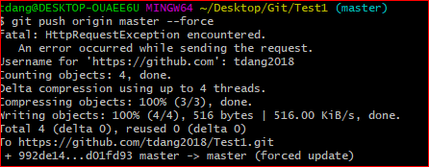  
Fix:

**Try this git command**

**git push origin master --force  
or short of force -f**

**git push origin master -f**

1. Bug 2