

Software Requirement Specification

PROJECT NAME | Micro Workflow System | DATE | 13/09/2018
TITLE | HNBA Micro Workflow Development Sep-2018
VER. NO. | 1.2.1
PREPARED BY | Tharindu Athapattu
SUMMARY | This SRS outlines the requirement of HNBA Life Operations – MRP unit on developments requested to develop Micro Workflow system

Revision of History
Version # | Release Date | Sections Changed | Change Description
1.0 | 15/03/2018 | All Sections | Initial Version
1.1 | 10/04/2018 | 5.2.2 | Modified section
1.2 | 31/08/2018 | 6 | New section for modifications
1.2.1 | 13/09/2018 | 6 | Modified section

Table of Contents

1. Introduction 3
2. Definitions, Acronyms and Abbreviations 3
3. References 3
4. Business Requirement 3
5. Solution 4
6. Modifications 8
7. Scope of Work 12
8. Assumptions 12
9. Constraints/Limitations 12
10. Deliverables 12
11. Unresolved Issues 12
12. Acceptance 13

Software Requirements Specification

- Introduction
This SRS is prepared to identify the business requirement and provide a view of the proposed solution to develop Workflow system for Micro insurance.

- Definitions, Acronyms and Abbreviations
None

- References
None

- Business Requirement
This will be developed similar to existing MRP workflow and any modifications, exclusions or additions to current MRP workflow will be listed in section-5 of this SRS.
- MRP Unit has given following items as requirement.
  - Processes which doesn’t need any change from MRP workflow
    - Pendings master data management screen
    - Manage Box numbers and Add proposals
    - Job transfer screen

  - Processes need changes from MRP workflow
    - Job Assign screen
    - Main workflow screen
    - Benchmark reports
    - Pendings and other system generated e-mails

  - Process which can be excluded
    - None
  - Process newly added to MCR
    - None
  - Common processes which does not need any changes
      - Bank e-mails
      - Banks
      - HNBA Branches
      - MRP Brokers
      - MRP Business parties
      - Medical Labs
      - Signing persons

- Solution

  - Job Assign screen
    - Need to generate job numbers in following format

MCR/YEAR/Sequence no

Ex- MCR/2018/0001

  - Main workflow screen
5.2.1 Following fields should remove from main workflow screen.
  - Courier Service
  - Skip To Certificate Issued
  - Re Insurer
  - RI Ref No
  - HNBA Ref No
  - Loan Amount 2, 3
  - Interest Rate 2, 3
  - Term 2, 3
  - TPPD market limit

    - Following field should add to main workflow screen
    - Beneficiary cover (Check box)
    - New fields should display to enter Name, NIC and Address if user click on Beneficiary cover
    - Separate cover note should generate for jobs with Beneficiary cover

Cover note document format for Non beneficiary jobs

<<Date>>

The Manager
<<Bank>> <<Branch>>

Dear Sir / Madam,
PROPOSAL FOR MICRO INSURANCE
PROPOSAL NUMBER :
LIFE ASSURED 1 :
LIFE ASSURED 2 :
SUM ASSURED :
REPAYMENT PERIOD :
With reference to the above Proposal for Micro insurance, we wish to confirm the cover for the life of the above Assured with effect from ------

The following risks will be covered under the Policy;
• Natural or Accidental death.
• Total Permanent disability as a result of Bodily injury.
Kindly send us the single premium of ------------- within 7 days of this letter in order for us to issue the Certificate of insurance.
If the Premium payment is not submitted within 07 days, the cover will be automatically ceased.
Thank you very much for approaching HNB Assurance Plc.

HNB ASSURANCE PLC

------------------------------
Authorized Signatory

Cover note document format for beneficiary jobs

<<Date>>

The Manager
<<Bank>> <<Branch>>

Dear Sir / Madam,

PROPOSAL FOR MICRO INSURANCE

PROPOSAL NUMBER :
LIFE ASSURED 1 :
LIFE ASSURED 2 :
SUM ASSURED :
REPAYMENT PERIOD :
NAME OF BENEFICIARY :

With reference to the above Proposal for Micro insurance, we wish to confirm the cover for the life of the above Assured with effect from ----------------
The following risks will be covered under the Policy;

• Natural or Accidental death.
• Total Permanent disability as a result of Bodily injury.
• Payment of Sum Assured to the Beneficiary in the event of death of the Assured.

Kindly send us the single premium of ------------- within 7 days of this letter in order for us to issue the Certificate of insurance.
If the Premium payment is not submitted within 07 days, the cover will be automatically ceased. Thank you very much for approaching HNB Assurance Plc.

HNB ASSURANCE PLC

Authorized Signatory

    - Modified design of main workflow screen
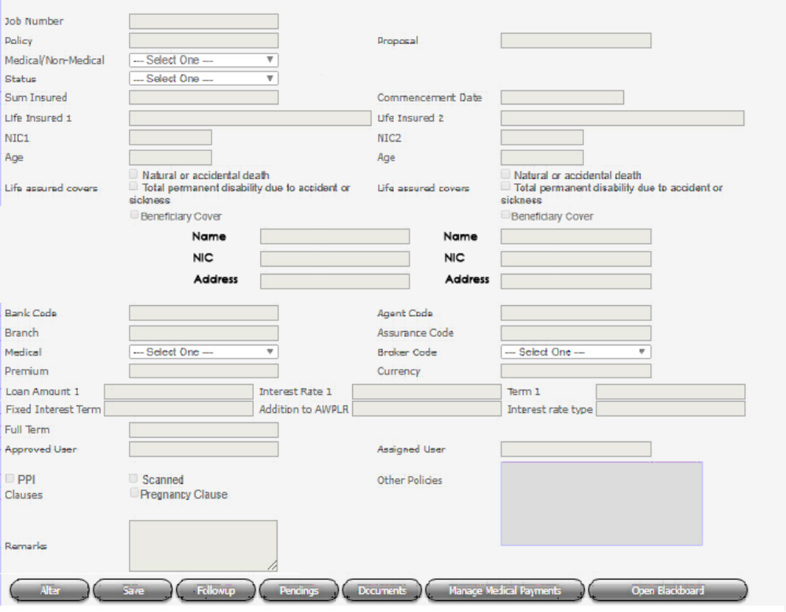

  - Pendings master data management screen
Front end of the pendings master data management is same as MRP, But need separate pendings.

  - Manage Box numbers and Add proposals
Need to manage box numbers for Micro. This should not conflict with MRP box numbers. Box number can be entered in any format.

  - Job transfer screen
Micro workflow needs job transfer facility which is same as MRP.

  - Benchmark reports
    - Micro workflow user performance should be monitored using benchmark reports. Micro need same reports as MRP in same format except
  - Re Insurance Confirmation Report
  - All Pending Cleared
    - All the benchmark times as same as MRP

  - Pendings and other system generated e-mails
All the e-mails generated from MRP workflow should generate from the Micro workflow too in same format. But all the texts mentioning MRP must change as MCR.

  - Common screens
Following screens and their particular data are common for both MRP and MCR.
      - Bank e-mails
      - Banks
      - HNBA Branches
      - MRP Brokers
      - MRP Business parties
      - Medical Labs
      - Signing persons

- Modifications
  - Add new dropdown box to workflow job assigning screen as “Business Channel”.
  - Add new dropdown box to Online MRP quotation screen as “Business Channel”. It should display only for HDO users.
  - Add new check box as “Free cover limit” to workflow job assigning screen.

  - Modify cover note formats as follows

10 April 2018

The Manager

Hatton National Bank
……………………………….

Dear Sir / Madam,

COVER NOTE FOR MICRO INSURANCE

PROPOSAL NUMBER :

LIFE TO BE ASSURED 01 :

LIFE TO BE ASSURED 02 :

SUM ASSURED :

REPAYMENT PERIOD :

INTREST RATE :

With reference to the above, we are pleased to inform you that the proposal is acceptable to cover the following risks and the single premium payable is Rs ………………………

- On the death of the Life Assured before the expiry date
- Total Permanent Disablement as a result of bodily injury as defined in the policy before the expiry date.
Kindly adhere to the following requirements enabling us to issue the Certificate of Assurance.

LIFE TO BE ASSURED 01 LIFE TO BE ASSURED 02
Original Proposal Form Original Proposal Form
Single Premium Single Premium

This offer is valid only for 7 days and will cease automatically unless the above requirements are not fulfilled. Please feel free to communicate with us on telephone numbers 0114677010 (EXT 391/306) if you need any clarification in this regard.

Thank You,

Yours faithfully,

HNB ASSURANCE PLC
………………………………
Authorized Signatory

10 April 2018

The Manager

Hatton National Bank
……………………………….

Dear Sir / Madam,

COVER NOTE FOR MICRO INSURANCE

PROPOSAL NUMBER :

LIFE TO BE ASSURED 01 :

LIFE TO BE ASSURED 02 :

SUM ASSURED :

REPAYMENT PERIOD :

INTREST RATE :

NAME OF BENEFICIARY : <<Full Name Holder of NIC>>

With reference to the above, we are pleased to inform you that the proposal is acceptable to cover the following risks and the single premium payable is Rs ………………………

- On the death of the Life Assured before the expiry date
- Total Permanent Disablement as a result of bodily injury as defined in the policy before the expiry date
- Payment of sum Assured to the Beneficiary in the event of death of the Assured
- Kindly adhere to the following requirements enabling us to issue the Certificate of Assurance.

LIFE TO BE ASSURED 01 LIFE TO BE ASSURED 02
Original Proposal Form Original Proposal Form
Single Premium Single Premium

This offer is valid only for 7 days and will cease automatically unless the above requirements are not fulfilled. Please feel free to communicate with us on telephone number 0114677010 (EXT 391/306) if you need any clarification in this regard.

Thank You,

Yours faithfully,

HNB ASSURANCE PLC

………………………………….
Authorized Signatory

  - Need to generate a report in provided format for COE businesses
  - Add new drop down box to re-insurance as “Sending Reason” which contains “Medical Opinion” or “Facultative” option.
  - Sending Reason should appear in the RI report
  - In the MRP workflow when the status is changed by the Users as “Reinsurance received”, a pop up message is required mentioning “Please complete the RI data”.
  - Allow to save the re-insurance data without selecting the re-insurer

- Scope of Work
Activity | Responsibility
Requirement analysis | IT/MRP
SRS confirmation | MRP
Software Development | IT
User Acceptance Testing & confirmation | MRP
Live deployment | IT

- Assumptions
N/A

- Constraints/Limitations
N/A

- Deliverables
New workflow system for Micro business process of MRP department which connected and update data with Micro system.

- Unresolved Issues
N/A

- Acceptance
# | Name & Designation | Date | Signature
1 | Venuri Ekanayake  Junior Executive – MRP Department
2 | Anuradha Ranasinghe - Manager-MRP
3 | Dinesh Udawatta - Chief Technical Officer, HNBA

