

Software Requirement Specification

PROJECT NAME | Micro Workflow System | DATE | 15/03/2018
TITLE | HNBA Micro Workflow Development Mar-2018
VER. NO. | 1.0
PREPARED BY | Tharindu Athapattu
SUMMARY | This SRS outlines the requirement of HNBA Life Operations – MRP unit on developments requested to develop Micro Workflow system

Revision of History
Version # | Release Date | Sections Changed | Change Description
1.0 | 10035/03/2018 | All Sections | Initial Version

Table of Contents

1. Introduction 3
2. Definitions, Acronyms and Abbreviations 3
3. References 3
4. Business Requirement 3
5. Solution 4
6. Scope of Work 6
7. Assumptions 6
8. Constraints/Limitations 6
9. Deliverables 6
10. Unresolved Issues 6
11. Acceptance 7

Software Requirements Specification

- Introduction
This SRS is prepared to identify the business requirement and provide a view of the proposed solution to develop Workflow system for Micro insurance.

- Definitions, Acronyms and Abbreviations
None

- References
None

- Business Requirement
This will be developed similar to existing MRP workflow and any modifications, exclusions or additions to current MRP workflow will be listed in section-5 of this SRS.
- MRP Unit has given following items as requirement.
  - Processes which doesn’t need any change from MRP workflow
    - Pendings master data management screen
    - Manage Box numbers and Add proposals
    - Job transfer screen

  - Processes need changes from MRP workflow
    - Job Assign screen
    - Main workflow screen
    - Benchmark reports
    - Pendings and other system generated e-mails

  - Process which can be excluded
    - None
  - Process newly added to MCR
    - None
  - Common processes which does not need any changes
      - Bank e-mails
      - Banks
      - HNBA Branches
      - MRP Brokers
      - MRP Business parties
      - Medical Labs
      - Signing persons

- Solution

  - Job Assign screen
    - Need to generate job numbers in following format

MCR/YEAR/Sequence no

Ex- MCR/2018/0001

  - Main workflow screen
5.2.1 Following fields should remove from main workflow screen.
  - Courier Service
  - Skip To Certificate Issued
  - Re Insurer
  - RI Ref No
  - HNBA Ref No
  - Loan Amount 2, 3
  - Interest Rate 2, 3
  - Term 2, 3
  - TPPD market limit

    - Following field should add to main workflow screen
    - Beneficiary cover (Check box)

    - Modified design of main workflow screen
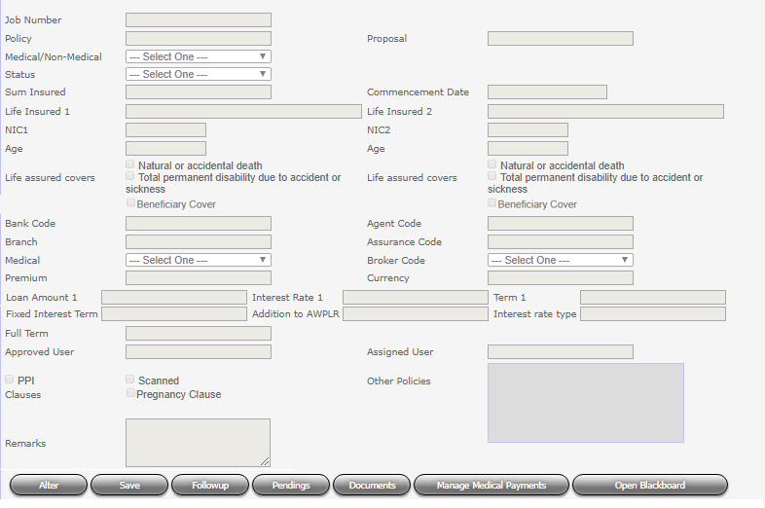

  - Pendings master data management screen
Front end of the pendings master data management is same as MRP, But need separate pendings.

  - Manage Box numbers and Add proposals
Need to manage box numbers for Micro. This should not conflict with MRP box numbers. Box number can be entered in any format.

  - Job transfer screen
Micro workflow needs job transfer facility which is same as MRP.

  - Benchmark reports
    - Micro workflow user performance should be monitored using benchmark reports. Micro need same reports as MRP in same format except
  - Re Insurance Confirmation Report
  - All Pending Cleared
    - All the benchmark times as same as MRP

  - Pendings and other system generated e-mails
All the e-mails generated from MRP workflow should generate from the Micro workflow too in same format. But all the texts mentioning MRP must change as MCR.

  - Common screens
Following screens and their particular data are common for both MRP and MCR.
      - Bank e-mails
      - Banks
      - HNBA Branches
      - MRP Brokers
      - MRP Business parties
      - Medical Labs
      - Signing persons

- Scope of Work
Activity | Responsibility
Requirement analysis | IT/MRP
SRS confirmation | MRP
Software Development | IT
User Acceptance Testing & confirmation | MRP
Live deployment | IT

- Assumptions
N/A

- Constraints/Limitations
N/A

- Deliverables
New workflow system for Micro business process of MRP department which connected and update data with Micro system.

- Unresolved Issues
N/A

- Acceptance
# | Name & Designation | Date | Signature
1 | Venuri Ekanayake  Junior Executive – MRP Department
2 | Anuradha Ranasinghe - Manager-MRP
3 | Dinesh Udawatta - Chief Technical Officer, HNBA

