**Figures**

Figure 1: SP for 2008 and 1998

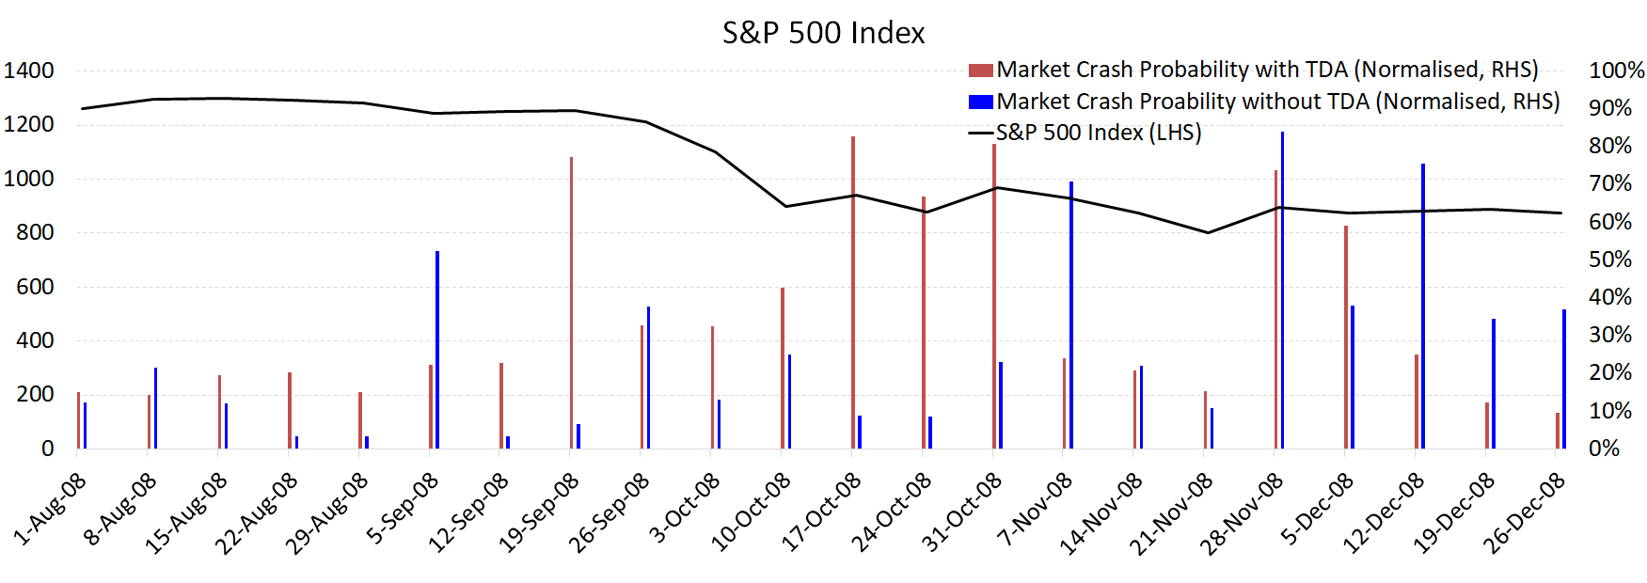

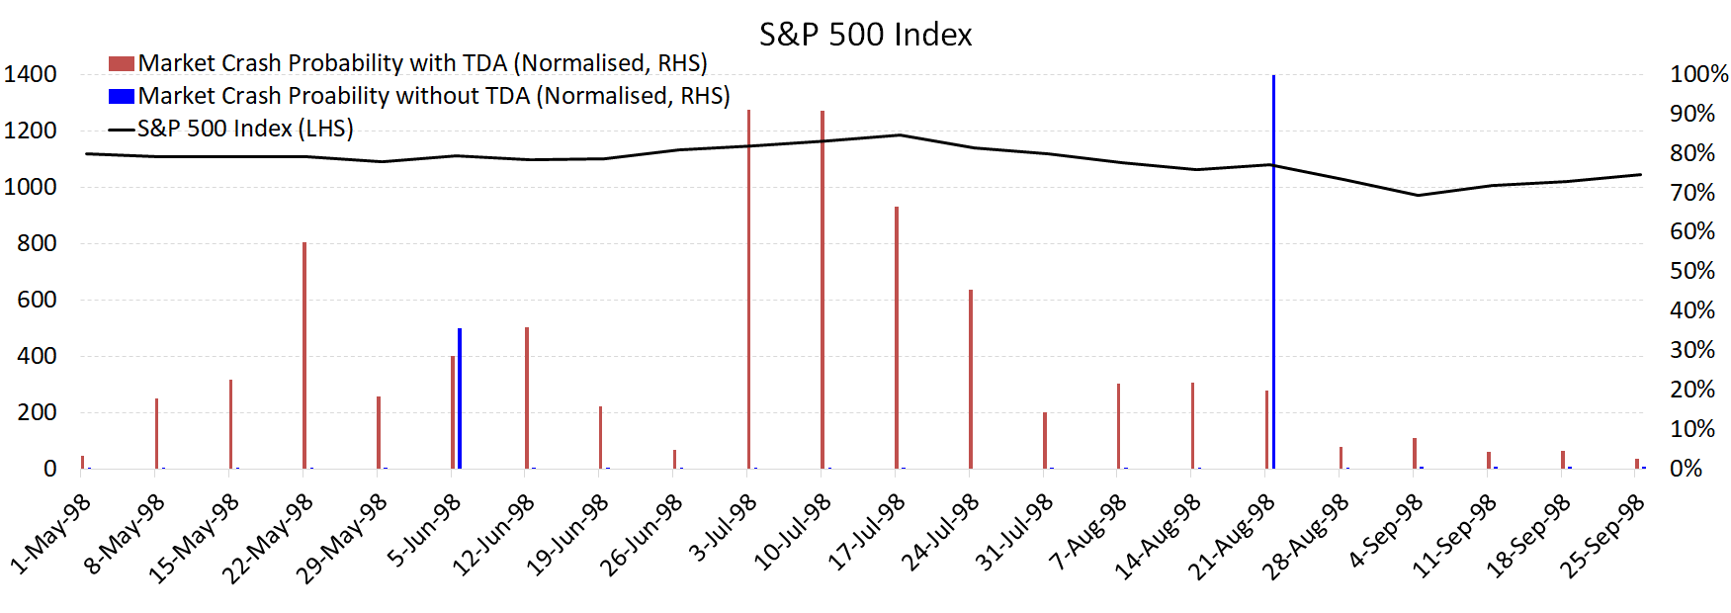

Figure 2: FTSE and HSI for 2008

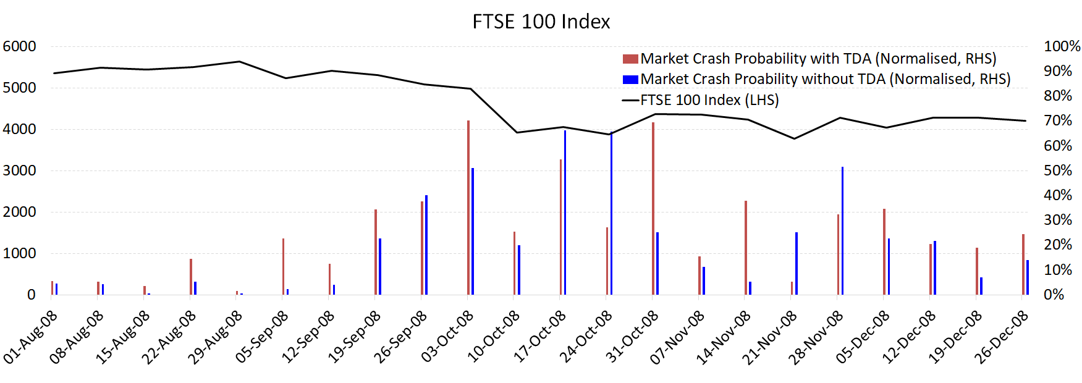

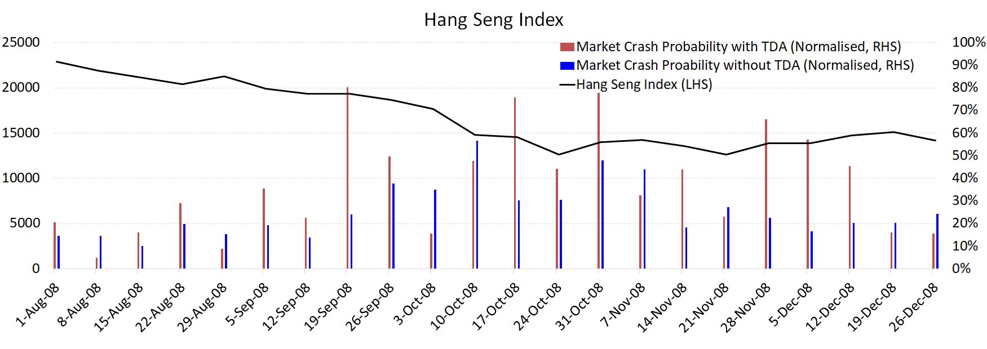

Figure 3: Feature weights for SP 2008 and 1998 with and without TDA

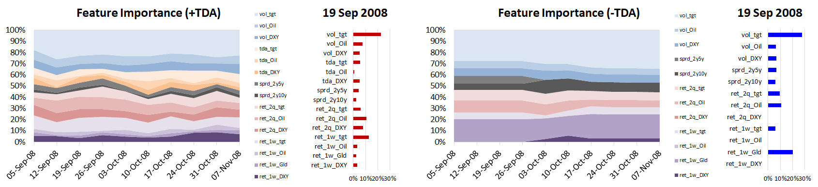

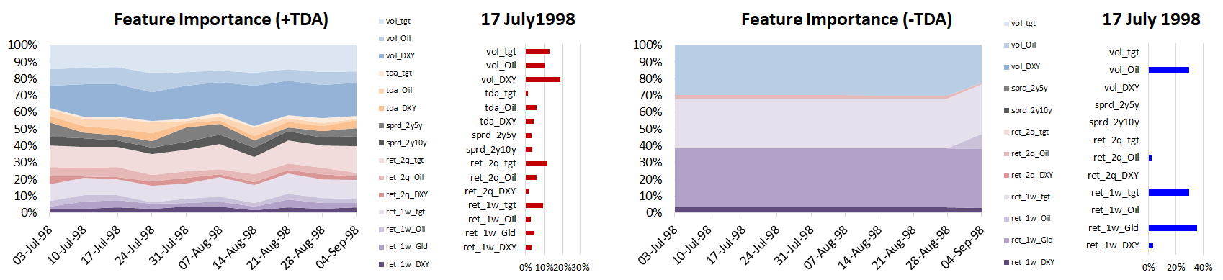

Figure 4: Feature weights for FTSE and HSI 2008 with and without TDA

FTSE 100

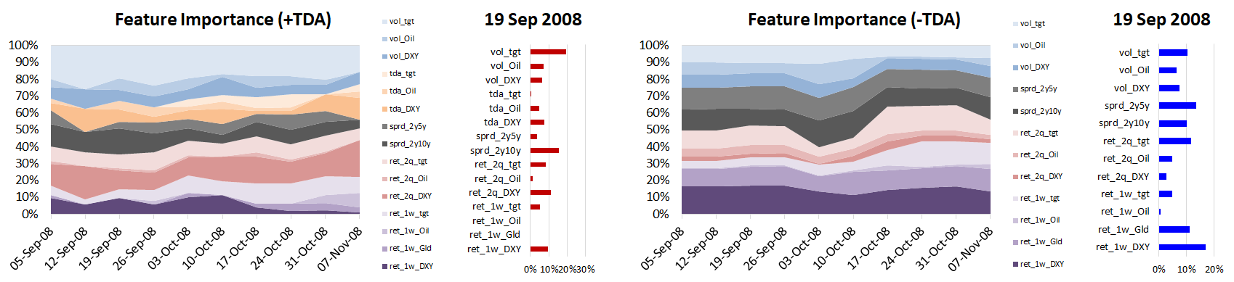

Hang Seng

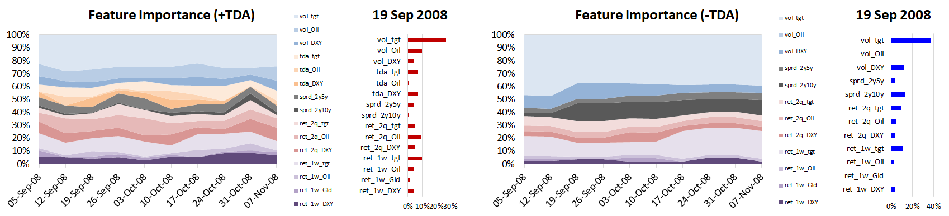

Figure 5: F1 Score for SP, FTSE, HSI

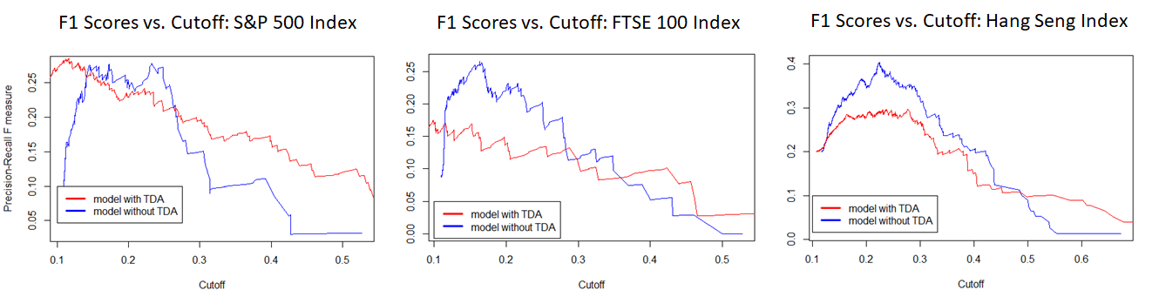

Figure 6: Crash Probability with and without TDA, AUC for SP

