Dat Tien Tran

T INFO 200 A

03/11/2021

L7mvc

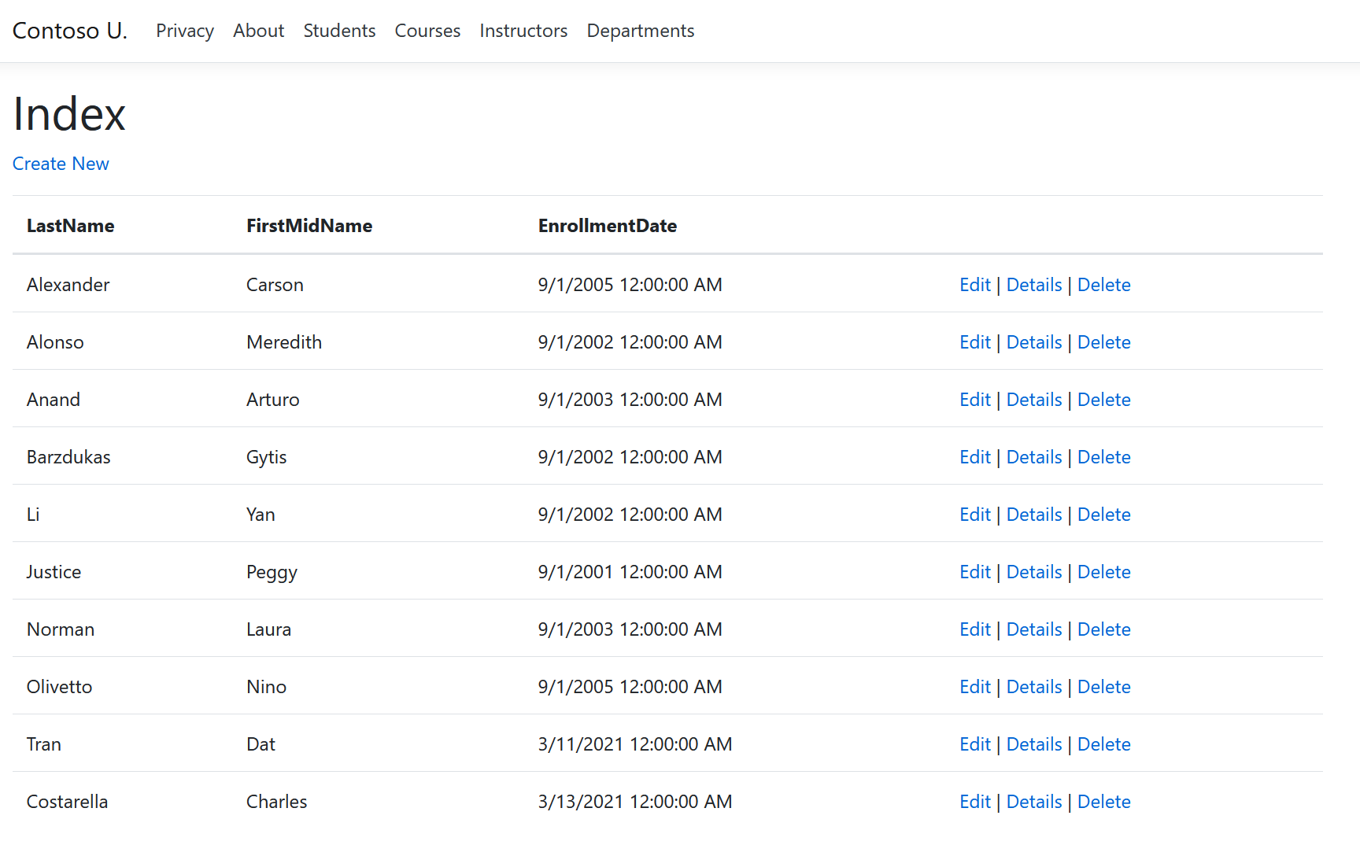**/Views/Students/Index.cshtml**

**/Views/Students/Edit.cshtml**

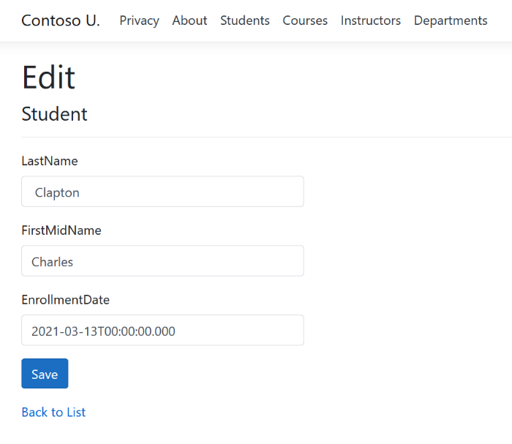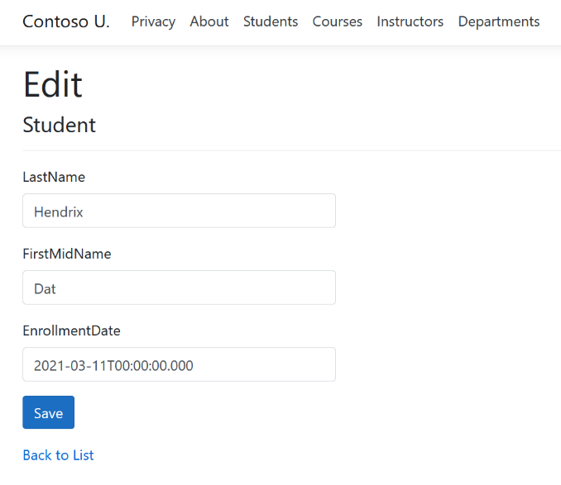

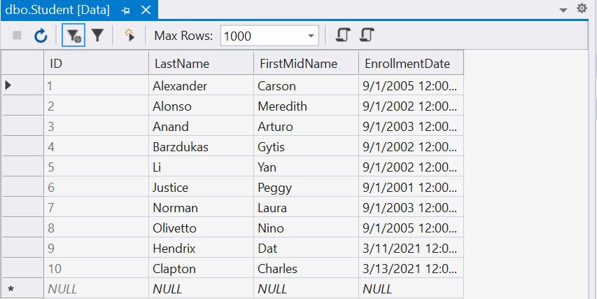**SQL Server Object Explorer**