**MSDS 6306: Introduction to Data Science**

**Live session unit 05 assignment**

**Travis Deason Oct 4th 2017**

Calculation Questions (using R) - Use R to calculate the following:

**NOTE:** Submit **a word file with the R codes** and **its screenshot** that shows the result.

**1.** (80%) Complete *bootstrap.R* code and take screenshots of the results by completing the following TODOs: **a.** (40%) Complete TODO 1 and 2 • Take a screenshot(s) that shows the TODO 1 code and TODO 2 histogram

* TODO 1

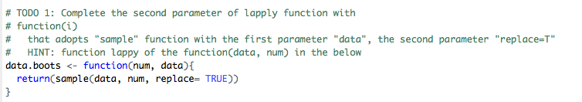

- TODO2

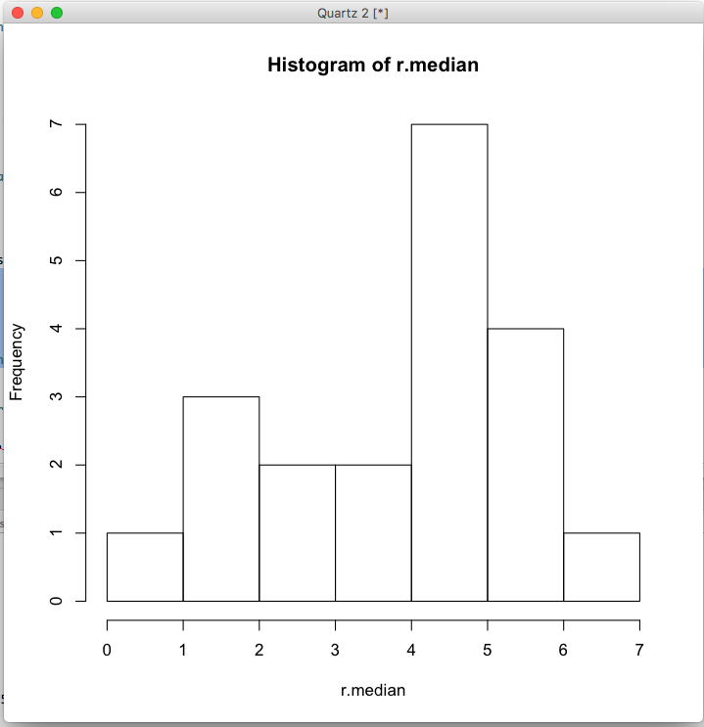

**b.** (40%) Complete TODO 3 and 4 • Take a screenshot(s) that shows the TODO 3 code and TODO 4 histogram

* TODO3

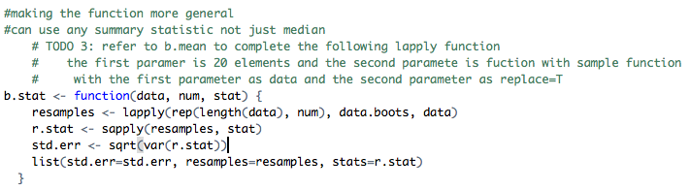

- TODO4

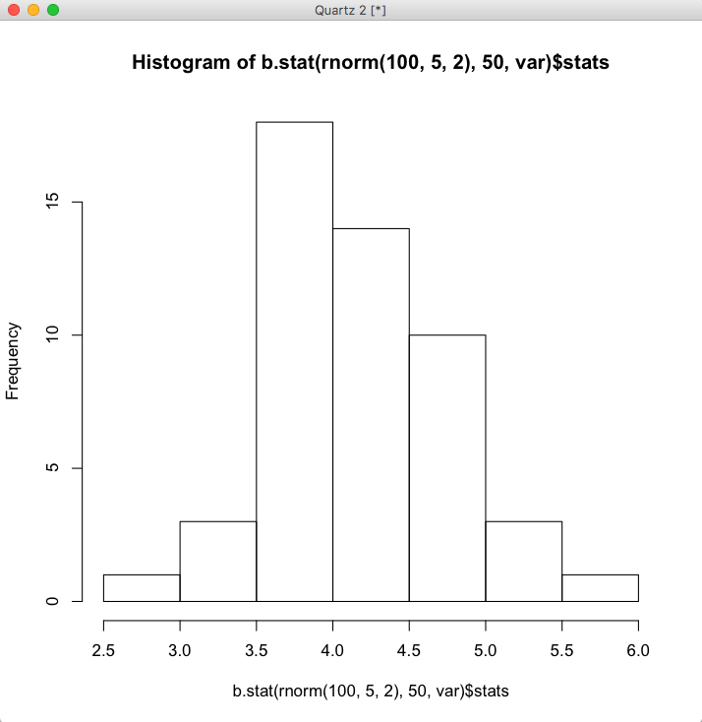

**2.** (20%) Complete R Swirl Bootstrapping code "14: Resampling" in Rstudio. Take a screenshot of “100% complete”:

