UNIT 6 HW 6

1. 



µ1, µ2, µ3, µ4, and µ5, are the mean scores in the none, amputee, crutches, hearings and wheelchair groups respectively. Be careful when identifying ‘k’ here.

1. 



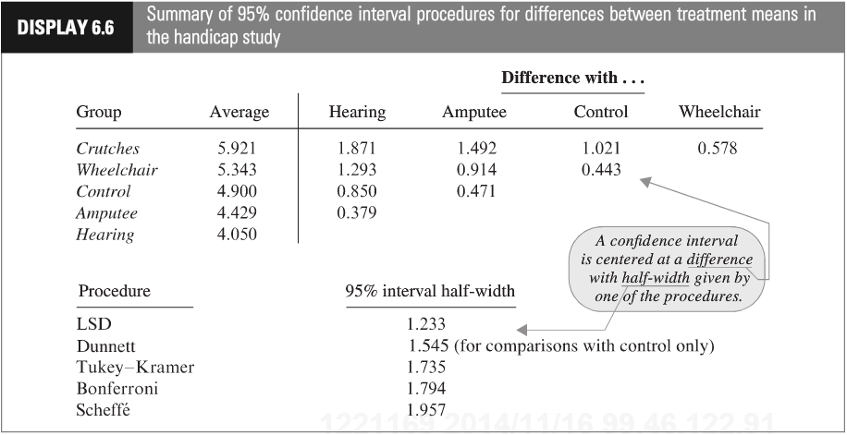

To show your work for this problem by simply copying the code and relevant output for each comparison. (Cut and paste your code.) Do this for both R and SAS.

1. 

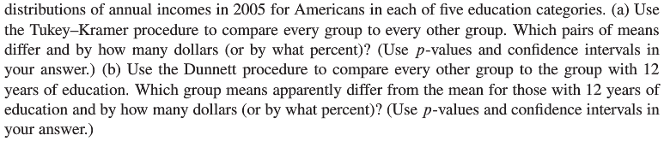

This question is obviously from the book, but assume you are starting this problem from scratch. Show all parts: (1) Discussion of Assumptions (2) Selection and Execution of Tests (3) Interpretation and Conclusion. In short, perform a complete analysis like you usually do. Provide and interpret all the confidence intervals that suggest a significant difference in mean incomes; provide your SAS and R code as well. (Generate your statistics using both softwares.)

Bonus: Max 5 pts



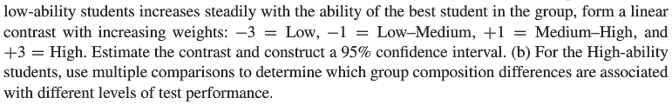

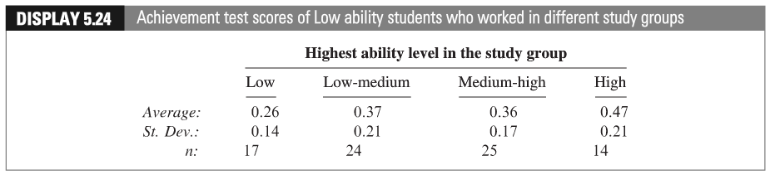

Give the levels of ability a quantitative representation (Low = 1, Low-Medium = 2 etc.) and conduct a linear regression of the average performance against the level variable you just created. Be sure and address the assumptions. Defend the ones you can and assume the others are met. Include a scatterplot and residual plot. Is there evidence of linear trend? Is this inferred from the contrast? Assume the levels are equal distant in ability from each other.