Determining the Volume, Surface Area and Centroid of an Object represented as a closed set of 3-D triangular meshes

by A. V. De Caria
June 2016

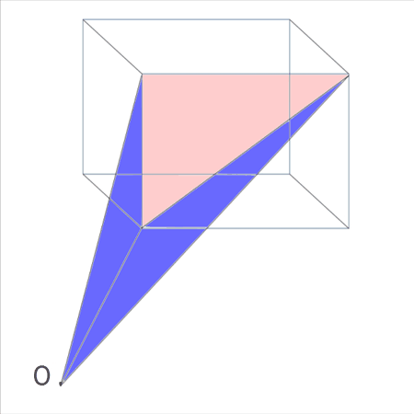
Table of Contents

Introduction.....................................................................................3

History..............................................................................................3
Trapazoidal Method........................................................................4
Triangular Method..........................................................................4
Volume Method................................................................................5

Program Description.......................................................................7
Program Usage for Windows and Linux.......................................7
Program Output..............................................................................7
Program Logic.................................................................................7
Determining the volume of a tetrahedron...................................10
Program Results............................................................................10
Program Notes...............................................................................11

Appendix A Equations..................................................................13
Appendix B Performance.............................................................18
Introduction

My objective in writing this program is to provide a general solution to the problem of finding the volume of an object from a set of connected surfaces enclosing it.

I have a strong interest in making knowledge freely available to the world and so have entered this program and documentation into the public domain (see Program Description below).

The approach I have chosen was to use a triangular mesh to estimate the geometry of the object. Obviously a triangular mesh may only be an approximation if the surface has any curvature. This problem is normally overcome by making the triangles in the mesh smaller where you need more detail.

Triangular meshes are commonly used in 3-D modeling software as a means to represent an object's surfaces. A standard file format (.obj) already exists which contains, in addition to other items, the geometry of an object in terms of its vertices (x, y and z points) and faces. High quality object files can have 40,000 vertices and 50,000 faces. Fortunately modern laptop computers can easily perform the hundreds of calculations required for each face in less than a second.

Determining the volume of the 3-D triangular mesh was not that intuitive to me. It took me a long time to understand the process of using the object's surface triangles to construct tetrahedrons with an external point like the origin, then finding the tetrahedron's volume and adding back-facing surface volumes and subtracting forward-facing surface volumes to get the object's overall volume. In order to make this less confusing I have attempted to explain this process first by looking at the equivalent problem in 2-D. By understanding the approach to the calculation of area in 2-D, the calculation of volume in 3-D becomes a natural extension.

History

Originally I had designed a generalized algorithm to calculate areas bound by line segments using trapezoids (see Trapazoidal Method below). I had all the points required to construct the trapezoids needed to compute the area and it was not too hard to determine which areas to add and which got subtracted. This worked but I could not figure out how to extend this approach to the volume problem.

A friend of mine introduced me to a professor at Carnegie Mellon University who after reviewing my approach suggested that I instead use an external point O and connect each line segment to form triangles (see Triangular Method below). When I asked why the triangles were any better he said that it was closer to the approach often used to determine volumes with tetrahedrons. He said just as you go around the 2-D object and form triangles with the origin, in 3-D you go around the object and construct tetrahedrons. Adding and subtract volumes based on whether the surface was visible from the perspective of the external point O. The light went off in my head and I finally understood this approach to finding the volume.

This took me on a long journey exploring volume formulas of irregular tetrahedrons, surface normals, cross products and object (.obj) files. With some help from Wikipedia and the internet I was able to piece together the code to accomplish the task.

Trapazoidal Method

One approach to the area problem is to form a trapezoid from each of the line segments by dropping two vertical lines to the x axis. By adding the area's from the top line segments and subtracting the area's of the lower line segments the exact volume can be calculated.

Area of a trapezoid = ((b1 + b2) /2) * h
where b1 and b2 are the two base (y) values and h is difference in x values.

Example of Trapazoidal Method:
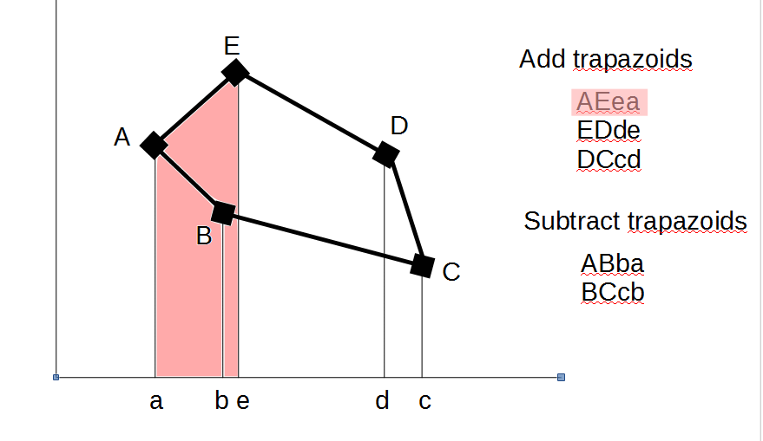
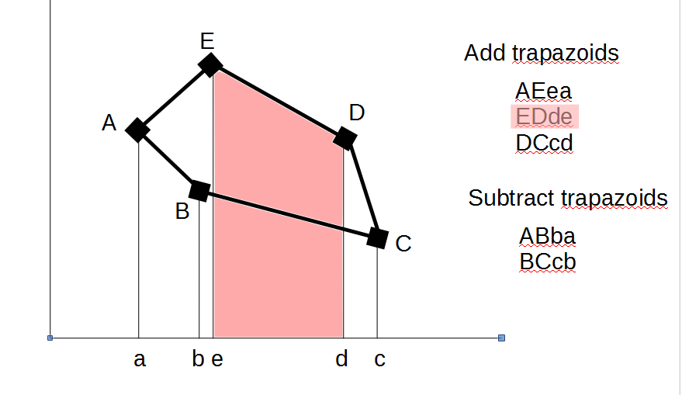
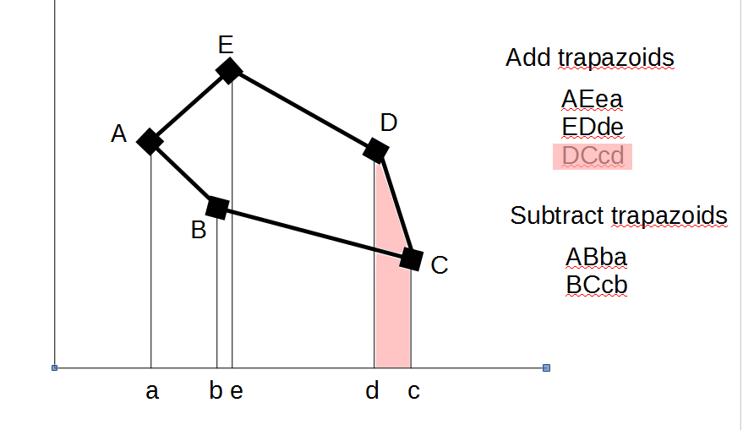

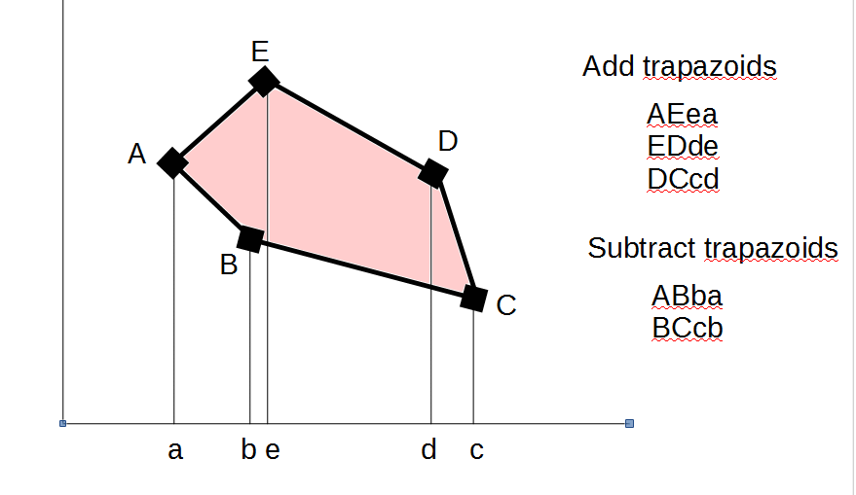
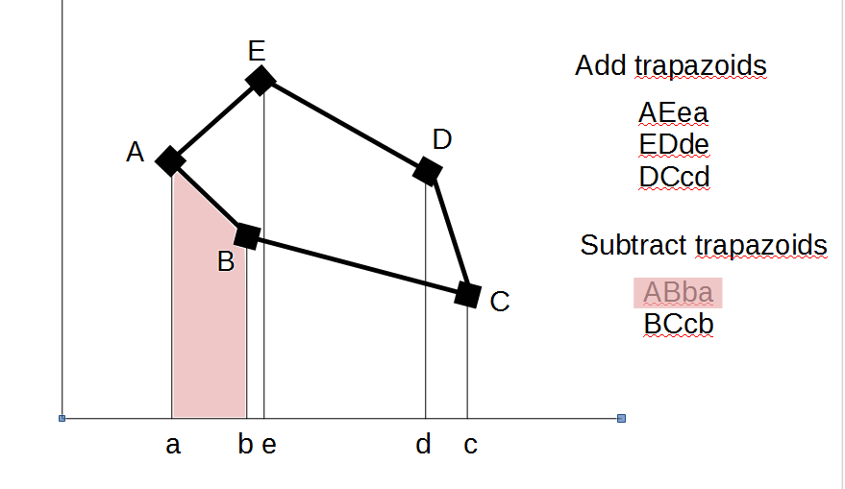
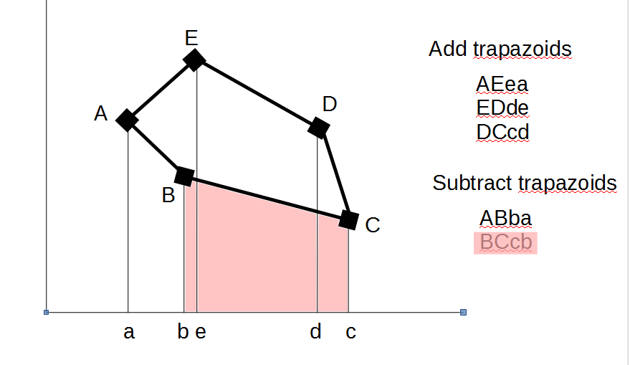

This method works well for convex (interior angles not greater that 180º) polygons but would have trouble for some shapes. The idea here is to understand the process of using line segments to make a trapezoid and the process of adding and subtracting trapezoid areas to get the exact area of the polygon.

Triangular Method

A similar approach uses the same line segments to form a triangle with an external point such as the origin O. Here we add triangle areas that are blocked from the view of the origin O and subtract the areas that are visible from the origin O, again yielding the exact polygon area. The area of any triangle with sides a, b and c can be obtained from Heron's formula (from Wikipedia).

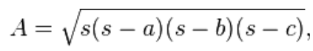
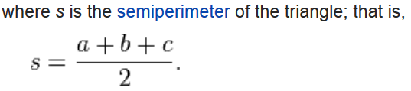

Example of Triangular Method:
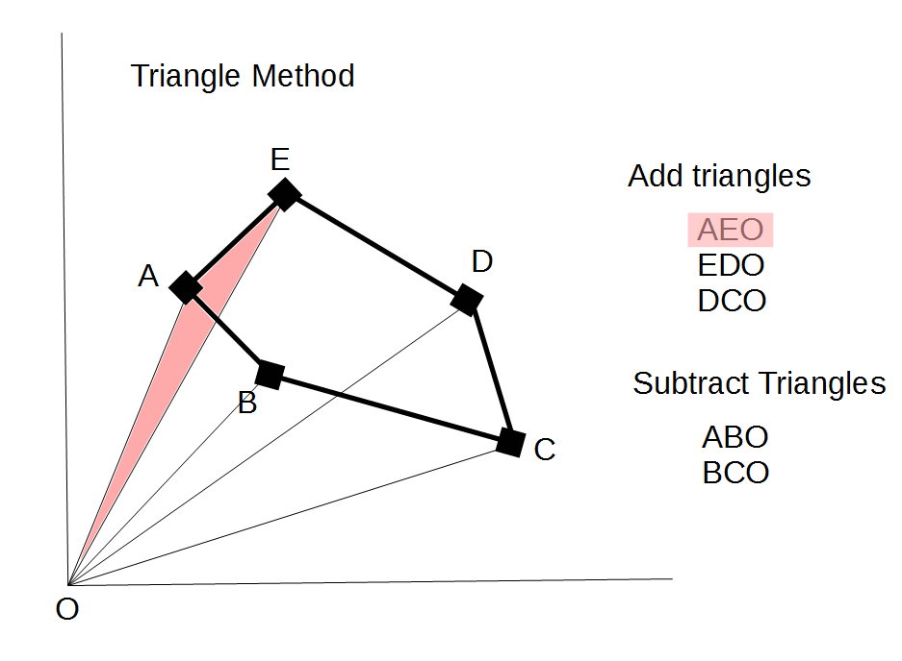
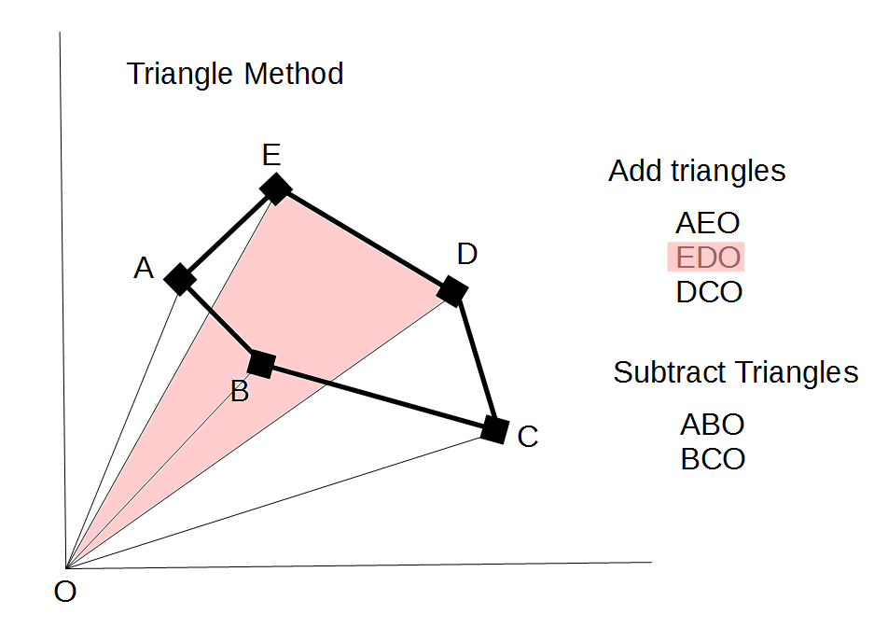
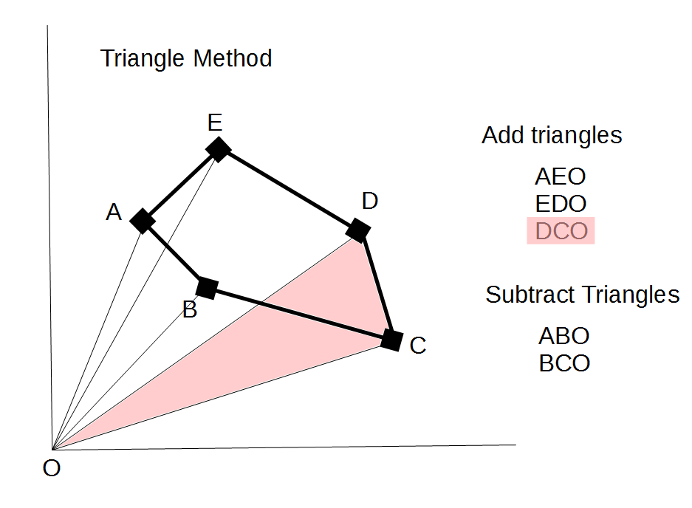

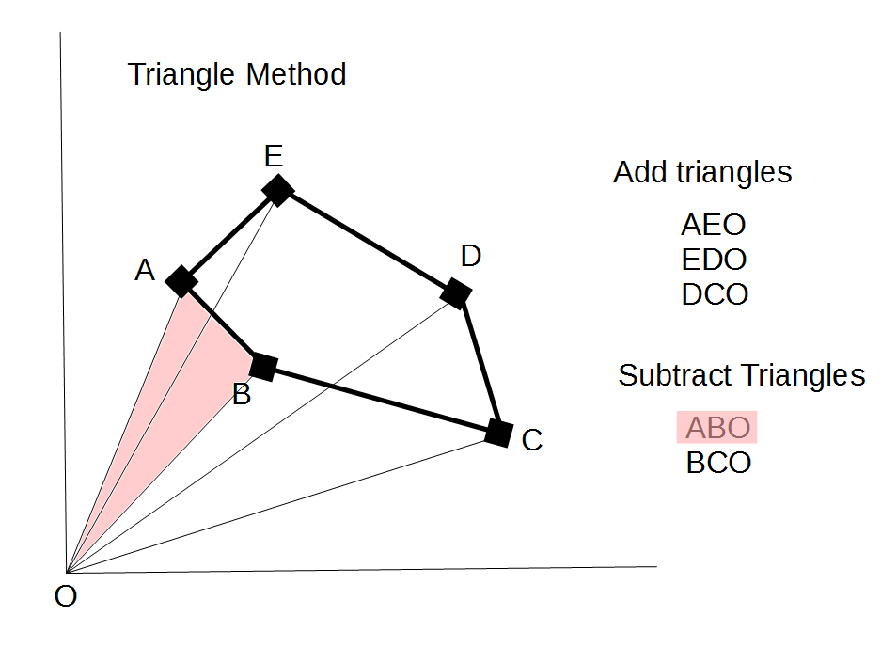
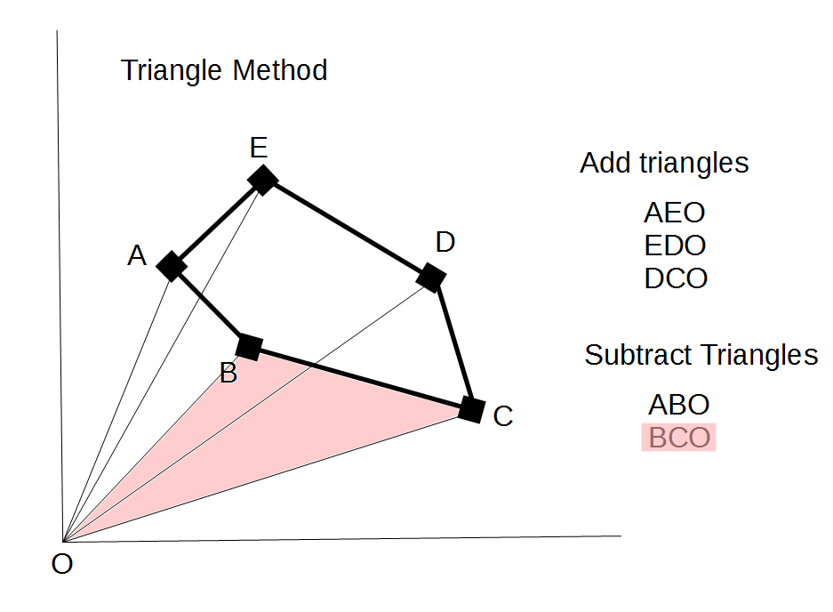
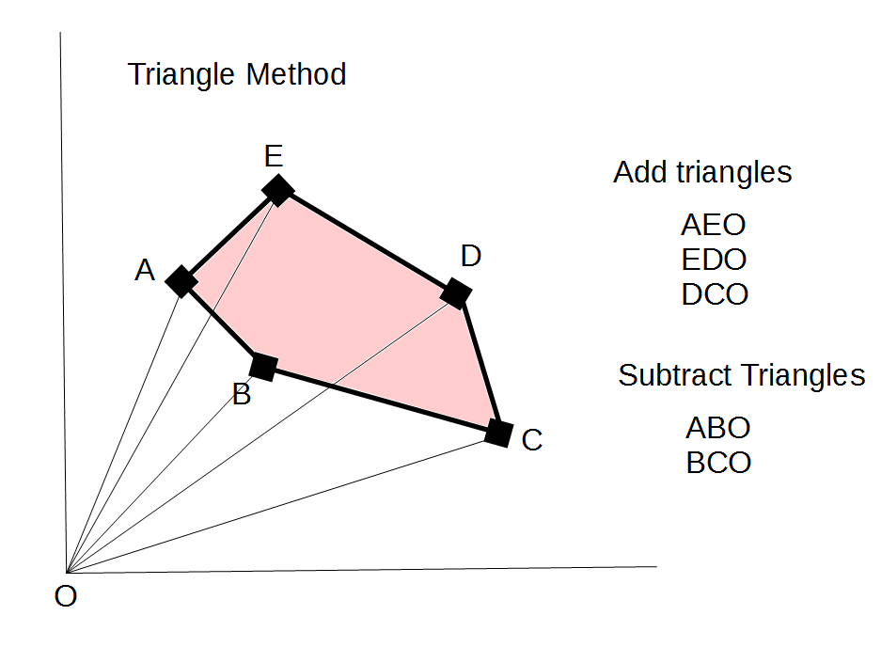

Volume Method.

The basic approach for volume is similar to the Triangular Method described above but instead of forming triangles with the origin O, tetrahedrons (four points not all in the same plane) are constructed from the object's triangular surface mesh and the origin O.

This method uses an external point (O) outside the object (oftentimes the origin) to form a tetrahedron with each triangular face defining the surface of the object. By calculating the volume for each constructed tetrahedron and subtracting the forward-facing surface volumes (blue) from the back-facing volumes (red), the exact volume of the object can be obtained.

In the example below the surface of the rectangular object has been broken into 12 triangles each forming a tetrahedron with the origin O. Even though this is an extremely simple object it demonstrates the same approach used for very complex objects with thousands of triangles.

Example Using Tetrahedrons to Determine an Object's Volume
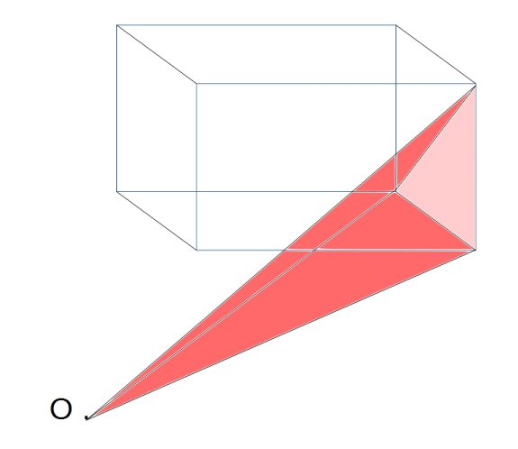
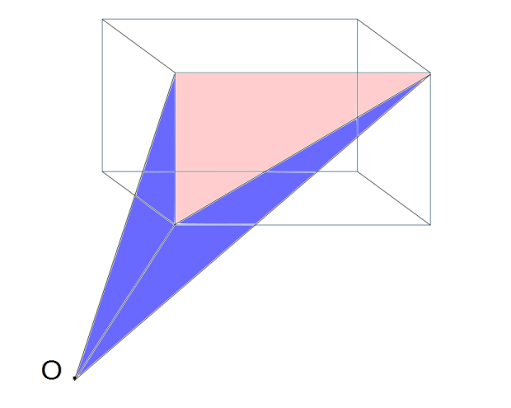
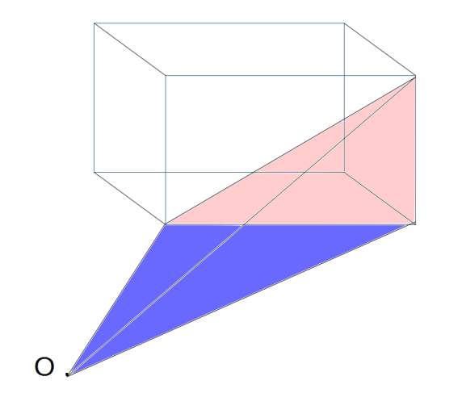

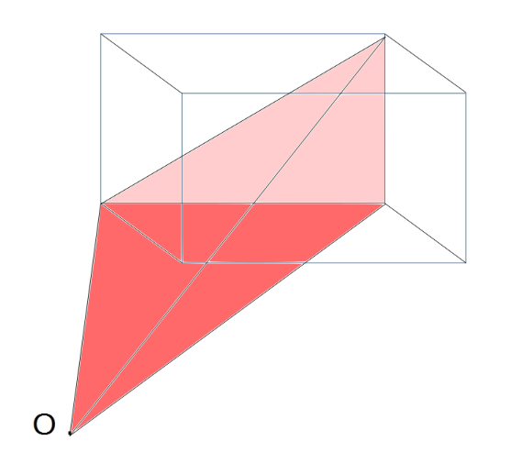
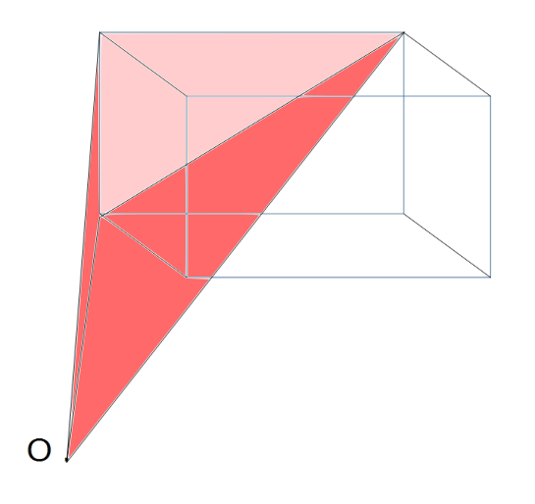
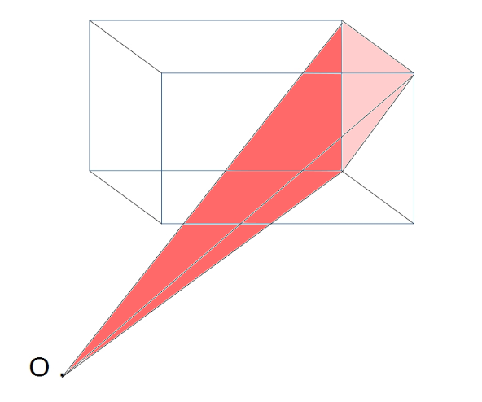

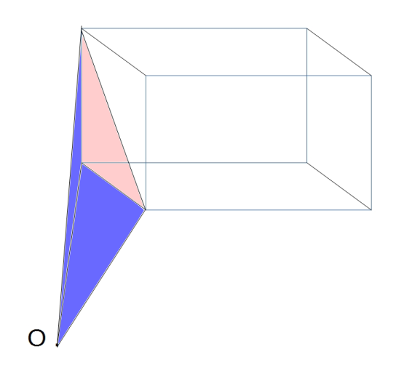
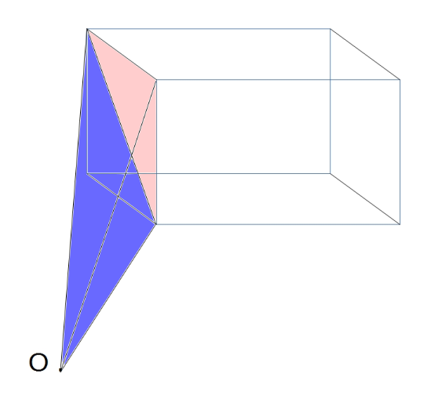
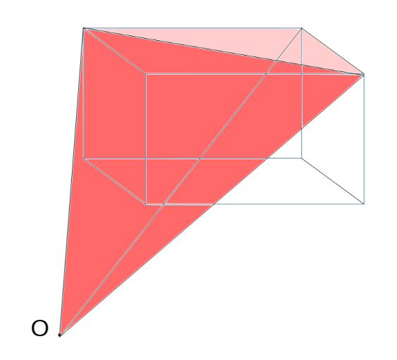

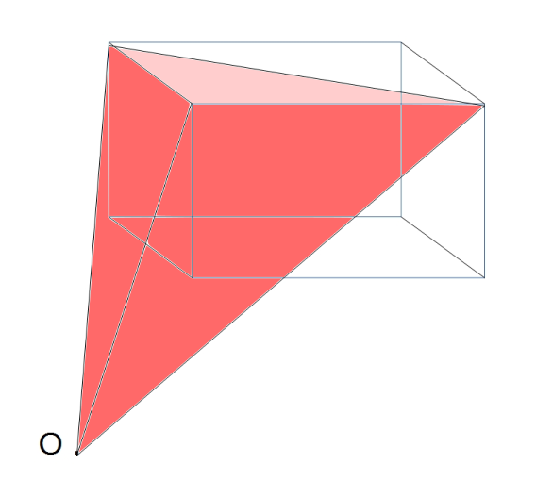
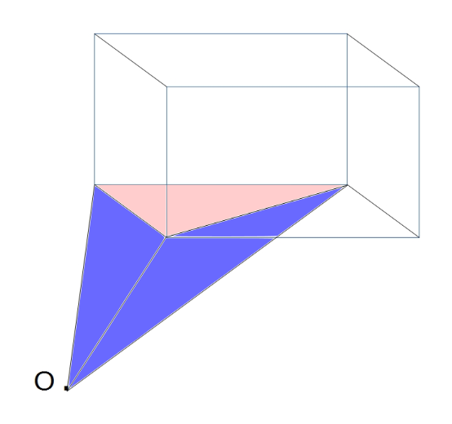
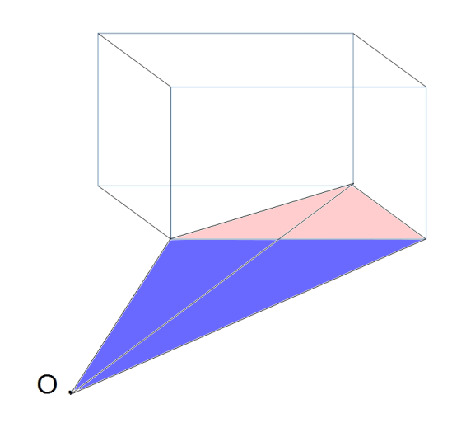

When all the vertices for each triangle are input in a counterclockwise manner, as they are in object files (.obj), the normal vector (90º from the surface) for each triangular surface will be pointing outward from the object. This surface normal is used to determine if the tetrahedron's volume is treated as a positive or negative value. If the triangle's surface normal vector has any component pointing toward the external point O, it is forward-facing and so its volume (blue) is subtracted from the total. If the normal vector is facing away from the external point it would be a back-facing surface and its volume (red) is added to the total.

This is the same approach used when one tries to display the visible portions of a 3 dimensional object on a 2 dimensional screen from the perspective of an origin point O. The surface's normal vector is used to determine back-facing areas which are ignored as they are not visible and only the forward-facing surfaces are rendered to the screen.

It turns out that even if the external point O is located within the object, the method will still work. As long as the object's surface is closed, the volume will be calculated correctly. This applies to complex forms such as the human body or a teapot. In the program the origin (0, 0, 0) is used as the first point connected to every surface triangle.

Program Description

The program was written entirely in java and runs as a stand alone application. The java code, application and this document are freely available at
http://sourceforge.net/projects/ObjectVolume
under a Public Domain license.

Program Usage from the Command Line (Windows or Linux):

java ObjectVolume filename.obj
Example:
java ObjectVolume female.obj

Program Output:

ObjectVolume - Calculates Volume, Surface Area and Centroid of an Object

Input File: C:\Users\Tony\Projects\ObjectVolume\teddy.obj

Total Volume = 8679.56458
Total Surface Area = 3199.31512

Centroid of Object (x,y,z):( -0.21981 , -3.52637 , 1.02739 )

Total Number of 3D Points = 1598
Total Number of Faces = 3192

Number of Sides Count
3 3192

Total Number of Triangles Processed = 3192
Total Number of Undefined Volumes = 0

Total Program Run Time = 52 milli seconds
Time in Calc Method = 21 milli seconds

Program Logic

The program consists of a main routine which:
- reads in the all of the vertices (x, y, z) from the specified object (.obj) file and stores each set of three values as a single vertex in a 2 dimensional array.

- reads and processes each face
Each face consists of a set of index values which point to the vertices in the above array. All the vertices referred to in a face lie on a single plane and forms one piece of the object's surface. Oftentimes triangles and rectangles are used to represent real surfaces so higher quality is obtained by making the faces smaller. Smaller faces means a lot more faces are needed to model the same surface area but this permits a finer level of detail to be achieved.

- if the face contains three points the surface is represented as a single triangle
- if the face contains four points (any four sided polygon) it is easily broken up into two triangles by constructing a line between the first and third points.

- in a similar manner if there are more than four points an attempt is made to reduce the face to a set of triangles. The algorithm arbitrarily selects a single point (first point) from the face and constructs a line from this first point to the third through (n - 1) points. In general this will create (n - 2) triangles from an n-sided face. So a face with 5 points will produce 3 triangles (5 – 2) and a face with 6 points produces 4 triangles.

However, unless these faces are regular and convex this process may not work well. For this reason it is best to avoid using this program with meshes containing irregular shaped faces or until a better face-to-triangle algorithm is implemented.

Once a face is broken into a set of triangles, each triangle produced is connected to an external forth point O (0, 0, 0) to form a tetrahedron. The four points of the constructed tetrahedron are passed to the calc method using the origin as the first point followed by the three points of the triangle. The calc method is called once for each triangle in the face and continuing over all the faces in the object.

The calc method
The calc method is the workhorse of the algorithm. The inputs to this method are the four points of a tetrahedron. Using these four points this method is designed to:

- Calculate the normal vector for the triangular surface. Two vectors (a and b) are constructed from the last three points. The cross product of these two vectors produces the normal vector n = a x b. The normal vector is 90º from the plane of the triangle.

In an object (.obj) file the points of each face are entered in a counter clockwise manner looking from outside. This assures that the normal vector for each face will always be pointing out of the object.

- Determine if the volume is positive or negative. If the normal vector to the triangle points away from the origin O it is a back-facing triangle and indicates a positive volume. When the normal points towards the origin O it is a forward-facing triangle indicating a negative volume.

- Calculate the area of the triangle formed from the last three points using the following formula:
Area of triangle in 3 space = | a x b | / 2 or | n | / 2

- Calculate the volume of the tetrahedron formed from the four input points. There were four methods found to perform this calculation and they are listed in Appendix A Equations. Method 2 from Wikipedia is used in the current implementation although all four methods produced similar results (see Appendix B Performance) and have been made available in the current distribution.

Method 2 from Wikipedia

From Wikipedia (https://en.wikipedia.org/wiki/Tetrahedron#Heron-type_formula_for_the_volume_of_a_tetrahedron)

Heron-type formula for the volume of a tetrahedron

where
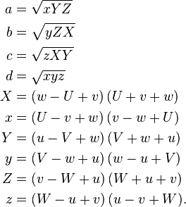
The program first uses the four input points to determine the six edge lengths of the tetrahedron (u, U, v, V, w, W). It is important to understand the relationship between the opposite edge pairs (u, U), (v, V) and (w, W) when you construct the six edge lengths from the four input points. Once these edge lengths have been determined the given equations were used to produce the volume of the tetrahedron.

- Calculate the centroid or geometric center of the tetrahedron.
Calculating the centroid of a tetrahedron is achieved by averaging the x, y and z values of its four points. These averaged values are then multiplied by the tetrahedron's signed volume to be used to produce a weighted average value for the overall object once all the triangles in the objects surface are processed.

- End of calc method

Each call to the calc method returns five values in the ans array.
1) signed volume of this tetrahedron
2) surface area of the triangle formed from last three points
3) average of the four x values multiplied by signed volume
4) average of the four y values multiplied by signed volume
5) average of the four z values multiplied by signed volume
Each returned value is accumulated into five separate global variables.
After all the faces have been processed:
1) The global variable for volume contains the object's total volume.
2) The global variable for the area contains the object's total surface area.
3) The x, y and z global variables are each divided by the total volume giving the object's centroid or geometric center of volume.

Determining the volume of a tetrahedron

After searching the internet for formulas that calculate the volume of a tetrahedron I found three different sets of equations that claimed to do just that. In addition to these three methods a forth method was implemented by manually reducing the 5 x 5 determinant in Tartaglia's formula to a set of equations based on the line lengths of the tetrahedron.

1 - Keisan Online Calculator (http://keisan.casio.com/exec/system/1329962711)

2 - Wikipedia (https://en.wikipedia.org/wiki/Tetrahedron#Heron-type_formula_for_the_volume_of_a_tetrahedron)

3 - Zobayer Hasan's blog “Volume of an irregular tetrahedron” (http://zobayer.blogspot.com/2009/11/volume-of-irregular-tetrahedron.html)

4 – 5 x 5 determinant reduced to equations in Tartaglia's formula.

The content of the above web sites are highlighted in Appendix A Equations as well as the equations I produced by reducing the 5 x 5 determinant. Four separate calc subroutines were written using the equations defined for each method. The four subroutines are provided as four separate files. I wanted to see if the four different methods produced the same results and if there was any difference in their individual run times. Remember that the calc subroutine is called once for each face in the object and with objects that can contain over 50,000 faces I thought that I might see a difference in performance.
The result of testing the four methods (see Appendix B Performance) showed little or no difference in the calculated value for volume, surface area or the timing. I was amazed to see that each method somehow produced the same result in about the same time. Method 2 from Wikipedia is used in the current implementation.

Program Results

Once all the faces have been processed a short report (see Program Output above) is produced displaying:
- the input file
- the volume, surface area and centroid of the object's
- the number of vertices and faces in the object file
- the total calc time and total program time
- the number of “undefined” volumes (NaN = Not a Number)

The program seems to run quickly and is able to perform over 31,000 calls to calc in just 218 milliseconds on a modern laptop computer using an Intel Core i7 processor.
The program seems to spend an equal amount of time reading and parsing the object file as performing the calculations in the calc method.

Program Notes

The program output is completely independent of the units of measure used for the input data. If the points defining the object were entered in centimeters (cm) then the value of the volume would correspondingly be in cm³.

I have tested this program with a variety of source files (object files) from the internet and have found that although the data is mostly the same in all files, the exact format sometimes differs and additional lines of code were needed to accommodate the various formats found. Many of the object files I used were produced from the free software tool Blender so that format is handled. Other software tools may not be formatted in the manner that my program expects and so may cause problems.

I have found example object files on the internet that while valid object files, the surface described is not a continuous closed triangular mesh. If, for example, you had a leg segment that was pushed up into the body to get the right look, the volume this program calculates would be overstated since the triangles on the inside of the body would still be processed. There is no problem with having multiple closed triangular meshes in an object file but you need to understand the impact on volume when these meshes intersect or are completely contained one within the other. Remember that every face in the model is processed sequentially adding or subtracting from the overall volume.

Currently the program does not support object files that use vertex normal (vn) lines to determine the surface normals. The normals for each face are always calculated assuming that each triangle is entered in a counterclockwise manner when viewed from the outside of the object. This generates a vector pointing out of the object and is used to tell if the surface is back-facing or forward-facing.

The number of Undefined Volume (NaN - Not a Number) values are caused when the four points are all on the same plane causing the value under the square root to become negative. These zero volumes are ignored although the surface area associated with the triangle is still valid and is returned.

Since all the vertices from the object file are stored in an array (V), the number of vertices is limited to the size of this array. It is currently set to 50,000 but can be increased if memory permits. The number of faces does not matter since each face is processed sequentially and is not stored.

In addition, the maximum number of vertices on a face line is arbitrarily set to 100 in the array faceValues[].

This program requires a Java Runtime Environment (JRE) on the client computer (this software is normally already installed to support web and other components). Since the actual java code is available, any changes can be made by simply editing the ObjectVolume.java file with your favorite editor (I like eclipse) and recompiling the code then executing the generated class file:

> javac ObjectVolume.java // Compiles the program
> java ObjectVolume cup.obj // Executes the program with a single input parameter
Appendix A Equations

Method 1
From: Keisan Online Calculator (http://keisan.casio.com/exec/system/1329962711)

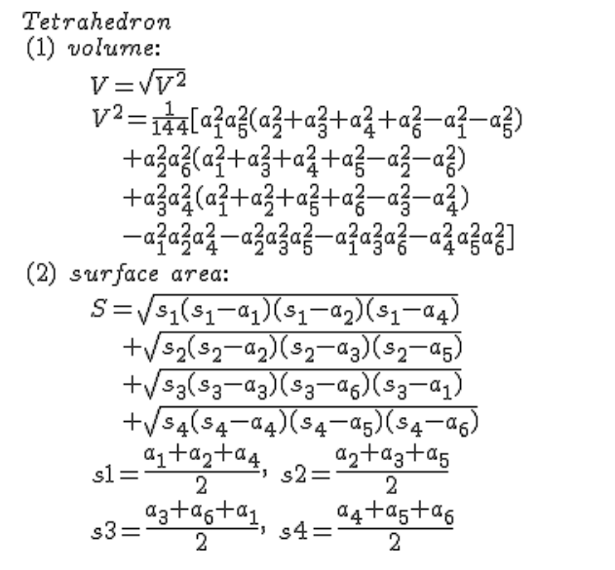

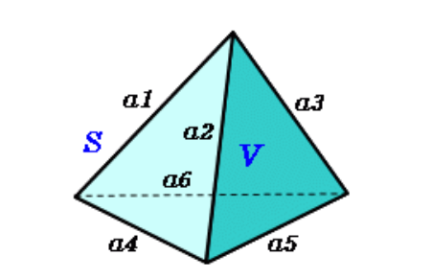

Method 2
From Wikipedia (https://en.wikipedia.org/wiki/Tetrahedron#Heron-type_formula_for_the_volume_of_a_tetrahedron)

Heron-type formula for the volume of a tetrahedron
If U, V, W, u, v, w are lengths of edges of the tetrahedron (first three form a triangle; u opposite to U and so on), then
where

Method 3
From: Zobayer Hasan's blog “Volume of an irregular tetrahedron” (http://zobayer.blogspot.com/2009/11/volume-of-irregular-tetrahedron.html)
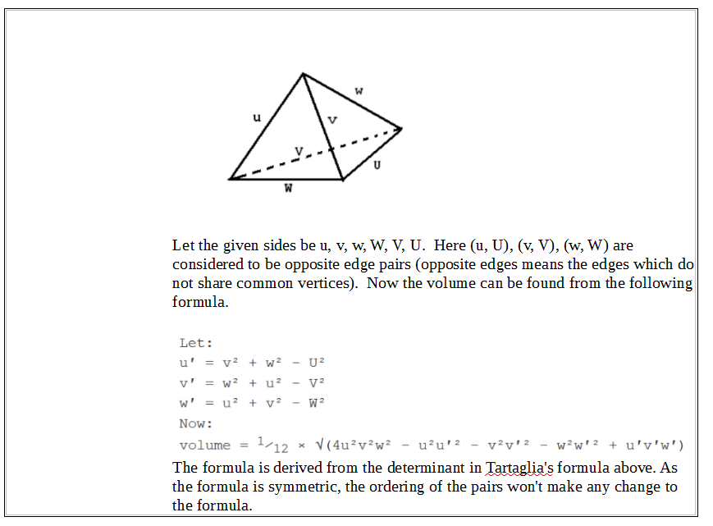

Method 4
Taking the 5 x 5 determinant

Tartaglia's formula from Wikipedia (https://en.wikipedia.org/wiki/Niccol%C3%B2_Fontana_Tartaglia#Volume_of_a_tetrahedron)

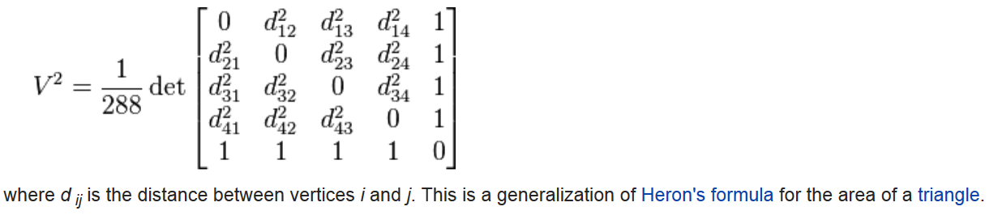

The values used in the matrix are determined by calculating the six line lengths and substituting them into the above matrix. This is a 5 x 5 matrix but since the first term is zero only four (4 x 4) determinants need to be evaluated.

The determinant was calculated by hand and took me several hours to complete. The result is the value of each of the four terms (A, B, C and D) defined below. Each term is the evaluation of one of the 4 x 4 determinants. Adding these four components gives the value of the 5 x 5 determinant in the above formula.

Calculate the six edge lengths of the tetrahedron from the four input points

d21 = (x2 - x1) * (x2 - x1) + (y2 - y1) * (y2 - y1)
+ (z2 - z1) * (z2 - z1);
d31 = (x3 - x1) * (x3 - x1) + (y3 - y1) * (y3 - y1)
+ (z3 - z1) * (z3 - z1);
d32 = (x3 - x2) * (x3 - x2) + (y3 - y2) * (y3 - y2)
+ (z3 - z2) * (z3 - z2);
d41 = (x4 - x1) * (x4 - x1) + (y4 - y1) * (y4 - y1)
+ (z4 - z1) * (z4 - z1);
d42 = (x4 - x2) * (x4 - x2) + (y4 - y2) * (y4 - y2)
+ (z4 - z2) * (z4 - z2);
d43 = (x4 - x3) * (x4 - x3) + (y4 - y3) * (y4 - y3)
+ (z4 - z3) * (z4 - z3);

// Set the lower matrix values from the upper values
d12 = d21;
d13 = d31;
d14 = d41;
d23 = d32;
d24 = d42;
d34 = d43;

// Calculate the four components of the determinant in Tartaglia's
// formula.
A = -d23 * d34 * d42 - d24 * d32 * d43 - d12 * d34 * d43 + d12 * d23
* d34 + d12 * d24 * d43 + d13 * d34 * d42 - d13 * d24 * d42
+ d13 * d24 * d32 + d14 * d32 * d43 + d14 * d23 * d42 - d14
* d23 * d32;
B = -d21 * d34 * d43 + d23 * d34 * d41 + d24 * d31 * d43 - d13 * d34
* d41 + d13 * d21 * d34 + d13 * d24 * d41 - d13 * d24 * d31
- d14 * d31 * d43 + d14 * d21 * d43 - d14 * d23 * d41 + d14
* d23 * d31;
C = d21 * d34 * d42 - d24 * d31 * d42 + d24 * d32 * d41 + d12 * d34
* d41 - d12 * d21 * d34 - d12 * d24 * d41 + d12 * d24 * d31
+ d14 * d31 * d42 - d14 * d32 * d41 - d14 * d21 * d42 + d14
* d21 * d32;
D = d21 * d32 * d43 + d23 * d31 * d42 - d23 * d32 * d41 + d12 * d31
* d43 - d12 * d21 * d43 + d12 * d23 * d41 - d12 * d23 * d31
- d13 * d31 * d42 + d13 * d32 * d41 + d13 * d21 * d42 - d13
* d21 * d32;

double vol = Math.sqrt((A + B + C + D) / 288);
Appendix B Performance

