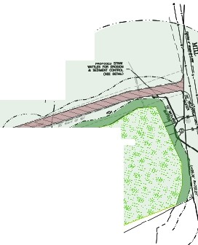·--..

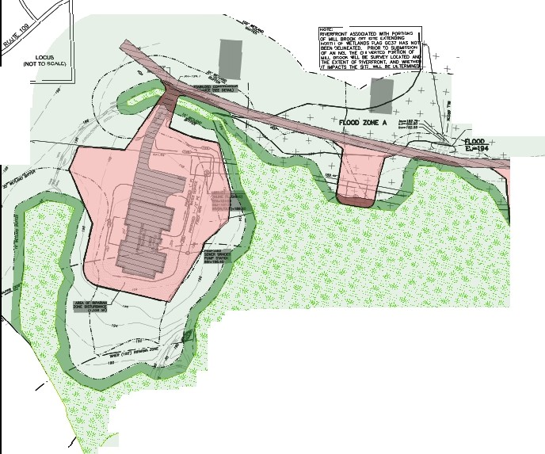

-�- *t-,,*

+--.,_ _,..;-.,,,,

+

..

**l.f-**

+ .. -·--•'•,;

+ + I

*I I*

·+. "-f j

....---�: *.f .. '*

**._;,,:_**--**�**· **;:-.�**,.**�°**,**:-.**•.• � • "· • .. - .!ll:, •• *YJ,-.v1•.* -:-�� - .,.. "' ,� **Legend**

**�. .w(;-..;�:��** t::�:;-'w :.·,.'"'*:•'rj::�.. .. -.-* **�->t�"--- ...��· �BVW**

,1l<--*t�* --�---*'!'_* ·.;-I',//1i<-�--,. *Impacts associated with repaving �

*:, 'I'••'tj_,,*, �-.-. ' ' �"" **1**

��·:-:*.�. ---_:·_,:* ***t::·:("'i,;:/·,.*** :,/ of the driveway will occur within the

**_,,,�:,/·f:, ,t\:;...•'._·:,(r,":.** /\ footprint of existing impervious surface

,., !,.·'c',::,��:(',,j,::.;;:�0- *f·>.::* (100'- 7,223sf. 0-10' -1.164sf)

**til:J}f;f;S'[;/�** �:��f�fe�!����!�·i:���; Zone

. ,.;;;�::��-"--, ./ #2 and #3 are temporary (845sf)

100' Buffer Zone

* 10' Buffer Zone
* 10' Buffer Zone Impact 2.379sf*

D 100' Buffer Zone Impact 35.438sf*

Impervious Surface