Cap Folard - Point Ronald

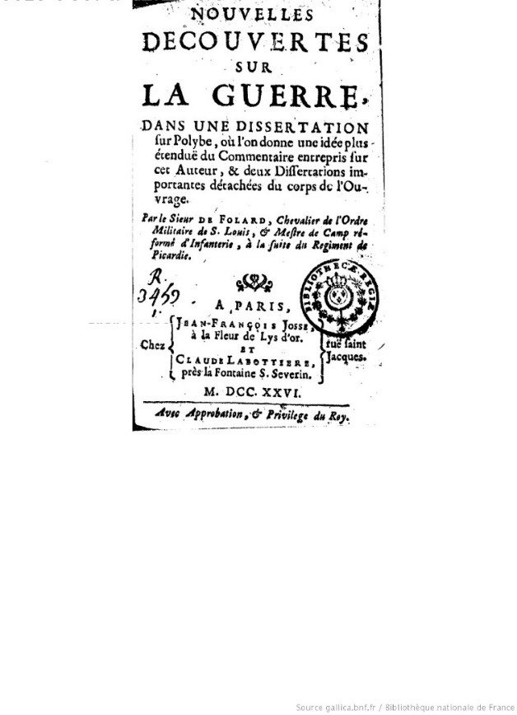
New discoveries on warfare: in a dissertation on Polybius ... By Sieur of Folard, 1726
Source : Bibliothèque nationale de France, département Littérature et art, R-24908
http://catalogue.bnf.fr/ark:/12148/cb36599420t

Jean-Charles de Folard, known as the Chevalier de Folard, (1669-1752), after whom the landmark was later named, was a war strategist and engineer who commented, annotated, and translated Polybius from Greek into French, and whose works included major references used to master the art of war. He advocated infantry attacks in columns rather than in lines, and his theory was widely discussed in military circles. Napoléon, read his books methodically, especially ‘Nouvelles découvertes sur la guerre’ (new innovations in relation to warfare) and ‘traité de la colonne’ (treatise on the subject of military column).

References:
References:
Baudin, N (1974) The journal of Post Captain Nicolas Baudin, Op.cit., p.373
Péron, F (2011) Voyage de découvertes aux Terres Australes, tome 1, Op cit., p..253

