Île Latreille- Broken Head

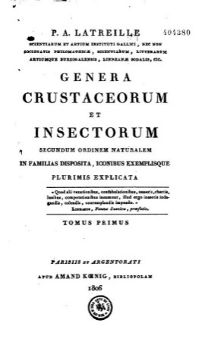
Title page of Genera crustaceorum et insectorum, secundum ordinem naturalem, in familias disposita... explicata by P.-A. Latreille vol1, 1806
Source: Biodiversity Heritage Library
https://www.biodiversitylibrary.org/item/132620#page/7/mode/1up

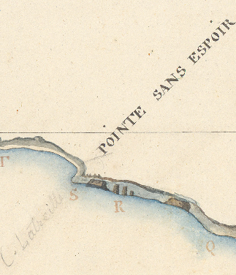
Pointe sans Espoir/Cap Latreille, with the islets Latreille, as sketched on the ‘Carte de la Côte Sud Ouest de la Nouvelle Hollande, dressée à bord de la Corvette le Géographe sheet 3, chart 57, 1802, Mar/6JJ/4/B piece 77, manuscript cartographic document
Source : Archives nationales de France
https://www.siv.archives-nationales.culture.gouv.fr/mm/media/download/FRAN_0147_0069_L-medium.jpg

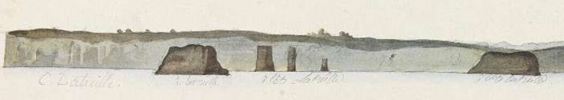
Close-up on the Coastal profile n. 13 sketched on 31 March 1802 at 3.45pm. depicting the Pointe sans Espoir/Cap Latreille and sculpted limestone islands, also seen on the map to the right ‘Carte de la Côte Sud Ouest de la Nouvelle Hollande, dressée à bord de la Corvette le Géographe feuille 3, chart 57, 1802, Mar/6JJ/4/B piece 77 and Mar/5JJ/51/1/ view 38
Source : Archives Nationales de France :
https://www.siv.archives-nationales.culture.gouv.fr/mm/media/download/FRAN_0044_02230_L-medium.jpg

Latreille worked at the Muséum d’Histoire Naturelle and assisted Lamarck in his public lectures on invertebrates.
Further information: Baudin called the cape Pointe Sans Espoir (Cape without hope), because ‘of the calm and a faint north and north-westerly breeze we were thus prevented from making any great advance and were even carried away from the coast’.
A cape in Western Australia also bears the name of Latreille.

References:
References:
Dupuis, C (1974) 'Pierre Andre Latreille (1762-1833): The Foremost Entomologist of his Time', Annual Review of Entomology, vol. 19, pp. 1-14.
Baudin, N (1974) The journal of Post Captain Nicolas Baudin, Op.cit, p.374.

