Cap du Mont-Tabor- Pickering Point

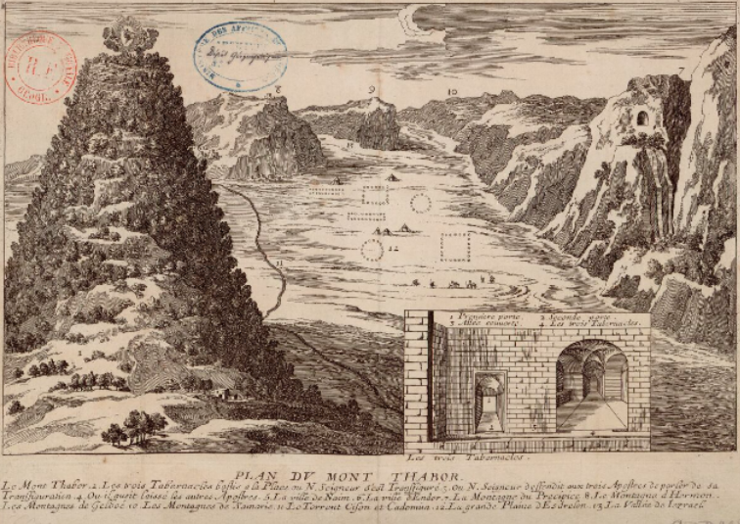
Plan du Mont-Thabor, engraving, [16 or 17]
Source : Bibliothèque nationale de France
https://gallica.bnf.fr/ark:/12148/btv1b85929186.r=Mont-Thabor?rk=85837;2
The site of the battle is also symbolic, since the mount as shown on this picture is also the place where, according to Christians, Christ was tempted by the devil.

The Battle of Mount Tabor holds significant symbolic value in Napoleonic history, as it is often regarded as the most distinguished military achievement of the Syrian campaign. The engagement effectively thwarted a major Ottoman attempt to strike the rear of Napoleon’s forces. Despite the overall failure of the Syrian campaign, this victory, achieved under the command of General Kléber, is commemorated on the Arc de Triomphe.
Freycinet mentions ‘an enormous rock’ between Île Latreille and Cap du Mont-Tabor ‘with the most singular form; it presents a natural bridge with two arches … A smaller protruding rock forms a kind of spur in front of the first, while the top of the main rock, which is slightly convex in the middle and flat throughout, is quite reminiscent of a marshal's anvil.’ It may refer to the Bay of Islands. However, the area is characterized by intense coastal erosion, where marine processes actively wear down the limestone cliffs and islands, leading to the frequent collapse and reformation of features.
Freycinet warns also that the coasts are mostly ‘inaccessible’, with reefs. Indeed, the Miocene limestone cliffs of the coastline have been weathered and eroded forming caves, arches and rock stacks resulting in numerous shipwrecks in past times.

References:
‘Carte de la côte Sud-Ouest de la Nouvelle Hollande dressée à bord de la corvette le Géographe’., feuille 3. (1802). Archives Nationales de France /MAP/6JJ/4/B/77. Paris : département des cartes et plans.
Péron, F, continued by Freycinet, L. (2016) Voyage of Discovery to the Southern Lands., vol1. Op. cit., p.252
Eccleston, GC (2010) 'The Neglect of Baudin’s Manuscript Charts of the Victorian Coastline', The Globe, vol. 66, pp. 27-58.
Freycinet, L (1812) Voyage de Découvertes aux Terres Australes Navigation et Géographie, Atlas, 1812. Op. cit., plate13, http://nla.gov.au/nla.obj-230975051)
Freycinet, L. (1815) Voyage de Découvertes aux Terres Australes Navigation et Géographie. Op cit., p.116

