Archipel de la Recherche
AusE name : Archipelago of La Recherche

Cap des Basses, Baie de l’Espérance, Cap Arride, La Chaussée, Île de Remarque, L’avant-garde, Île du Mondrain, Groupe de l'Ouest, Île du Milieu, Îles du Sud-Est, Groupe de l'Est, Baie de l'Espérance, Île de l'Observatoire, Cap Le Grand

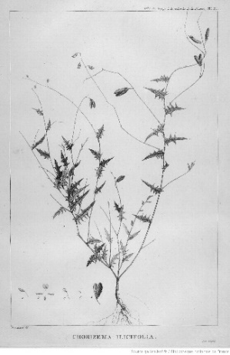
Fig.58: Chorizema Ilicifolia, in Atlas pour servir à la relation du voyage à la recherche de La Pérouse fait par ordre de l'Assemblée Constituante pendant les années 1791, 1792... By La Billardière, J.-J.H.d (author of the text), Dien, C. (drawer), Houdan, F.(engraver), Piron, J.-H (engraver)., Copia, J.-L., 1799, Plate 21
Source : Bibliothèque nationale de France
https://gallica.bnf.fr/ark:/12148/btv1b2300146x/f22.item.planchecontact

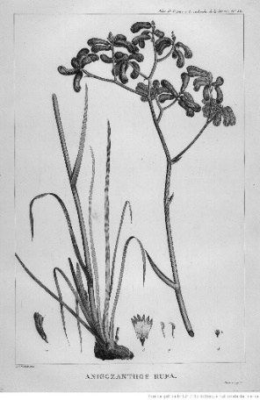
Fig.59: Anigozanthos Rufa:
In Atlas pour servir à la relation du voyage à la recherche de La Pérouse, Op.cit., Plate 23
https://gallica.bnf.fr/ark:/12148/btv1b2300146x/f22.item.planchecontact

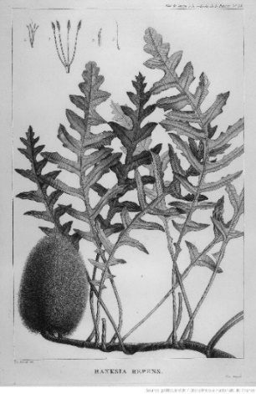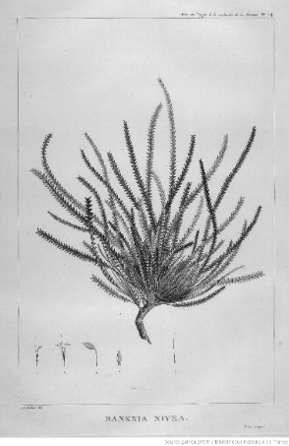
Fig.60: Banksia Repens(left) and Banksia Nivea (right):
In Atlas pour servir à la relation du voyage à la recherche de La Pérouse, Op.cit., Plates 24 and 25
Source : Bibliothèque nationale de France
https://gallica.bnf.fr/ark:/12148/btv1b2300146x/f24.item
https://gallica.bnf.fr/ark:/12148/btv1b2300146x/f25.item

The d’Entrecasteaux expedition surveyed the Archipelago of La Recherche between 9 and 17 December 1792, at a particularly difficult moment in their voyage. Despite it being summer, the crew faced relentless bad weather, heavy seas, and the constant threat of hidden reefs, which made progress slow and dangerous. To add to their hardship, the scarcity of fresh water placed the expedition under further strain.

The toponyms bestowed along this stretch of Western Australia reflect both the geographical challenges encountered and the traditions of maritime exploration. Many names describe the coast’s physical features, useful for navigation: Îles du Sud-Est, Cap Aride, Île du Milieu, Groupe de l’Est, Île du Mondrain (for its hummock), Groupe de l’Ouest, la Chaussée, Cap des Basses, and l’Avant-garde. Others carry a more personal resonance. Cap Le Grand and Île Remarque honoured a crew member who, in the midst of a violent storm, noticed / “remarked” a break in the surf—an observation that allowed l’Espérance, in desperate straits, to reach safe harbour. Île de l’Observatoire recalls the scientific work carried out there, while Archipel de la Recherche and Baie de l’Espérance commemorated the expedition’s two ships.

The expedition’s naturalist, Jacques Labillardière, made landfalls on Observatory Island between 13 and 15 December. On his first landing he was accompanied by the chaplain Ventenat, who gave the party a fright when he slipped into the sea—at a time when large sharks were in sight—but was rescued swiftly by the coxswain. During his explorations, Labillardière identified several new species of plants, remarkable for their resilience to the arid conditions of the archipelago’s coastline. Among them were Chorizema ilicifolium, Anigozanthos rufus, Banksia repens, and Banksia nivea. He also recorded observations of the local fauna, which included shooting Pacific gulls and a seal for study.

References
Bruni-Dentrecasteaux, J.A., edited by Rossel, É. (1808) Voyage de Dentrecasteaux, Tome1. Op cit., p.184.
Duyker, E., Duyker, M., Editors&Translators (2013) Bruny d'Entrecasteaux Voyage to Australia and the Pacific 1791-1793. Op. cit., p.113
Labillardière, J.-J. H. 1800. Relation du voyage à la recherche de La Pérouse, fait par ordre de 'Assemblée Constituante, pendant les années 1791 et 1792, et pendant la 1ère et la 2e année de la République Française, . H.J. Jansen, p.152-154. (See also the english translation, edited by J. Stockdale, 1800, pp.111, 133).

