**Template for creating quiz question**

This is template file for creating quizzes that can be imported into wordpress quiz providers such as WpProQuiz and LearnPress. The advantage of using WP Quiz Importer plugin along with this MSword template is that quiz creator can clearly visualise how a quiz question looks, insert equations in the question in latex format (recommend to utilize MathType add-on to MSWord for this purpose). In order to use this template, the user must enable macros. Questions must entered in a tabular format as described below. Once questions are prepared, click on BuildXML 🡪 CreateXML command so that an XML file will be created. Save this XML file at a known location to import quizzes using WP Quiz Importer plugin.

**Procedure to create question(s):**

1. Open the MS word file and enable macros
2. Click on BuildXML 🡪 InsertQuestion command button on the menu. The following table will be inserted.

|  |  |  |  |  |  |
| --- | --- | --- | --- | --- | --- |
| **Name**: Enter name of the question, which will be displayed as title of the question. | | **Type**: Enter question type here. All available question types are shown below this table. | | **Marks**: Enter overall marks allocated to the question. | |
| **Question**: Enter question content here. Questions can contain equations (in latex format) and html tags. Answers to this question can be provided below. Correct answer(s) must be surrounded by curly braces as shown below. | | | | | |
| {Correct Answer} | Wrong Answer 1 | | Wrong Answer 2 | | Wrong Answer 3 |

Available question types:

1. SC: Single choice question (user can select only one answer)
2. MC: Multiple choice question (user can select more than one answer)
3. TF: True or False answer

Note: (a) More question types are available in the pro version of the plugin. (b) Please make sure your quiz provider supports the answer type you are entering.

1. Enter data into the table in UTF-8 format (plain text) as explained in the example table above.
2. Please note that the text entered outside the table(s) will be ignored.
3. Once data entry (all questions are prepared) is complete, click BuildXML 🡪 CreateXML menu option. This will create an XML file, which can later be imported into wordpress using WP Quiz Provider.
4. Each question must be entered in a separate table and few sample questions are provided below.

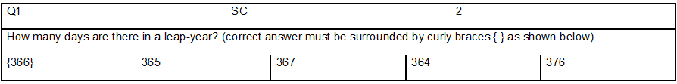

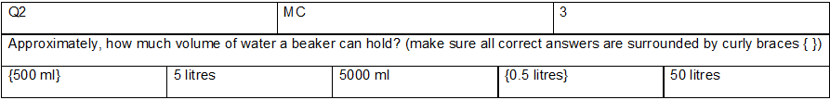

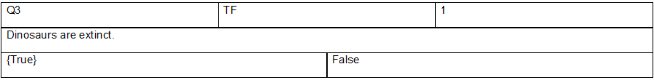

|  |  |  |  |  |  |  |
| --- | --- | --- | --- | --- | --- | --- |
| Q1 | | SC | | | 2 | |
| How many days are there in a leap-year? (correct answer must be surrounded by curly braces { } as shown below) | | | | | | |
| {366} | 365 | | 367 | 364 | | 376 |

|  |  |  |  |  |  |  |
| --- | --- | --- | --- | --- | --- | --- |
| Q2 | | MC | | | 3 | |
| Approximately, how much volume of water a beaker can hold? (make sure all correct answers are surrounded by curly braces { }) | | | | | | |
| {500 ml} | 5 litres | | 5000 ml | {0.5 litres} | | 50 litres |

|  |  |  |  |
| --- | --- | --- | --- |
| Q3 | TF | | 1 |
| Dinosaurs are extinct. | | | |
| {True} | | False | |