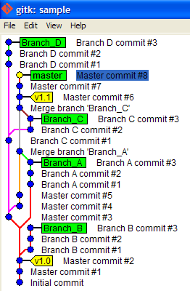
GIT need some Hyperlink!

TestFootnote

