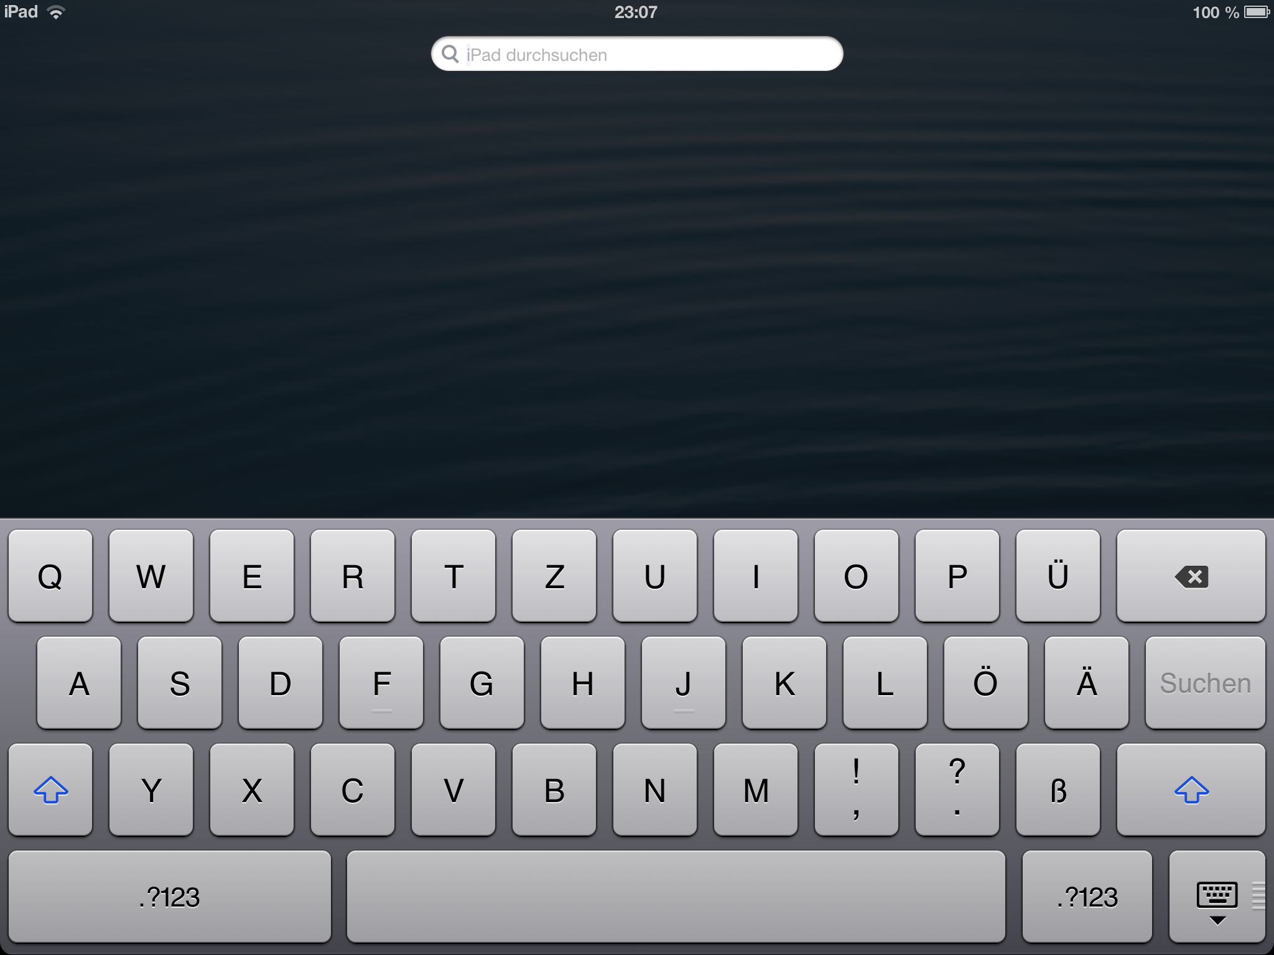
A text before footnote, .
A text before endnote.

A footnote?
An endnote?

