[alone on line]
mnop

[with leading space]
mnop

[with trailing space]
mnop

[with leading and trailing space]
mnop

[in a larger string]
abcdefghijklmnopqrstuvwxyz

[in a different style]
abcdefghijklmnopqrstuvwxyz

[after a different style]
abcdefghijklmnopqrstuvwxyz

[before a different style]
abcdefghijklmnopqrstuvwxyz

[partially in one style]
abcdefghijklmnopqrstuvwxyz

[partially in one style following]
abcdefghijklmnopqrstuvwxyz

[mixed styles]
abcdefghijklmnopqrstuvwxyz

[In a list]
- abcdefghijklmnopqrstuvwxyz

[In a table cell]

abcd | efg | hijk
lmnop | qrs | tuv
w | x | yz

[In a hyperlink link]

abcdefghijklmnopqrstuvwxyz

[In a footnote]

This is a footnote.

[In a caption]

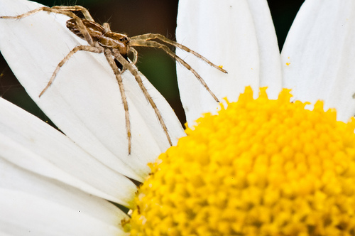
Figure 1 abcdefghijklmnopqrstuvwxyz

But this is not a hit, since it splits over two bullet items:

- abcdefghijklmn
- opqrstuvwxyz

And this is not a hit, since it is in two different paragraphs:

abcdefghijklmn

opqrstuvwxyz

- abcdefghijklmnopqrstuvwxyz

