SPX Express — Regional Speed Review
2026-01-01 to 2026-01-30 · 30 days · 185,266,641 parcels · 4 markets, 10 carriers
Where we stand
Buyer waiting time (avg_BWT) 3.33 days
Of which seller preparation (avg_APT) 0.758 days (22.8% of total)
Of which network transit 2.571 days
What the month shows
1. Speed degrades two days AFTER every campaign, not during it. Correlation of daily volume with buyer waiting time peaks at a 2-day lag (r = 0.886, 95% CI 0.776–0.953). Campaign dates are known weeks ahead, so this is schedulable rather than merely observable.
2. The delay is in the network, not with sellers. Preparation time is flat at 0.758 days across every carrier, region and date. Effectively all variation buyers feel occurs after the seller hands the parcel over.
3. Island crossings are a step change, not a gradient. Sea and air legs into Sabah, Sulawesi and Sumatra run roughly 3.5× same-region lanes. This is where the recoverable time sits.
4. The obvious carrier ranking is misleading. Comparing carriers only on lanes they both serve moves Pos Indonesia from 9th to 5th — it is being penalised for its geography. The same correction confirms SiCepat's gap is real.
5. Two carriers are failing in opposite ways. SiCepat is consistently slow and deteriorating. Ninja Van is average on speed but generates about half of all severe incidents. These need different interventions.
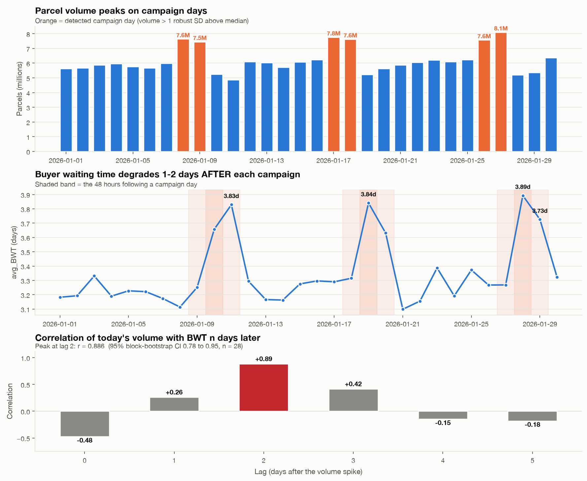
Volume peaks on campaign days; buyer waiting time peaks two days later.

What it is worth
Recoverable buyer waiting, per month 213M parcel-days
Counterfactual: every country × lane-class segment reaching the median segment's speed — not best-in-class, simply typical. The two island-crossing segments (Indonesia and Malaysia) account for roughly two thirds of the total.
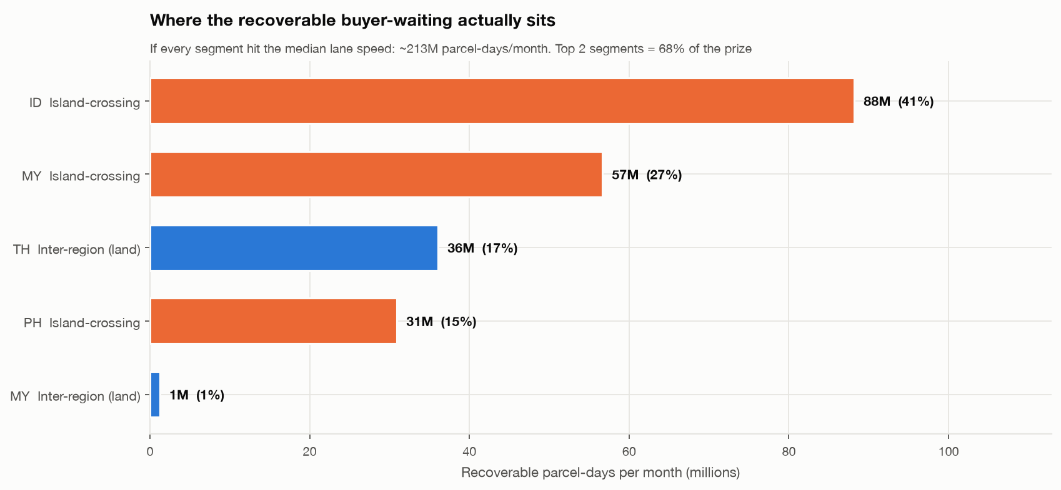
Recommended actions
Owner | Action | Horizon
Capacity & Network Planning | Staff hubs and linehaul for a +2 day lag after each campaign, not on the campaign day itself. | This month
3PL Partner Management | Open a performance review with SiCepat on the lane-matched gap. Close the Pos Indonesia issue — its raw figure reflects geography, not execution. | This quarter
Operations Excellence | Treat Ninja Van as a reliability problem, not a speed one: focus on incident response and hub handover rather than average transit. | This month
Data Engineering | Fix region mapping. Unmapped rows are the slowest lanes in the network and are currently invisible on every regional dashboard. | This quarter
Seller Operations | No action required. Preparation time is consistent everywhere; this is evidence, not an oversight. | —
How to read these numbers
- 61 rows were excluded from headline metrics: 29 carried zero parcels and 32 reported preparation time exceeding total waiting time, which is not physically possible and indicates a source-data fault.
- 303 rows (3.52% of parcels) have an unmapped region. These were retained, not dropped: they are slower than mapped rows in 18 of 18 carrier-country pairs, so excluding them would understate national waiting time.
- All lanes in this dataset are domestic — there is no cross-border traffic to report on.
- One month covers roughly three campaign cycles. The lag finding is strong but rests on three events; a full quarter would be needed before committing headcount to it.
Generated automatically from the analysis pipeline on 2026-08-27. Narrative sections drafted by the routed language model and machine-verified against the computed fact pack: every figure above traces to a value in the source data.

