Understanding Information-Seeking Behaviour of Singapore Secondary School Students through Google Search Queries: Specific-Broad and Surface-Deep Patterns

Tan Dan Feng
College of Computing and Data Science

Asst. Prof Farhan Ali
National Institute of Education

Abstract – With the nationwide rollout of Personal Learning Devices (PLD), web search has become central to Singapore secondary school students’ learning. Despite this, little is known about how students formulate information needs and how these needs evolve across search sessions. Hence, this study examines large-scale Google search query logs from PLDs to characterise student information-seeking behaviour along two dimensions: Specific-Broad (S-B), which captures query scope and granularity, and Surface-Deep (S-D), which captures cognitive depth and intent complexity.
Queries were extracted from Google URLs, with navigational queries removed and query streams segmented into episodes using a 5-minute inactivity threshold. This yielded 4,961 active users and 3.38 million queries across 47 schools after filtering from 40,586 users, enabling reliable behavioural analysis. For S-B, episode- and user-level measures spanning lexical and semantic diversity, named-entity diversity, WordNet hypernym specificity, Brysbaert concreteness ratings and topical breadth via a pretrained 99-topic model were engineered. For S-D, intent cues such as closure-seeking and comparative queries, episode engagement and within-episode reformulation using normalised Levenshtein distance were captured.
Our results show that most search episodes are single-topic, with a smaller proportion of multi-topic sessions. Clustering on S-B features reveals four distinct user profiles. For S-D, closure-seeking (6.4%) and comparative (3%) queries are rare, while query reformulation is common in longer episodes, suggesting that extended sessions reflect iterative refinement rather than repeated queries. These findings provide an interpretable and scalable framework for profiling students’ information-seeking behaviour, guiding educational interventions that support question formulation and self-directed learning.
Keywords – Information search behaviour, information retrieval, query log analysis, Google search, Singapore secondary school students

1 Introduction
As part of Singapore’s National Digital Literacy Programme, all secondary school students are provided with a Personal Learning Device (PLD) to support classroom activities and self-directed learning [1]. This has led to web search becoming an integral part of everyday learning, with Google serving as one of the primary sources of information for over 80% of students [2]. Since each search query issued on a PLD constitutes a timestamped digital trace of a student’s information-seeking behaviour, such search logs, when aggregated at scale, enable the analysis of learning and search processes in naturalistic educational settings [3]. Compared to surveys or controlled experiments, which rely on self-reported or artificial tasks, query logs capture behaviour in situ, supporting large-scale analysis of authentic user interactions [4].
Yet, despite the importance of web search in education, relatively little is known about how secondary school students formulate information needs and how these needs evolve throughout a search session. Existing studies have largely relied on surveys and interviews, while large-scale analyses of student search logs remain limited [5]. Furthermore, much of the existing literature focuses on a different demographic, such as undergraduate students in Western contexts, where search practices and learning environments may differ from those of Singaporean secondary school students [6]. As a result, key questions about how Singaporean adolescents seek, refine, and explore information in their learning environment remain largely unanswered.
To address this gap, we examine Google search queries generated from PLDs and characterise student information-seeking behaviour along two complementary dimensions grounded in prior work on search-as-learning and query log analysis [7]. The Specific-Broad (S-B) dimension captures the scope of an information need, ranging from narrowly focused queries targeting specific concepts to broader exploratory searches across topic areas [8]. The Surface-Deep (S-D) dimension captures the complexity of the search process, ranging from simple fact-seeking lookups to sustained sessions involving comparison, reformulation, and iterative refinement [8]. Together, these dimensions provide an interpretable framework for understanding not only what students search for, but also how they engage with information during the search process.
In this study, we analysed Google search logs collected from PLDs, retaining 3.38 million meaningful queries generated by 4,961 students across 47 schools. Using this data, we developed a scalable preprocessing and feature-engineering pipeline to operationalise the S-B and S-D dimensions using behavioural signals derived from query structure, semantic properties, and session dynamics. This enables systematic analysis of search behaviour at both the episode and user levels. We also constructed a comprehensive set of episode-level features, characterised distributional patterns of student search behaviour, and derived user-level profiles that reveal distinct behavioural archetypes. In doing so, we aim to respond to calls in the Educational Data Mining (EDM) community for empirically grounded, multi-feature frameworks that advance search-as-learning research and inform the design of adaptive learning systems [9]. Finally, this work establishes a pre-generative-AI baseline against which future post-GenAI search behaviour can be evaluated.
The contributions of this paper are as follows:
(1) a replicable preprocessing and feature-engineering pipeline for large-scale Google Search URI logs
(2) operationalisation of S-B and S-D dimensions for modelling student search behaviour
(3) introduction of behavioural measures capturing specificity, breadth, intent, and query reformulation at scale
(4) derivation of interpretable user-level profiles of information-seeking behaviour with implications for learning analytics and educational design

2 Related work
This section highlights prior work focused on analysing search behaviour and its relation to cognitive function.
2.1 SEARCH AS LEARNING AND QUERY BEHAVIOUR
An increasing number of studies view web search as an integral part of the learning process, whereby the act of formulating and refining queries reflects a learner’s evolving understanding of a topic [10]. Beyond serving as a tool for information retrieval, search also supports knowledge acquisition, sense-making and exploration, allowing individuals to build understanding through their interactions with these online resources [11]. This further reinforces the pivotal role of query logs in providing behavioural traces of how learners articulate their information needs, evaluate resources and adapt their search strategies over time.
A foundational distinction in the search literature is between lookup search and exploratory search [12]. Lookup searches are characterised by narrower querying and a desire to retrieve specific facts efficiently, whereas exploratory searches involve open-ended goals that evolve throughout the search process [13]. This distinction highlights two important aspects of information-seeking behaviour: the scope of an information need, which may range from narrowly focused to broadly exploratory, and the complexity of the search process, which may range from simple fact retrieval to sustained knowledge construction. These ideas motivate the two dimensions examined in this study: Specific-Broad (S-B), which captures the granularity and breadth of an information need, and Surface-Deep (S-D), which captures the depth of engagement involved in satisfying that need.
Research analysing large-scale search transaction logs has also revealed several consistent patterns. Firstly, queries are typically short with two to three terms [14]. Secondly, most search sessions typically comprise only a small number of queries [15]. Lastly, query reformulation is a common feature of the information search process. More specifically, reformulation has been associated with users refining their information needs, evaluating search results and iteratively constructing understanding [16]. While these are significant findings, they are derived predominantly from adults using general-purpose search engines. Whether similar behavioural patterns emerge among adolescents using school-managed devices, where access contexts and usage constraints may differ substantially, remains underexplored.
Furthermore, studies found that search behaviour differs substantially across age groups. While most queries of adults are navigational or transactional, those of children and adolescents are more informational in nature and shorter on average [17]. In addition, children and adolescents also rely more on simple keyword-based queries, employ fewer advanced search strategies and experience greater difficulty translating information needs into effective search terms [18].
Although recent studies in Singapore have examined how PLDs influence students' access to online information and learning practices, these investigations were often dependent on qualitative methods or self-reported survey data, limiting visibility into students' actual search behaviour [19]. Thus, there remains a limited understanding of how Singaporean secondary school students craft, refine, and pursue information in authentic settings.
Therefore, this study aims to address this gap by analysing a large-scale corpus of Google search queries generated from school-issued PLDs. By operationalising information-seeking behaviour along the Specific–Broad (S-B) and Surface-Deep (S-D) dimensions, we extend existing search-as-learning research with a computational framework capable of characterising authentic student search behaviour across millions of queries.
2.2 QUERY SPECIFICITY
In previous work, lexical specificity has been operationalised using a range of lexical, semantic and psycholinguistic indicators. Common lexical approaches include query length (measured by word or token count) and lexical diversity (Shannon entropy over unique terms), which reflect the amount and granularity of information being expressed in a query [20]. Recent advances in information retrieval have also enabled semantic embedding techniques to capture relationships between query terms in latent semantic space, enabling richer representations of query meaning beyond surface-level lexical features and improving retrieval effectiveness, especially in dense retrieval and neural ranking systems [21].
Entity-oriented representations can also provide another perspective on specificity. In particular, Named Entity Recognition (NER) has been widely used to distinguish between specific searches targeting particular named entities and general searches concerning broader conceptual categories by identifying the type of entities targeted by users in their queries, such as persons, organisations and locations [22]. Such entity-based query characterisation provides a more nuanced understanding of user intent and query scope than lexical features alone.
Moreover, conceptual specificity has also been modelled using WordNet taxonomies, whereby terms located deeper in the hypernym hierarchy correspond to more targeted concepts (eg. chihuahua → dog → animal) [23]. In addition, Brysbaert’s concreteness ratings have enabled references to tangible entities to be distinguished from abstract concepts, providing a complementary psycholinguistic measure of specificity [24].
Together, these studies suggest that query specificity is a multidimensional construct encompassing lexical, semantic, entity-based and psycholinguistic characteristics, motivating our use of a diverse set of engineered features to model the S-B query specificity more comprehensively than what would be possible using any proxy alone.
2.3 QUERY COGNITIVE DEPTH
Past research has analysed the cognitive depth displayed by users during their information search process by examining their use of words when forming queries. These include the presence of interrogative words (eg. WH-questions), comparative expressions (eg. “vs”, “pros and cons”) and closure-seeking terms (eg. “definition”, “meaning”). These words are often interpreted as intent signals and proxies for higher-order cognitive processing, whereby individuals may be evaluating alternatives, seeking definitional precision, or hypothesising, all of which are behaviours recognised in hierarchical models of cognition [25].
Apart from static query features, research has also explored query reformulation as a dynamic indicator of cognitive depth. More specifically, within-session reformulation, typically measured via string-edit distance or lexical overlap between consecutive queries, has been used to model iterative sense-making during information retrieval [9]. Furthermore, recent studies in conversational and neural search have further reinforced the pivotal role reformulation plays in clarifying user intent, resolving ambiguity and progressively refining information needs across multiple search iterations [26]. A high reformulation rate within a session may indicate that a user is actively constructing or exploring knowledge, whereas minimal changes across queries may reflect either task convergence or repetitive, low-reflection querying.
Therefore, these perspectives suggest that cognitive depth can not only be inferred from the linguistic structure of individual queries but also from temporal patterns of query evolution within a search session. This has inspired us to incorporate both intent-based linguistic features and reformulation-based behavioural features in modelling the S-D dimension.

3 METHODOLOGY
3.1 Data PREPROCESSING
The dataset consisted of students’ PLD browsing logs across 47 Singapore secondary schools during school terms. Data were provided as multiple timestamped CSV files for each school, corresponding to different collection periods. Thus, to facilitate large-scale analysis, all CSV files were consolidated into a single master log, while preserving crucial metadata such as school name, device identifier, browsing timestamps and visited URLs. The anonymised data analysis was approved by NTU Institutional Review Board.
3.1.1 Query Extraction and Normalisation
The raw logs contained full URLs rather than explicit search queries. Hence, following established practices in web-search log analysis, search queries were extracted by parsing Google Search URLs and retrieving the value associated with the q= parameter, which represents the query issued by the user [27]. A regex-based parser was also developed to recognise multiple Google URL formats observed in the dataset, such as URLs containing additional configuration parameters like language settings (eg. hl=en-SG) and SafeSearch options (eg. safe=active).
Only URLs containing a valid q= parameter were retained, while non-query URLs, such as system-generated redirects and configuration-only requests that did not represent user-initiated searches, were excluded from the dataset so that only user-initiated search actions were analysed.
Extracted queries were then normalised to lowercase for case-insensitive matching. In addition, as Google SafeSearch settings occasionally generated multiple URL variants for the same search, these duplicate query entries were removed to prevent redundancy while preserving the underlying search intent.
3.1.2 Identification of Navigational Queries
To focus on information-seeking behaviour, navigational searches were excluded from our dataset. This was done by first constructing a dictionary of navigational queries using an existing repository of frequently visited websites and online services (eg. platform logins, entertainment and gaming sites). The dictionary was further expanded with common navigational modifiers such as web, online, login, and channel, encapsulating the common words individuals append when they attempt to access known destinations directly [28].
Queries were subsequently classified using a two-layer filtering framework. The first layer applied fuzzy lexical matching to identify approximate matches between user queries and entries in the navigational dictionary, while the second layer performed substring matching against website and domain names to capture partial, abbreviated or implicit references. Queries satisfying either criterion were labelled as navigational and removed, while the remaining queries were retained for cognitive analysis.
Navigational queries were excluded to improve the quality of downstream cognitive analysis by removing behaviour that is predominantly goal-oriented and lacking exploratory or informational intent [29]. Such queries often have low semantic complexity and limited cognitive depth, and thus, omitting them allows for a more accurate representation of users’ informational needs and reasoning processes. Furthermore, this filtering step also improves the robustness of downstream metrics by lowering bias in measures such as lexical diversity and intent entropy [30]. This approach has been adapted from similar dictionary- and rule-based methodologies used in search-log studies to classify navigational and informational search intent [31].
3.1.3 Construction of Search Episodes
Following the filtering of navigational queries, the remaining queries were segmented into search episodes using a five-minute inactivity threshold [32], such that a new episode will be initiated whenever the time gap between two consecutive queries exceeds five minutes (300 seconds). This threshold is commonly used to separate distinct information tasks, with episode-based representation enabling the analysis of query reformulation, search progression [33], and other behavioural indicators associated with cognitive engagement [34].
3.1.4 Scaling of the Dataset
The full corpus consists of browsing histories from 40,586 users, obtained from the steps outlined in Sections 3.1.1 to 3.1.3. However, to support reliable estimation of episode-level features while maintaining computational feasibility for resource-intensive procedures like NER and semantic embedding, only users with at least 400 query episodes were retained. This threshold was chosen due to multiple considerations. Firstly, it excludes low-activity users whose query histories are insufficient for reliable semantic and behavioural modelling, while remaining above the 75th percentile of episode counts (254 episodes), thereby ensuring sufficient user activity. Secondly, it maintains a large and stable sample size for robust downstream analysis across multiple feature sets. Taken together, this threshold provides a balanced trade-off between data quality, representativeness and computational constraints, yielding a final dataset of 4,961 active users and 3,382,011 queries.
3.2 Specific-Broad Dimension
Nine episode-level features were engineered for the S-B dimension to capture lexical, semantic, entity-based, psycholinguistic and topical properties of user queries. These features show the degree of specificity versus breadth across multiple representational levels, as summarised in Table 1.
Table 1 Summary of S-B Features
Feature | Method | Interpretation
Query Length | Mean token count per episode | Surface complexity of information needs
Lexical Diversity | Shannon entropy over word types | Vocabulary variability within an episode
Semantic Diversity | Mean/ variance of pairwise Sentence-BERT distances | Conceptual spread across queries
Entity-Type Diversity | Shannon entropy over spaCy NER labels | Diversity of entity categories (eg. PERSON, ORG, GPE)
Topic Diversity | Entropy over topic distribution (99-topic LDA model) | Breadth of latent semantic topics
Topic Count | Number of unique topics per episode | Discrete topical coverage
Hypernym Specificity | WordNet hypernym depth (NLTK) | Degree of lexical specificity
Concreteness | Brysbaert et al. (2013) concreteness norms | Abstract vs concrete vocabulary use
Category Noun Signals | Lexicon and embedding-based detection of category-indicative nouns (eg. “type”, “kind”, “group”) | Degree of abstraction framing

Query length was computed as the mean token count across queries within an episode, reflecting the surface complexity of information needs. Lexical diversity was measured using Shannon entropy over word types, quantifying vocabulary breadth. Semantic diversity was computed using Sentence-BERT embeddings (all-MiniLM-L6-v2). To enhance efficiency, embeddings were generated once per unique query and cached before episode-level aggregation. Semantic dispersion was then quantified using the mean and variance of pairwise Euclidean distances between query embeddings.
Named entity structure was extracted using spaCy’s en_core_web_md model, which gave two entropy-based measures: diversity over entity types and diversity over unique entity strings, capturing both categorical and referential variability in entity usage within episodes. Topic structure was modelled using a pretrained 99-topic Latent Dirichlet Allocation (LDA) model, whereby each query was assigned a topic distribution, and episode-level topical breadth was measured using Shannon entropy over topic assignments. Topic count was additionally included to capture discrete coverage of distinct latent themes.
Lexical specificity was derived using WordNet hypernym depth via NLTK, with standard preprocessing steps being applied, such as multi-word merging, stopword removal, and lemmatisation. Queries above the 70th percentile of hypernym depth were classified as highly specific, and the proportion of such queries formed the episode-level specificity ratio. Lexical abstraction was also quantified using Brysbaert et al. (2013) concreteness norms, averaged across tokens within each episode to reflect the degree of abstract versus imageable language use.
Lastly, category noun signals were extracted using a lexicon and embeddings to identify abstraction markers (eg., “type”, “kind”, “group”), capturing explicit linguistic framing in queries.

3.3 Surface-deep dimension
Eleven features were engineered for the S-D dimension to capture intent signals, engagement dynamics and within-episode reformulation patterns. These features inform how users formulate queries at the surface level and how their search intent evolves dynamically over the course of an episode, as summarised in Table 2.
Table 2 Summary of S-D Features
Feature | Method | Interpretation
Open, Non-Possibility (O_NP) | Regex: WH-starter + NOT (can/may/ might/could/ would/will) | Explicit question-asking intent
Possibility Questions (O_P) | Regex: WH-starter + modal verbs (can/may/ might/could/ would/will) | Hypothetical or conditional inquiry
Closed Questions (C_NP) | Regex: must/should/ do/is/are/ does/did/ have/ has | Closed, factual-answer-seeking intent
Closure-Seeking | Lexicon + embedding expansion (eg. definition, meaning) | Intent to obtain a definitive, terminological answer
Comparative | Lexicon + embedding expansion (eg. vs, better than, pros, cons, compare) | Intent to compare and evaluate
Category Nouns | Lexicon + embedding expansion (eg. type, kind, group) | Taxonomic or categorical framing
Reformulation Strength | Mean normalised Levenshtein distance between consecutive queries | Degree of query rewriting
Reformulation Share | Proportion of consecutive query-pairs with non-zero Levenshtein distance | Prevalence of reformulation
Queries per Episode | Number of queries per session | Episode depth / search intensity
Time Interval | Mean time gap between consecutive queries (seconds) | Within-episode pacing
Total Episode Time | Sum of inter-query intervals | Overall session duration

Intent-related features were derived using a combination of rule-based pattern matching and lexicon expansion, while WH-question detection, possibility questions (WH-starters combined with modal verbs), and closed question forms (eg. must, should, do, is) were implemented using regular expression rules applied to the initial tokens of each query. For higher-level semantic intent categories, namely closure-seeking, comparative, and category-noun queries, a lexicon-embedding hybrid approach was used, which involves the expansion of initial seed lexicons (eg. definition, meaning, vs, pros, type, kind) using Sentence-BERT embeddings (all-MiniLM-L6-v2). Candidate terms were then identified as those with a cosine similarity above 0.58, and are subsequently manually validated, before merging them into a final classification lexicon used for query-level labelling.
Episode engagement was quantified using three measures: number of queries per episode, mean inter-query time interval, and total episode duration, capturing both intensity and temporal structure of user search sessions. Within-episode reformulation was measured using normalised Levenshtein edit distance between consecutive query pairs. The mean edit distance represents reformulation strength, whereas the proportion of non-zero distances captures reformulation prevalence within each episode.

4 Results

4.1 overview of dataset
There is substantial variation in how students engage with web search over time. Activity spans ranged from around 20 to over 150 active days, indicating large differences in search activity across users. Nonetheless, the distribution of activity spans remained approximately bell-shaped and centred around 60 to 80 active days, suggesting that most students engaged with search over a sustained period rather than short bursts (Figure 1).
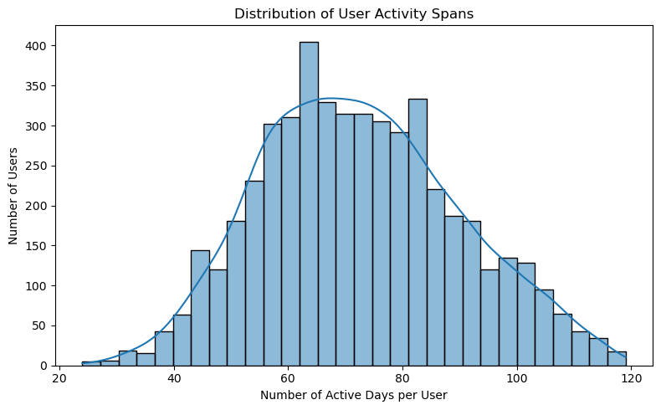
Figure 1 Distribution of Activity Spans
Daily search activity was similarly heterogeneous. Most users issued a median of 4 to 7 queries per day, whereas a smaller subset of highly active users generated more than 20 queries daily, producing a right-skewed distribution. Episode lengths were generally short, with a median of 2 to 4 queries per episode (Figure 2).
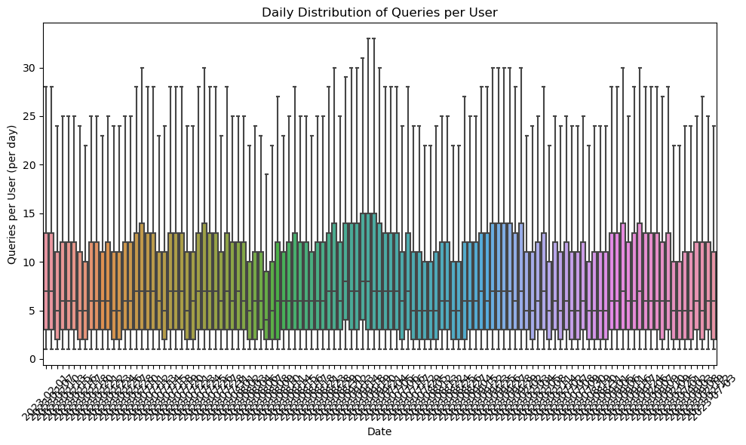
Figure 2 Daily Distribution of Queries per User
Therefore, these findings reveal a highly diverse population of searchers, ranging from occasional users to highly active individuals who use web search frequently over extended periods.

4.2 Specific-broad dimension
4.2.1 Query Length
Query length was highly consistent across users, peaking at 1 to 3 tokens across all activity bins and declining rapidly thereafter. Longer queries were uncommon, and the near-overlapping distributions across activity groups show that search volume does not influence query verbosity (Figure 3).
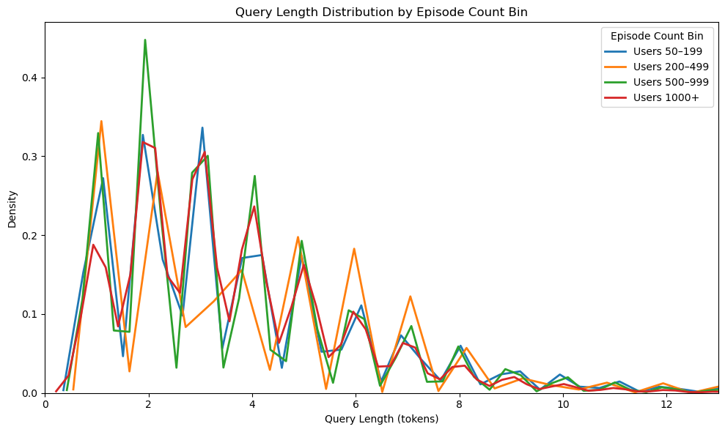
Figure 3 Distribution of Query Lengths Per Episode Bin
Users’ mean query lengths were centred around 3.5 to 4 tokens, showing that students typically rely on short, keyword-style queries rather than extended natural-language search statements (Figure 4).
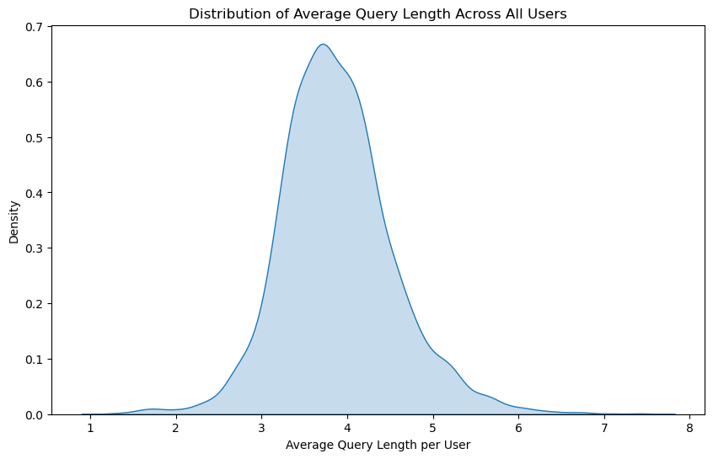
Figure 4 Distribution of Average Query Length
4.2.2 Lexical Diversity
Lexical diversity increases rapidly at low levels of user activity but more slowly as users accumulate additional queries, before eventually plateauing (Figure 5). This shows that users expand their vocabulary early in their search history, after which it saturates. Despite variation in activity levels, users converge toward a similar upper bound of lexical diversity, indicating a natural ceiling in vocabulary breadth within search behaviour.
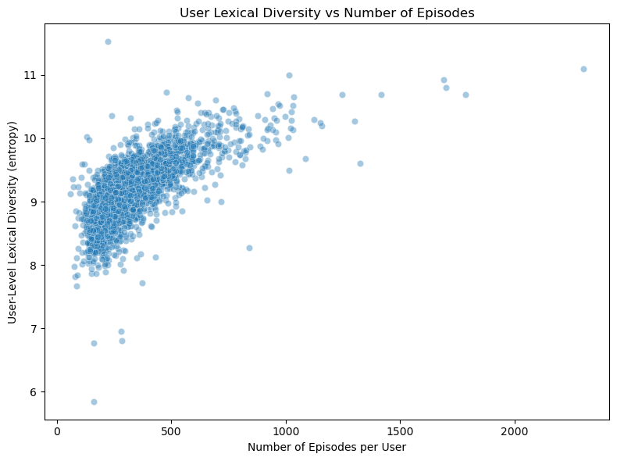
Figure 5 User Lexical Diversity vs Activity
4.2.3 Semantic and Entity Diversity
Mean user-level semantic diversity, measured using pairwise Euclidean distances between query embeddings, is concentrated around 1.18 to 1.24 (Figure 6). This means that most students explored a similar yet moderately broad range of topics. Semantic variance, however, is more dispersed, highlighting that users differed less in the breadth of topics covered than in how they navigated between them. Some users jumped widely across unfamiliar topics, while others transitioned consistently within familiar topic spaces. Semantic variance also tends to decrease for users with more search episodes, indicating that information-seeking behaviour becomes more stable over time.
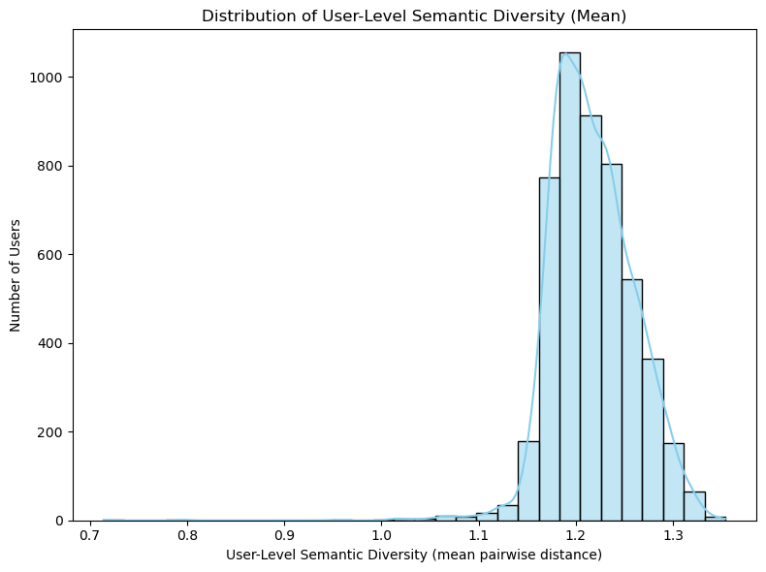

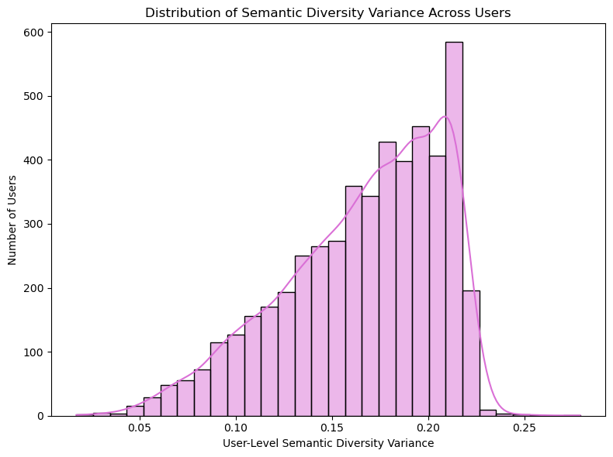
Figure 6 Distribution of Semantic Diversity
Entity-category diversity showed similar clustering around moderate entropy values of 2.4 to 2.8. However, episode-level entity diversity was often much lower than overall user-level diversity (Figure 7), suggesting that users typically focused on a narrow set of entity categories within individual search sessions. Together, these findings imply that search behaviour is characterised by broad interests across time but focused information needs within individual episodes.
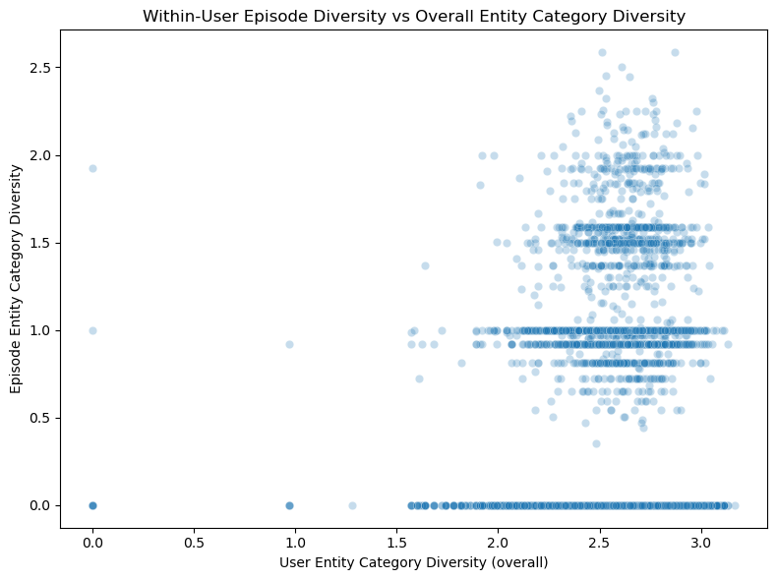
Figure 7 Within-Episode vs Overall Entity Diversity
4.2.4 Hypernym Specificity and Concreteness
Users exhibit moderate lexical specificity, with mean hypernym distances centred around 3.7 to 4.1 and about one-third of queries classified as specific. The high within-user variability (median standard deviation≈2.4) illustrates frequent switching between specific and broad queries. This is reflected in transition dynamics, where broad →broad transitions dominate at 76% but broad ↔ specific switches remain substantial at 80% (Figure 8), showing oscillation between exploratory and focused search modes rather than a linear refinement process.
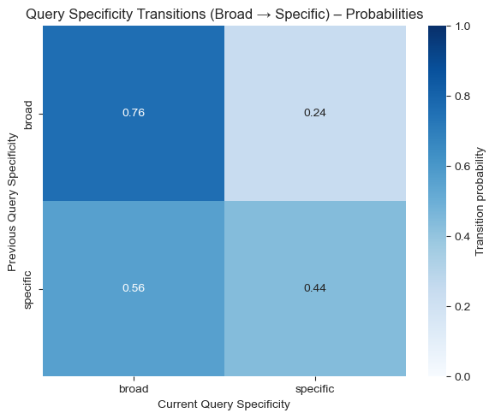

Figure 8 Query Specificity Transition
Brysbaert concreteness shows a similar balance, with 54% of queries classified as concrete and 46% as abstract. At the episode level, concreteness is moderately correlated with hypernym specificity (r ≈ 0.4), suggesting that lexically specific queries tend to involve more concrete concepts. Hence, while users operate within a moderate specificity range, their search behaviour is dynamic, alternating between broad and targeted information seeking.
4.2.5 Topic Breadth
The distribution of episode topic diversity is strongly bimodal, with most episodes clustered near zero entropy and a smaller tail extending to higher values of 1 to 2 (Figure 9). Episodes typically contain only one to two topics, implying that single-topic search sessions dominate, with occasional multi-topic explorations. Combined with the entity diversity results, this suggests that users generally pursue focused objectives within an episode, even though their interests may span multiple topics across longer time horizons.
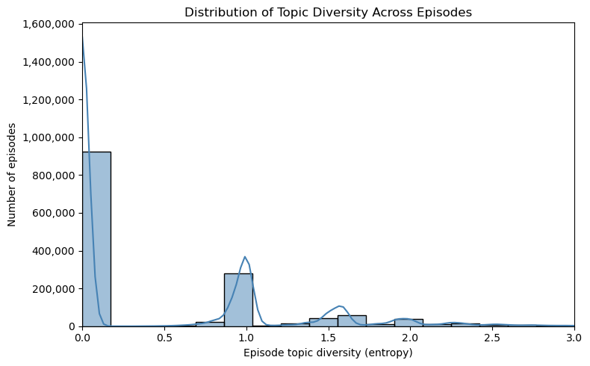
Figure 9 Distribution of Episode Topic Diversity
4.3 Surface-deep dimension
4.3.1 Closure and Comparative Queries
Closure-seeking queries (eg. “definition”, “meaning” or “synonym”) account for 6.4% of all queries, while comparative queries (eg. “better than”, “compare”) make up 3%. Evidently, both are rare but consistently present across users. Within comparative queries, the most frequent terms are “vs”, “best”, and “more”, implying that comparisons are typically framed as direct item-to-item contrasts rather than structured evaluations. Only 2 to 3% of comparative queries overlap with closure-seeking intent, suggesting that comparison and closure are largely independent behaviours.
Explicit forms are also uncommon. Open possibility questions (eg. “can”, “could” and “might”) form only 0.42% of queries, while closed non-possibility questions (eg. “is”, “are”, “does”, “did”, “should”) constitute about 3.8% of queries. This reinforces that most queries are keyword-style fragments instead of natural language questions.
4.3.2 Episode Engagement and Query Depth
Typical search episodes are short, with most users having median episode depths of 2 to 4 queries. Nonetheless, a small minority exhibited median depths of 5 or more queries, showing deeper and more persistent search engagement.
Episode duration is also found to be positively correlated to query count, but with wide variability (Figure 10): some short episodes contained many queries that can be associated with rapid scanning and frequent reformulation, whereas others are lengthy despite the few queries, likely reflecting extended reading between searches.
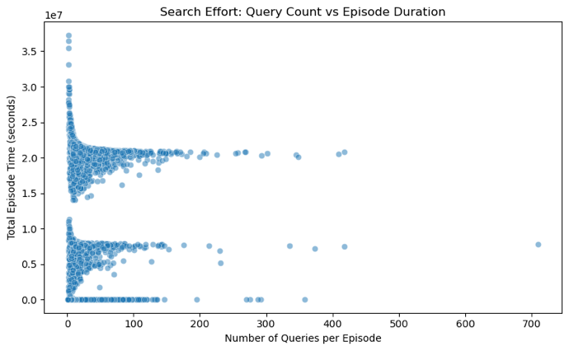
Figure 10 Duration vs Query Count
Question type also varies systematically over the course of an episode. Possibility-type questions tend to appear later in an episode instead of as the opening query (Figure 11), implying that users occasionally shift from broad keyword exploration to more hypothetical or evaluative framings as their search progresses. Closed questions showed a modest association with deeper episodes, as the need for a definitive answer emerges more often in longer, more focused search tasks.
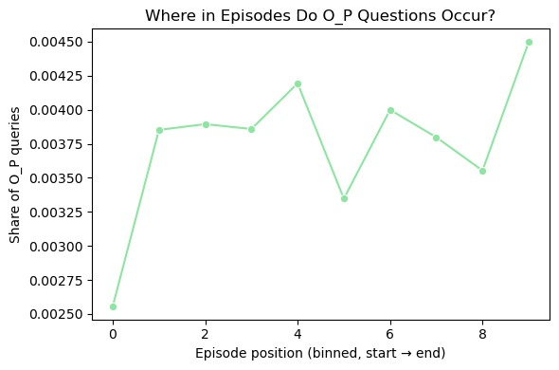
Figure 11 Possibility Questions by Position
4.3.3 Within-Episode Query Reformulation
Reformulation is a key signal of within-episode engagement. Consecutive query pairs within an episode display high normalised Levenshtein distances of 0.7 to 0.9, showing that most users rewrite their queries instead of making minor edits. Such reformulation shares also rose with episode depth, where shallow episodes of 1 to 3 queries show mixed behaviour ranging from small tweaks to near-complete rewriting, while deeper episodes converge toward distances of 0.9 to 1.0, with queries being almost fully reformulated (Figure 12).
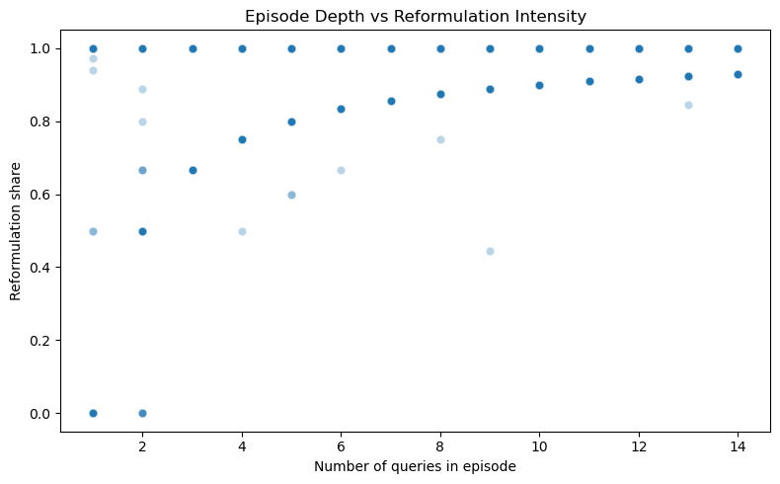
Figure 12 Episode Depth and Reformulation
This suggests that extended search sessions reflect iterative refinement of their information need, rather than repeated lookups. Notably, reformulation is largely independent of closure and comparative queries, making it a distinct and complementary dimension of search depth.

4.4 user profile
K-means clustering on user-level features such as mean hypernym distance, within-user variability, episode-level specificity ratio, and mean query length reveals four behavioural profiles (Figure 13). The first group shows consistently high specificity
with low variability, reflecting narrow, targeted searching due to stable information needs. The second group also has high mean specificity but greater variability, occasionally drifting to much broader or narrower queries. A third group searches at a moderately specific level with less variation and the last group has the lowest mean specificity, coupled with the highest variability, fluctuating most strongly between broad and specific framings.
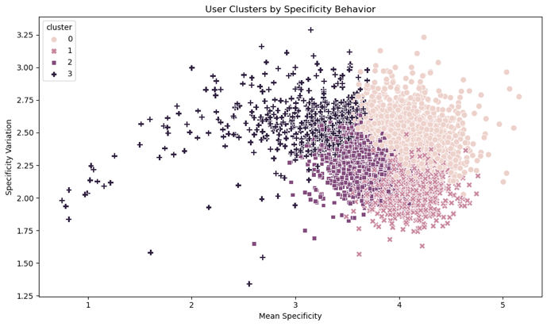
Figure 13 Clusters By Specificity Behaviour

5 DISCUSSION
5.1 BEHAVIOURAL PATTERNS AND EDUCATIONAL IMPLICATIONS
Overall, students’ information-seeking behaviour appears to be narrow, keyword-driven and largely task-oriented. Although students show broad interests across time, most of their search episodes are short and single-topic, indicating that students typically pursue specific information needs instead of engaging in open-ended exploration. These patterns align with previous findings on adolescent search behaviour, while extending them to the Singapore education context at scale.
The low prevalence of closure-seeking (6.4%) and comparative queries (3%) is also particularly noteworthy. Higher-order cognitive behaviours such as conceptual clarification, evaluation and comparison are not expressed spontaneously through search when structured scaffolding is absent. This means that schools that invest in PLD-supported learning may be obtaining much less higher-order engagement than assumed, rendering PLDs alone insufficient to promote deeper forms of inquiry. Hence, curriculum designers could consider explicit instructional routines that require students to compare alternatives, evaluate evidence and refine information needs during research tasks.
In contrast, query reformulation is pervasive and increases with session depth. Students resort to rewriting and refining their queries as sessions progress instead of repeatedly issuing similar ones. This highlights that extended sessions are opportunities for active knowledge construction and iterative sense-making rather than passive information retrieval. Thus, supporting these extended, reformulation-rich sessions, for example, by reducing platform interruptions during long search episodes or providing query prompts, may help maximise the learning value of web search.
5.2 IMPLICATIONS FOR LEARNING ANALYTICS
Among the behavioural signals examined, reformulation strength and episode depth emerge as more promising signals for learning analytics as they are continuous, widely observed and closely tied to search engagement. Therefore, these measures may be incorporated into dashboards to track students’ mean reformulation strength, average episode depth, and the distribution of S-B profile membership over time. Sudden drops in reformulation intensity or sharp decreases in episode depth could flag disengagement, reduced persistence, or difficulties in information search, warranting early teacher intervention.
The four user-level specificity profiles identified here may also serve as the basis for differentiated instructional support, both for individual students and for how teachers calibrate instruction more broadly. Schools or platforms can assign students to profiles using weekly query logs and adapt the level and intensity of guidance accordingly. For example, students displaying broader and less consistent search behaviour may benefit from explicit, step-by-step modelling of query narrowing, while those who already search narrowly and consistently may need less of that scaffolding and more prompting toward alternative angles to broaden their thinking. The same research task can thus be delivered with different instructional emphases, and class-level profile distributions may help teachers judge how much guided modelling is needed before transitioning students to independent inquiry.

5.3 limitations and future work
Several limitations should be noted. Firstly, although the 5-minute episode segmentation threshold is standard, it remains an approximation and thus, sensitivity analyses using varying thresholds are pivotal to future work for improved robustness in measuring search behaviour. Secondly, by restricting the analysis to users with at least 400 episodes, the study excludes a significant proportion of the school population, and it is therefore unclear whether the observed patterns generalise to less active students. Thirdly, demographic covariates (eg. gender, grade level, school PSLE band) were not incorporated in the current analysis, limiting the ability to assess subgroup differences or test for measurement invariance. Moreover, the data was collected before the widespread generative AI adoption in Singapore schools, establishing a pre-GenAI baseline. Hence, replication with post-2023 data will be essential to detect whether AI-mediated search has altered query formulation habits. Lastly, none of the S-B or S-D features have yet been validated against independently measured learning outcomes, which remains a key step for establishing their educational validity.

6 conclusion
This study analysed 3.38 million Google Search queries from 4,961 Singapore secondary school students to characterise information-seeking behaviour along two complementary dimensions, Specific-Broad (S-B) and Surface-Deep (S-D). Rather than treating search volume as a marker of sophistication, the findings suggest that students' search behaviour is better understood through how they search, instead of how much. Most students issue short, single-topic queries regardless of activity level, oscillate between broad and specific framings, and rarely use explicit definitional or comparative language even when, as reformulation patterns suggest, they appear to be iteratively refining their information need.
Together, these findings suggest that surface-level query features alone may underrepresent the cognitive work students engage in during search, whereas a small set of continuous, behaviourally grounded signals, such as reformulation and variability in specificity, provide a more faithful representation of engagement. This reframes search-log analysis in education not as a means of simply distinguishing “shallow” from “deep” searchers, but as a way of surfacing the nuanced and often invisible process of iterative refinement underlying even brief keyword-based queries. The feature-engineering pipeline developed in this study offers a replicable framework for making these processes observable and for grounding future educational analytics and interventions in empirically observed search behaviour.

Acknowledgement
Firstly, I would like to express my deepest appreciation to Asst. Prof Farhan Ali for his supervision and guidance. Next, I would like to extend my gratitude to Wang Jun Wei Serena for providing the trained classification models. Lastly, I would like to acknowledge the funding support from Nanyang Technological University – URECA Undergraduate Research Programme for this research project. The research was approved by the NTU Institutional Review Board.

References
[1] Ministry of Education, Singapore, “Personal Learning Device,” Nov. 02, 2020. https://www.moe.gov.sg/news/parliamentary-replies/20201102-personal-learning-device
[2] Published, By, University, S. Borås, and Vol, “Use of Web search engines and personalisation in information searching for educational purposes,” vol. 23, no. 2, 2018, Available: https://files.eric.ed.gov/fulltext/EJ1182241.pdf
[3] D. Gašević, S. Dawson, and G. Siemens, “Let’s not forget: Learning analytics are about learning,” TechTrends, vol. 59, no. 1, pp. 64–71, Dec. 2014, doi: https://doi.org/10.1007/s11528-014-0822-x.
[4] N. Craswell, B. Mitra, E. Yilmaz, D. Campos, and J. Lin, “MS MARCO: Benchmarking Ranking Models in the Large-Data Regime,” May 2021, doi: https://doi.org/10.48550/arXiv.2105.04021%20Focus%20to%20learn%20more.
[5] N. Kavitha and M. Chandrashekara, “Information Needs and Information Seeking Behaviour of Secondary School Students in Mysore North Block: A Study,” Asian Journal of Information Science and Technology, vol. 12, no. 1, pp. 18–25, Apr. 2022, doi: https://doi.org/10.51983/ajist-2022.12.1.3032.
[6] R. E. Nisbett and T. Masuda, “Culture and point of view,” Proceedings of the National Academy of Sciences, vol. 100, no. 19, pp. 11163–11170, Sep. 2003, doi: https://doi.org/10.1073/pnas.1934527100.
[7] P. Vakkari, “Searching as learning: A systematization based on literature,” Journal of Information Science, vol. 42, no. 1, pp. 7–18, Jan. 2016, doi: https://doi.org/10.1177/0165551515615833.
[8] J. Huang and E. Efthimiadis, “Analyzing and Evaluating Query Reformulation Strategies in Web Search Logs.” Accessed: Jun. 25, 2026. [Online]. Available: https://jeffhuang.com/papers/Reformulation_CIKM09.pdf
[9] N. Ferro, Bridging Between Information Retrieval and Databases. Springer: Springer, 2014, pp. 1–27.
[10] X. Dong, X. Zhang, Z. Li, Q. Hou, J. Xue, and X. Li, “A literature review of research on question generation in education,” PeerJ Computer Science, vol. 11, p. e3203, Sep. 2025, doi: https://doi.org/10.7717/peerj-cs.3203.
[11] G. Marchionini, “Search, sense making and learning: closing gaps,” Information and Learning Sciences, vol. 120, no. 1–2, pp. 74–86, Nov. 2018, doi: https://doi.org/10.1108/ILS-06-2018-0049.
[12] G. Marchionini, “Exploratory search,” Communications of the ACM, vol. 49, no. 4, p. 41, Apr. 2006, doi: https://doi.org/10.1145/1121949.1121979.
[13] M. K. Agarwal and T. Sahu, “Lookup or Exploratory: What is Your Search Intent?,” 2021. https://arxiv.org/pdf/2110.04640
[14] L. T. S. Rodrygo, C. Macdonald, and I. Ounis, “Search result diversification,” Foundations and Trends in Information Retrieval, vol. 9, no. 1, pp. 1–90, Mar. 2015, doi: https://doi.org/10.1561/1500000040.
[15] Y. Fang, N. Somasundaram, L. Si, J. Ko, and A. P. Mathur, “Analysis of An Expert Search Query Log,” Jul. 2011. https://dl.acm.org/doi/pdf/10.1145/2009916.2010113
[16] J. Guo, X. Zhu, Y. Lan, and X. Cheng, “Modeling users’ search sessions for high utility query recommendation,” Information Retrieval Journal, vol. 20, no. 1, pp. 4–24, Sep. 2016, doi: https://doi.org/10.1007/s10791-016-9287-1.
[17] T. Gossen, T. Low, and A. Nürnberger, “What are the real differences of children’s and adults’ web search,” Proceedings of the 34th international ACM SIGIR conference on Research and development in Information - SIGIR ’11, 2011, doi: https://doi.org/10.1145/2009916.2010076.
[18] D. Bilal and J. Kirby, “Differences and similarities in information seeking: children and adults as Web users,” Information Processing & Management, vol. 38, no. 5, pp. 649–670, Sep. 2002, doi: https://doi.org/10.1016/s0306-4573(01)00057-7.
[19] Nanyang Technological University, “MOE, schools looking to improve primary pupils’ digital literacy skills,” National Institute of Education (NIE), Oct. 2023. https://www.ntu.edu.sg/nie/news-events/news/detail/moe-schools-looking-to-improve-primary-pupils-digital-literacy-skills
[20] R. C. Carrasco, G. Candela, and M. Marco-Such, “Measuring the diversity of data and metadata in digital libraries,” International Journal on Digital Libraries, vol. 26, no. 1, Feb. 2025, doi: https://doi.org/10.1007/s00799-025-00411-1.
[21] M. Pan, Y. Liu, J. Chen, E. A. Huang, and J. X. Huang, “A multi-dimensional semantic pseudo-relevance feedback framework for information retrieval,” Scientific Reports, vol. 14, no. 1, pp. 31806–31806, Dec. 2024, doi: https://doi.org/10.1038/s41598-024-82871-0.
[22] H. Montani, “spaCy 2: Natural language understanding with Bloom embeddings, convolutional neural networks and incremental parsing,” Sentometrics Research, Jan. 01, 2017. https://sentometrics-research.com/publication/72/
[23] G. A. Miller, “WordNet: a lexical database for English,” Communications of the ACM, vol. 38, no. 11, pp. 39–41, Nov. 1995, doi: https://doi.org/10.1145/219717.219748.
[24] M. Brysbaert, A. B. Warriner, and V. Kuperman, “Concreteness ratings for 40 thousand generally known English word lemmas,” Behavior Research Methods, vol. 46, no. 3, pp. 904–911, Oct. 2013, doi: https://doi.org/10.3758/s13428-013-0403-5.
[25] N. E. Adams, “Bloom’s taxonomy of cognitive learning objectives,” Journal of the Medical Library Association : JMLA, vol. 103, no. 3, pp. 152–153, 2015, doi: https://doi.org/10.3163/1536-5050.103.3.010.
[26] Y. Jang, K. Lee, H. Bae, H. Lee, and K. Jung, “IterCQR: Iterative Conversational Query Reformulation with Retrieval Guidance,” Proceedings of the 2024 Conference of the North American Chapter of the Association for Computational Linguistics: Human Language Technologies (Volume 1: Long Papers), pp. 8121–8138, 2024, doi: https://doi.org/10.18653/v1/2024.naacl-long.449.
[27] B. J. Jansen, “The Methodology of Search Log Analysis,” Handbook of Research on Web Log Analysis, pp. 100–123, 2009, doi: https://doi.org/10.4018/978-1-59904-974-8.ch006.
[28] K. Järvelin and J. Kekäläinen, “Cumulated gain-based evaluation of IR techniques,” ACM Transactions on Information Systems, vol. 20, no. 4, pp. 422–446, Oct. 2002, doi: https://doi.org/10.1145/582415.582418.
[29] A. Broder, “A taxonomy of web search,” ACM SIGIR Forum, vol. 36, no. 2, p. 3, Sep. 2002, doi: https://doi.org/10.1145/792550.792552.
[30] R. W. White and S. M. Drucker, “Investigating behavioral variability in web search,” Proceedings of the 16th international conference on World Wide Web - WWW ’07, 2007, doi: https://doi.org/10.1145/1242572.1242576.
[31] B. J. Jansen, D. L. Booth, and A. Spink, “Determining the informational, navigational, and transactional intent of Web queries,” Information Processing & Management, vol. 44, no. 3, pp. 1251–1266, May 2008, doi: https://doi.org/10.1016/j.ipm.2007.07.015.
[32] C. Silverstein, H. Marais, M. Henzinger, and M. Moricz, “Analysis of a very large web search engine query log,” ACM SIGIR Forum, vol. 33, no. 1, pp. 6–12, Sep. 1999, doi: https://doi.org/10.1145/331403.331405.
[33] R. Jones and Kristina Lisa Klinkner, “Beyond the session timeout,” Information and Knowledge Management, Oct. 2008, doi: https://doi.org/10.1145/1458082.1458176.
[34] B. J. Jansen, D. Booth, and A. Spink, “Predicting query reformulation during web searching,” CHI ’09 Extended Abstracts on Human Factors in Computing Systems, pp. 3907–3912, Apr. 2009, doi: https://doi.org/10.1145/1520340.1520592.

