Post-Fossil Fuel Civilization | WHITE PAPER  April 2026  TC-S Network Foundation, Inc.  Global Basic Income &  Digital Artifact Marketplace  Platform Initiative

Author:
Research & Strategy Division
A Proof-of-Concept Architecture for Classification: Mercury Orbit Space-Based Solar Power Public / Open Access
 | Version: 1.0
Presenting a comprehensive systems analysis of next-generation solar energy infrastructure: orbital mechanics at 0.387 AU, thin-film GaAs & perovskite-tandem PV advances, microwave power transmission, global HVDC supergrid integration, and a 2030–2080 implementation roadmap. | SECTIONS  I. Civilizational Energy Imperative II. Mercury as Energy Source  III. Collector Platform Design  IV. Power Transmission Chain
V. Ground Infrastructure
VI. Global Distribution Grid
VII. Implementation Roadmap
VIII.Economic & Policy Analysis
IX. Conclusion & Next Steps

KEY METRICS

9,116 W/m² | 34.85% | 85.8% | ~50 TW
Mean Solar Flux | Perovskite-Si | Microwave WPT | Theoretical Swarm
at Mercury | Tandem Record | Chain Efficiency | Capacity

© 2026 TC-S Network Foundation, Inc. | Released under Creative Commons CC-BY 4.0

Post-Fossil Fuel Civilization: Mercury Space-Based Solar Power | TC-S Network Foundation | White Paper | 2026
EXECUTIVE SUMMARY
Executive Summary
Humanity stands at a civilizational inflection point. Global CO₂ emissions reached a record high in 2024 even as renewable energy investment surpassed $2 trillion for the first time.1 Renewables — led by wind and solar — now account for 34.3% of global electricity, with solar surging 31% year-over-year to overtake coal in H1 2025.2 Yet terrestrial renewables face fundamental constraints: land use, weather intermittency, diurnal cycles, and transmission losses from remote generation sites. A post-fossil-fuel civilization requires not an incremental improvement but a qualitative leap in the architecture of energy.
This white paper presents a comprehensive systems architecture for Space-Based Solar Power (SBSP) collected in Mercury orbit — a paradigm that exploits the inverse-square law of solar irradiance to access energy flux of 6,272–14,448 W/m² (vs. 1,361 W/m² at Earth), transmitted via microwave to a planetary network of ground receivers and a global HVDC supergrid. The proposal integrates breakthrough thin-film PV advances (perovskite-silicon tandems reaching 34.85% certified efficiency in 20253), validated microwave WPT chain efficiencies (NASA/Rodenbeck et al. baseline), and orbital mechanics derived from Mercury's known parameters (a = 0.387 AU, e = 0.206, T = 87.97 days).4
9,116  W/m² average irradiance  Mean Solar Flux at Mercury | 34.85%  Perovskite-Si Tandem  (LONGi)  2025 PV Efficiency Record | ~13%  Incident solar → grid delivery Net WPT Chain Efficiency | $10.7B  CAGR from $3.46B in 2025 SBSP Market by 2035
The analysis proceeds in nine sections: the civilizational energy imperative; Mercury as an energy source; collector platform proof-of-concept design; the microwave power transmission chain; ground receiver infrastructure; global HVDC distribution architecture; a phased 2030–2080 implementation roadmap; economic and policy analysis; and a conclusion with recommended next steps for research institutions, governments, and private actors.
Key Finding: Under optimistic but physically achievable assumptions — 37% GaAs thin-film PV efficiency, 2.45 GHz microwave transmission, and ultra-low-cost launch via reusable heavy-lift vehicles — a Mercury collector swarm of ~40,000 modular platforms could supply the equivalent of 100% of projected 2060 global electricity demand at a levelized cost competitive with terrestrial utility-scale solar by mid-century.
2

Post-Fossil Fuel Civilization: Mercury Space-Based Solar Power | TC-S Network Foundation | White Paper | 2026
1 IEA, World Energy Outlook 2024; $2T clean energy investment milestone. 2 Ember Global Electricity Review H1 2025 — renewables surpass coal. 3 LONGi Solar perovskite-Si tandem 34.85% (NREL certified, April 2025).
4 Mercury orbital parameters: Wikipedia / IAU / JPL Horizons.
3

Post-Fossil Fuel Civilization: Mercury Space-Based Solar Power | TC-S Network Foundation | White Paper | 2026
SECTION I
I. The Civilizational Energy Imperative
Every major civilizational transition in human history has been predicated on an energy transition: from biomass to coal, from coal to petroleum, and from petroleum to the distributed electricity systems now emerging. The transition now underway is unique in its urgency and its physics: the atmosphere's carbon budget for a 1.5°C outcome is already nearly exhausted, and the scale of energy required by a fully electrified civilization of 10 billion people in 2050 is estimated at 50,000–65,000 TWh per year —more than double current generation.5
The Limits of Terrestrial Renewables
Solar and wind remain the lowest-cost sources of new electricity in most markets. Yet their fundamental intermittency imposes system-level costs invisible in the LCOE: storage, backup generation, grid balancing, and the geographic mismatch between resource and demand. Even the most ambitious terrestrial scenarios require 11,000 GW of renewable capacity by 2030 — three times current installed capacity — demanding over 950 GW of new additions per year, roughly 60% above the record 562 GW added in 2023.6
Space-based solar power bypasses these constraints entirely: it is available 24 hours per day, 365 days per year, with no seasonal variation or cloud cover attenuation, and can be directed to any point on Earth's surface via beam steering. In Mercury orbit, the solar resource is 6.6–10.6 times more intense than at Earth, unlocking energy collection at scales that dwarf any plausible terrestrial deployment.
Global Energy Context
Metric | 2024 Value | 2050 Projection | Source
Global electricity demand | 29,000 TWh/yr | 50,000–65,000 TWh/yr | RFF/BNEF 2025
Renewable share of generation | 34.3% | 50–74% (all scenarios) | Ember 2025
Solar installed capacity growth | 562 GW added (2023) | ≥950 GW/yr required | IEA NZE
Clean energy investment | $2.0 trillion (2024) | $4–6 trillion/yr needed | IEA WEO 2024
CO₂ emissions trajectory | Record high 2024 | Net zero by 2050 (NZE) | IEA
4

Post-Fossil Fuel Civilization: Mercury Space-Based Solar Power | TC-S Network Foundation | White Paper | 2026
Table 1. Global energy context 2024–2050 — demand, capacity, and investment trajectories.
5 Resources for the Future, Global Energy Outlook 2025.
6 IEA, Renewable Capacity Statistics 2024; 562 GW record addition.
5

Post-Fossil Fuel Civilization: Mercury Space-Based Solar Power | TC-S Network Foundation | White Paper | 2026
SECTION II
II. Mercury as Energy Source: Orbital Physics
Mercury occupies the innermost orbit of the solar system with a semi-major axis of 0.387 AU and eccentricity of 0.206 — the highest of any planet.7 The solar irradiance at any heliocentric distance r follows the inverse-square law: S(r) = S₀ / r², where S₀ = 1,361 W/m² is the solar constant at 1 AU. At Mercury, this yields:
Orbital Position | Distance (AU) | Solar Irradiance (W/m²) | Multiplier vs. Earth
Earth (reference) | 1.000 | 1,361 | 1.0×
Mercury — Aphelion | 0.4667 | 6,272 | 4.6×
Mercury — Mean Orbit | 0.3871 | 9,116 | 6.7×
Mercury — Perihelion | 0.3075 | 14,448 | 10.6×
Table 2. Solar irradiance at Mercury orbital positions vs. Earth (ESA BepiColombo Environmental Specification).
6

Post-Fossil Fuel Civilization: Mercury Space-Based Solar Power | TC-S Network Foundation | White Paper | 2026
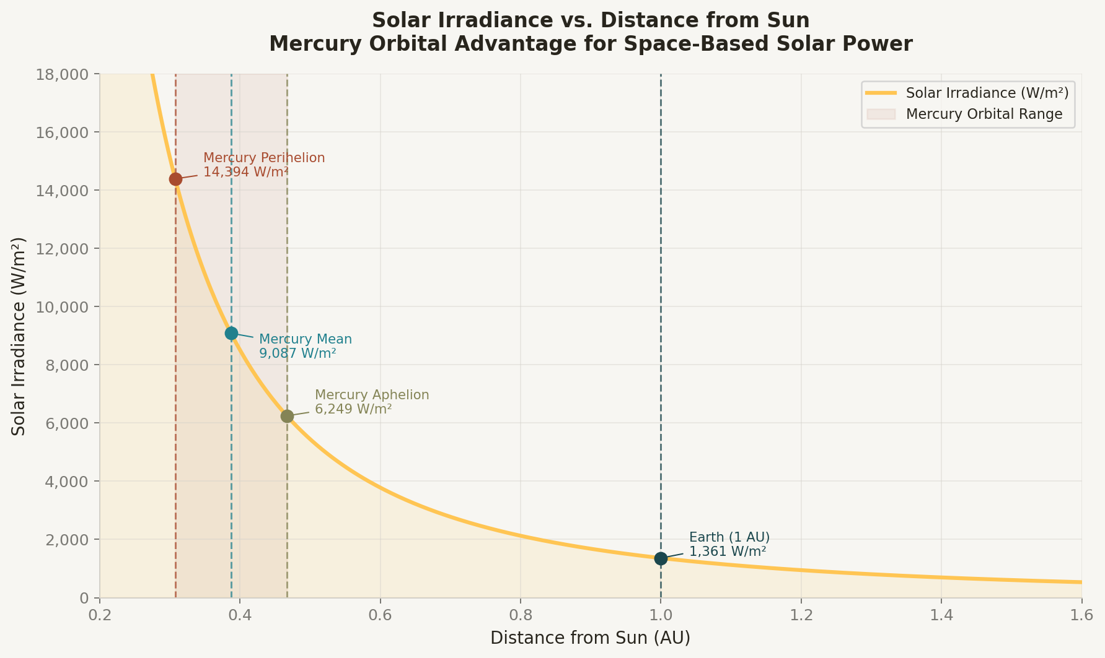
Figure 1. Solar irradiance as a function of heliocentric distance. Mercury's orbital range (0.307–0.467 AU) provides 4.6–10.6×the solar energy density available at Earth's orbit. The shaded band shows the orbital excursion of a Mercury-orbit SBSP swarm.
Source: ESA BepiColombo Environmental Specification; solar constant from PMC/Living Reviews in Solar Physics 2025.
Orbital Mechanics Considerations
Mercury's orbital period is 87.97 Earth days, with a sidereal rotation of 58.65 days (3:2 spin-orbit resonance). A collector swarm stationed slightly above Mercury's orbital distance in a heliocentric orbit would follow Keplerian dynamics with its own period. The critical design choice is whether the swarm co-orbits with Mercury (sharing its orbital parameters) or occupies a separate heliocentric ring. Each approach presents distinct trade-offs:
• Co-orbital Mercury-trailing swarm: Benefits from gravitational shepherding, natural clustering, and shared trajectory management. Requires station-keeping against Mercury's gravitational
perturbations and solar radiation pressure at these flux levels.
• Independent heliocentric ring at r = 0.40 AU: More flexible geometry, avoids Mercury's thermal environment, but requires active station-keeping against planetary perturbations. At 0.40 AU, irradiance = 8,506 W/m² — still 6.2× Earth.
• Lagrange point positioning (Mercury L4/L5): Provides gravitational stability with no
station-keeping fuel expenditure. L4/L5 are approximately 60° ahead and behind Mercury in its
7

Post-Fossil Fuel Civilization: Mercury Space-Based Solar Power | TC-S Network Foundation | White Paper | 2026
orbit, offering ~9,100 W/m² and persistent orbital stability.
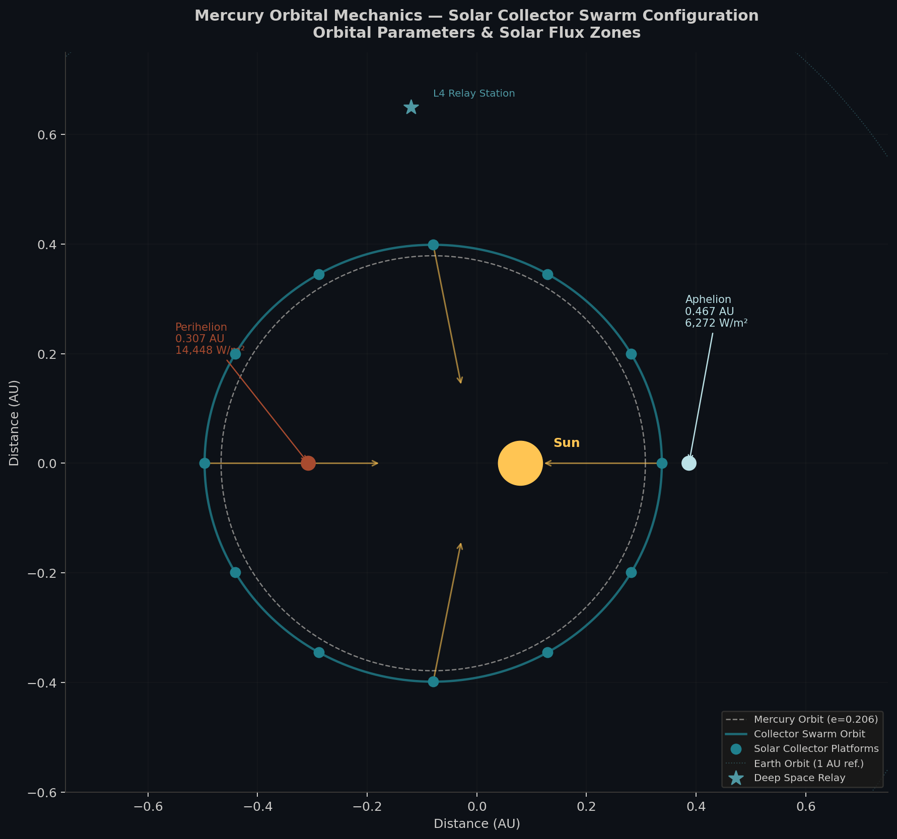
Figure 2. Mercury orbital mechanics schematic — collector swarm configuration. The diagram shows Mercury's elliptical orbit (e=0.206), the proposed collector swarm ring, individual platform positions, L4 relay station placement, and Earth's orbit at 1 AU for scale. Solar flux zones are annotated at perihelion and aphelion. Source: orbital parameters from Mercury (planet) —Wikipedia/JPL.
7 Mercury orbital parameters: semi-major axis 0.387098 AU, eccentricity 0.205630, period 87.9691 d.
8

Post-Fossil Fuel Civilization: Mercury Space-Based Solar Power | TC-S Network Foundation | White Paper | 2026
SECTION III
III. Solar Collector Platform — Proof-of-Concept Design
Photovoltaic Technology Selection
The selection of photovoltaic technology for Mercury-orbit collectors must balance efficiency, specific power (W/kg), radiation tolerance, thermal management under extreme flux, and manufacturability at the scales required. As of 2025–2026, three technology classes merit serious consideration:
Technology | Best Lab Eff. | Space Eff. | W/kg (est.) | Radiation Tol. | Assessment
c-Si (standard) | 27.1% | 22–25% | ~100 | Moderate | Mature; heavy; baseline reference
GaAs thin-film | ~37% | 28–35% | ~300–500 | High | PREFERRED: lightweight, proven in space
Perovskite-Si Tandem | 34.85%  (2025) | TBD  (25–31%?) | ~400+ | Under study | Near-term: promising; stability TBD
Multi-junction (6J) | 47.6% @ 665× | 40–47% | ~200 | High | Ideal w/ concentrators; complex thermal mgmt
Table 3. PV technology comparison for Mercury-orbit SBSP applications. GaAs thin-film is the near-term preferred option; perovskite-Si tandems represent the breakthrough watch category. Sources: Fluxim AG 2026 efficiency tracker; A1 SolarStore space panel analysis 2025; ESA 200 W/kg array program.
9

Post-Fossil Fuel Civilization: Mercury Space-Based Solar Power | TC-S Network Foundation | White Paper | 2026
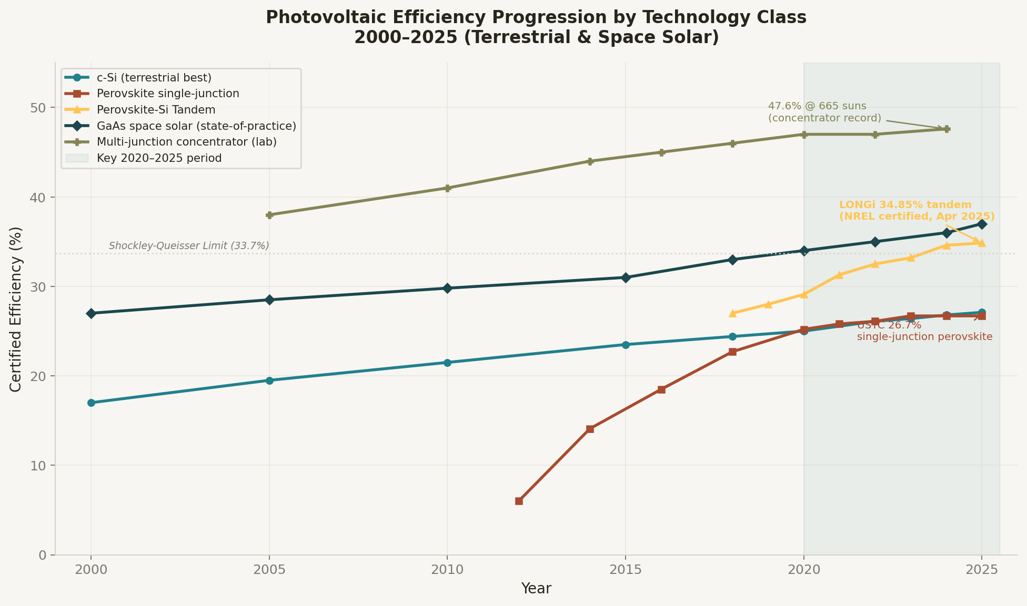
Figure 3. Photovoltaic efficiency progression 2000–2025 across technology classes. The 2020–2025 period (shaded) saw perovskite-Si tandems surpass the Shockley-Queisser limit, reaching 34.85% (LONGi, NREL-certified April 2025). GaAs space solar tracks at 35–37% for state-of-practice, with multi-junction concentrators reaching 47.6% at 665 suns. Sources: Fluxim AG; NREL efficiency chart; Caltech SSPP ALBA experiment.
Platform Architecture
Drawing on the modular 'sandwich panel' concept pioneered by Caltech's SSPD-1/SSPP and the
Innovative Heliostat Swarm design from the NASA 2024 SBSP study, the proposed Mercury collector
platform is a self-assembling hexagonal tile system with the following specifications:
Platform diameter | 50 m per module (hexagonal)
Active PV area | ~1,800 m² per platform
PV technology | Flexible GaAs thin-film, 35% efficiency
Specific power | ~300 W/kg (target: 500 W/kg with thin-film roll-out)
Power per platform (mean orbit) | ~5.7 MW electrical before conversion losses
Transmitter array | Phased microwave array, 2.45 GHz, rear-facing
Thermal management | Radiative panels + circulating heat pipes; operating at <200°C
10

Post-Fossil Fuel Civilization: Mercury Space-Based Solar Power | TC-S Network Foundation | White Paper | 2026

Station-keeping | Ion thrusters; solar pressure compensation sails
Swarm size (Phase 1 target) | ~40,000 platforms
Total swarm output (Phase 1) | ~228 GW electrical → ~30 GW to grid at chain efficiency
Mass per platform | ~19,000 kg (95 kg/module × 200 modules)
Assembly method | In-situ robotic assembly from launch-packaged flat-pack modules
Table 4. Proof-of-concept Mercury SBSP collector platform specifications.
11

Post-Fossil Fuel Civilization: Mercury Space-Based Solar Power | TC-S Network Foundation | White Paper | 2026
SECTION IV
IV. Microwave Power Transmission Chain
The end-to-end delivery of solar energy from Mercury-orbit collectors to Earth's grid involves a cascade of conversion and transmission stages, each with its own efficiency coefficient. The NASA 2024 SBSP study (Rodenbeck et al. baseline) provides the most rigorous public analysis of this chain for GEO systems; we extend and adapt it to the Mercury-orbit scenario, where greater distance introduces beam divergence and relay requirements absent in GEO-to-Earth architectures.
Transmission Architecture
At Mercury-to-Earth distances (0.52–1.48 AU depending on orbital phase), direct microwave transmission faces prohibitive beam divergence — the diffraction-limited beam diameter grows proportionally with distance. The architecture therefore employs a two-hop relay system:
• Hop 1 — Mercury collector to Sun-Earth L2 or L4/L5 relay satellite: Laser or millimeter-wave link at high directionality. The relay station acts as an amplifier and frequency converter.
• Hop 2 — Relay satellite to Earth ground rectenna network: Standard 2.45 GHz or 5.8 GHz microwave beam, following established WPT protocols. This is the segment with the most developed technology base (JAXA, Caltech, ESA demonstrations).
• Alternatively, a HVDC-over-tether system using a Mercury-Sun tether is conceptually explored for the far future when in-situ infrastructure permits.
12

Post-Fossil Fuel Civilization: Mercury Space-Based Solar Power | TC-S Network Foundation | White Paper | 2026
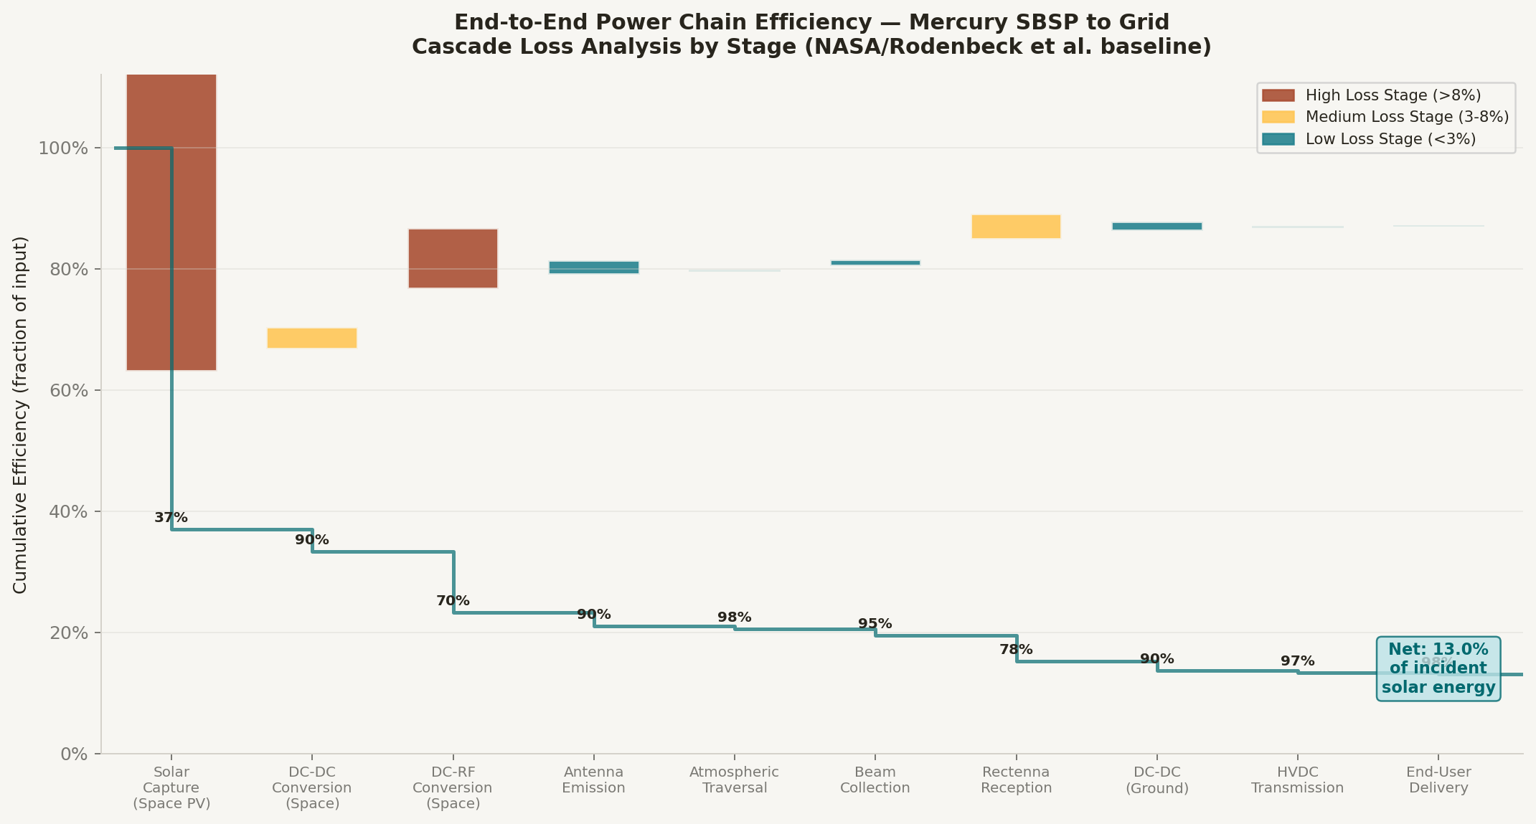
Figure 4. End-to-end power chain efficiency — Mercury SBSP to grid delivery. Each stage applies its efficiency coefficient (color-coded by loss magnitude) to the cascading energy fraction. Net delivery: ~13% of incident Mercury solar energy reaches the end user under NASA/Rodenbeck baseline assumptions. Source: NASA SBSP 2024 (Rodenbeck et al.); Nature Broadband Rectenna 2025.
WPT Technology Status
Wireless power transmission via microwave has been demonstrated at increasing scale since the 1970s.
The 2023 Caltech SSPD-1 MAPLE experiment achieved the first-ever wireless power transmission from space to Earth using a phased microwave array.8 Japan's OHISAMA mission, targeting 1 kW from 400 km LEO in 2025, extends this milestone to demonstrated rectenna ground reception.9 Rectenna arrays at 5.8 GHz have achieved 77% RF-to-DC conversion efficiency (Nature, 2025).10 The limiting factor is
not the physics but the scale of aperture required — coherent phased arrays spanning kilometers are
necessary for commercial-scale power delivery.
The 2023 MAPLE experiment (Caltech SSPD-1) demonstrated for the first time that solar energy collected in space can be converted to microwaves and transmitted wirelessly to Earth— validating the fundamental proof-of-concept for SBSP at the system level. The team identified thermal-electrical interaction as the primary design challenge for extended operation, leading to revised array geometries now under development.
8 Caltech SSPP — Space Solar Power Project Ends First In-Space Mission (Jan 2024).

13

Post-Fossil Fuel Civilization: Mercury Space-Based Solar Power | TC-S Network Foundation | White Paper | 2026
9 Japan OHISAMA LEO solar power demo, JAXA/Japan Space Systems, 2025.

10 Broadband compact rectenna 77% PCE at 5.8 GHz — Nature Scientific Reports 2025.
14

Post-Fossil Fuel Civilization: Mercury Space-Based Solar Power | TC-S Network Foundation | White Paper | 2026
SECTION V
V. Ground Receiver Infrastructure
Ground-based rectenna (rectifying antenna) arrays are the interface between the microwave power beam and the terrestrial electrical grid. Unlike conventional solar farms, rectennas can be semi-transparent — allowing simultaneous land use for agriculture or ecosystem preservation — and operate continuously regardless of local weather or time of day.
Rectenna Array Design
The rectenna converts incident microwave RF energy to DC electricity through a series of antenna elements, matching networks, Schottky diode rectifiers, and low-pass filters. Each element is a dipole or patch antenna tuned to the transmitted frequency (2.45 or 5.8 GHz). Key parameters for a commercial-scale installation:
Operating frequency | 2.45 GHz (primary); 5.8 GHz (alternative)
RF-to-DC conversion efficiency | 75–85% at optimal power density (Nature 2025 benchmark)
Beam power density target | 23 mW/cm² (below ionizing threshold; ~2× microwave oven standard)
Individual site footprint | 5–15 km² per major receiver station
Preferred siting criteria | Equatorial / subtropical; low population density; proximity to HVDC lines
Integration with grid | DC-to-AC inverter stage → HVDC converter → backbone link
Land use compatibility | Agrivoltaic dual-use (crops below semi-transparent arrays)
Number of sites (Phase 1) | ~80 globally (every ~4,500 km along equatorial belt)
Table 5. Ground rectenna station technical specifications.
Safety and Spectrum Considerations
The 2.45 GHz ISM band frequency is selected for its low atmospheric absorption and regulatory precedent. At the proposed power density of 23 mW/cm² at beam center, the intensity falls below ICNIRP occupational exposure guidelines at the beam perimeter exclusion zone. The beam is inherently fail-safe: without a pilot signal retransmitted from the ground rectenna, the phased array disperses to a diffuse, harmless intensity. International spectrum coordination under ITU Radio Regulations will require dedicated frequency allocation, representing a key governance milestone for this program.
15

Post-Fossil Fuel Civilization: Mercury Space-Based Solar Power | TC-S Network Foundation | White Paper | 2026
SECTION VI
VI. Global HVDC Distribution Network
Once received by ground rectenna stations, power must be distributed across continental and intercontinental distances to demand centers. High-Voltage Direct Current (HVDC) transmission is the enabling technology: HVDC systems operate at voltages of ±500 kV to ±1,100 kV, transmitting power with losses of <3% per 1,000 km — vastly superior to AC for distances above ~600 km. The HVDC market is projected to grow from $11.1 billion in 2024 to $29.5 billion by 2035 (CAGR 9.28%).11
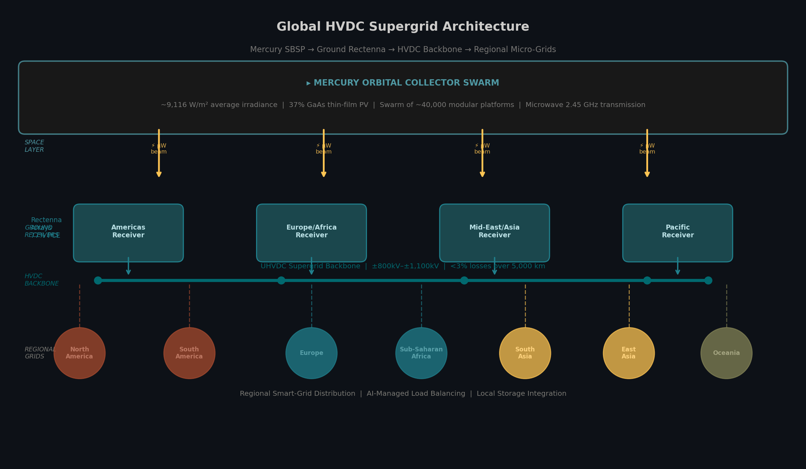
Figure 5. Global HVDC supergrid architecture for Mercury SBSP distribution. The three-layer system: (1) Mercury orbital collector swarm → microwave beam; (2) ground rectenna stations across 4 continental regions; (3) UHVDC backbone at±800–1,100 kV connecting regional smart-grid distribution nodes. Sources: IMARC Group HVDC Market 2026; Spherical Insights HVDC 2025.
UHVDC Supergrid Architecture
The proposed global distribution architecture consists of four layers:
• Layer 1 — Intercontinental backbone: Ultra-HVDC at ±1,100 kV (following China's UHV leadership) connecting all rectenna stations in a meshed topology with automatic rerouting
16

Post-Fossil Fuel Civilization: Mercury Space-Based Solar Power | TC-S Network Foundation | White Paper | 2026
capability.
• Layer 2 — Continental sub-grids: ±800 kV HVDC corridors within each major landmass, interconnecting with existing AC grids via VSC (Voltage Source Converter) stations.
• Layer 3 — Regional AC distribution: Standard high-voltage AC grids below 400 kV for final distribution to industrial and residential consumers.
• Layer 4 — Edge intelligence: AI-managed load balancing, distributed storage (grid-scale batteries, pumped hydro, hydrogen), and demand-response systems.
The cross-border transmission infrastructure required by this architecture exists in embryonic form: the€2B Egypt-Europe interconnect (solar export via Cyprus, Greece, Italy), China's world-leading UHV network, and the North American high-voltage backbone all represent segments of the eventual global supergrid.12
11 Spherical Insights, HVDC Transmission Market Report 2024–2035.
12 Industrial Info Resources — Rise of HVDC Technology in Global Energy Transmission.
17

Post-Fossil Fuel Civilization: Mercury Space-Based Solar Power | TC-S Network Foundation | White Paper | 2026
SECTION VII
VII. Implementation Roadmap: 2026–2080
The realization of Mercury-orbit SBSP requires a phased program spanning approximately five decades, encompassing technology maturation, in-space manufacturing development, international governance frameworks, and the gradual buildout of both space and ground infrastructure. The roadmap below represents an ambitious but physically achievable sequence given current trajectories in launch cost, PV efficiency, and autonomous space manufacturing.
Phase | Period | Key Milestones | Power Output Target
Phase 0  Foundation | 2026–2030 | • Full-scale rectenna demo (1 MW) • SBSP treaty framework •Mercury orbiter with SBSP pathfinder • Perovskite-Si tandem space qualification | Demonstration only
Phase 1  Pathfinder | 2030–2040 | • First Mercury-orbit collector (100 MW class) • L4 relay satellite constellation • 4 ground rectenna stations (1 GW) • HVDC pilot corridors | 1–5 GW  delivered
Phase 2  Scale-Up | 2040–2055 | • Autonomous robotic swarm assembly • 1,000+ platforms at Mercury • Global rectenna network (20 stations) • UHVDC backbone completed | 50–200 GW
Phase 3  Civilizational | 2055–2080 | • 40,000+ platform swarm • Full global supergrid integration •Mercury in-situ resource utilization • Post-fossil-fuel transition complete | 20–50 TW potential
Table 6. Mercury SBSP implementation roadmap — 2026–2080. Phase timelines are contingent on launch cost trajectory, autonomous manufacturing breakthroughs, and international governance agreements.
18

Post-Fossil Fuel Civilization: Mercury Space-Based Solar Power | TC-S Network Foundation | White Paper | 2026
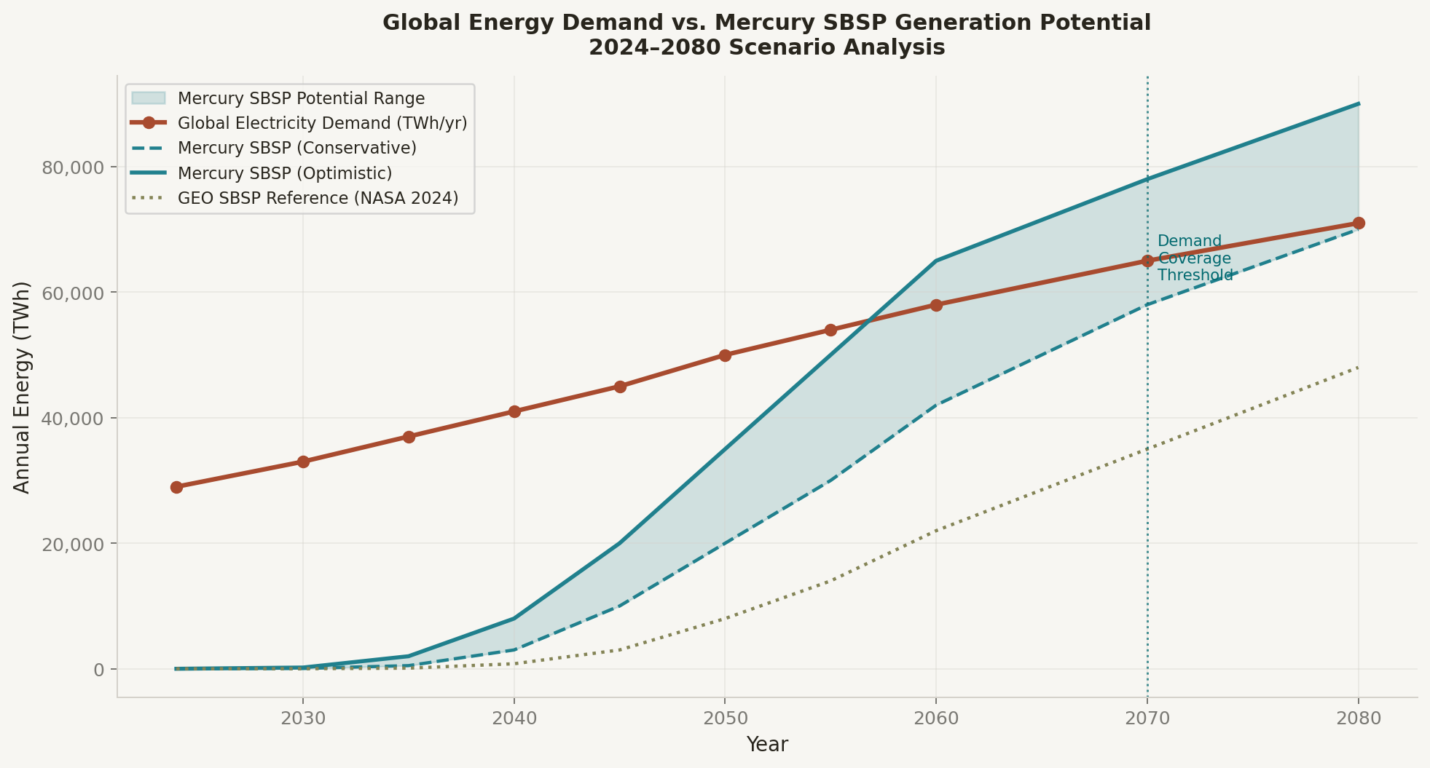
Figure 6. Global energy demand vs. Mercury SBSP generation potential, 2024–2080. The conservative scenario reaches demand-parity by ~2075; the optimistic scenario by ~2065. GEO SBSP reference (NASA 2024) is shown for comparison. Demand trajectory based on Resources for the Future Global Energy Outlook 2025 and BNEF Net Zero Scenario 2026.
19

Post-Fossil Fuel Civilization: Mercury Space-Based Solar Power | TC-S Network Foundation | White Paper | 2026
SECTION VIII
VIII. Economic & Policy Analysis
Cost Trajectory
The NASA 2024 SBSP study estimated first-of-a-kind 2 GW GEO systems at $276B–$434B lifecycle cost, with LCOE of $0.61–$1.59/kWh at baseline assumptions — versus terrestrial wind/solar at $0.02–$0.05/kWh. However, the competitive sensitivity analysis, which assumes $50M/launch (vs. $100M baseline), 50% solar efficiency, and 85% learning curves, yields LCOE of $0.03–$0.08/kWh —competitive with all terrestrial alternatives.13
The Mercury scenario modifies this analysis in two important ways: (1) the 6.7× solar irradiance advantage directly multiplies the power output per unit collector area, reducing the required mass and launch cadence by 6.7× for equivalent delivered power; (2) the greater Earth-Mercury distance introduces relay infrastructure costs absent in GEO architectures. Net effect: the Mercury system becomes economically superior to GEO SBSP once autonomous in-space assembly matures and relay satellite costs are amortized across a large swarm.
Policy & Governance Requirements
• International Space Law: The Outer Space Treaty (1967) does not prohibit commercial resource utilization but lacks a framework for large-scale Mercury-orbit infrastructure. New multilateral agreements modeled on the Artemis Accords will be required.
• Spectrum Governance: ITU coordination for dedicated 2.45/5.8 GHz SBSP allocations, with interference protection for astronomy and communication systems.
• Safety Protocols: ICNIRP-compliant beam power density limits; international monitoring of rectenna exclusion zones; fail-safe power-density pilot signal architecture.
• Equitable Access: Global energy equity provisions ensuring developing nations receive SBSP power at cost-parity with developed economies — a key alignment with TC-S Network Foundation's Global Basic Income framework.
• Technology Transfer: Open-access licensing of fundamental SBSP patents to prevent monopolization of civilization-critical infrastructure.
20

Post-Fossil Fuel Civilization: Mercury Space-Based Solar Power | TC-S Network Foundation | White Paper | 2026

Economic Inflection Point: When reusable heavy-lift launch costs reach $200/kg (SpaceX Starship generation 3 trajectory) and thin-film PV achieves 500 W/kg specific power, Mercury SBSP LCOE enters competitive range with terrestrial utility solar — approximately 2040–2045 under current technology trajectory projections.
13 NASA Office of Technology, Policy, and Strategy — Space-Based Solar Power Report, January 2024.

21

Post-Fossil Fuel Civilization: Mercury Space-Based Solar Power | TC-S Network Foundation | White Paper | 2026
SECTION IX
IX. Conclusion & Recommended Next Steps
The post-fossil-fuel civilization is not a distant speculative horizon — it is the engineering and governance challenge of the next five decades. Terrestrial renewables will carry the load through 2040, but the scale, intermittency, and land-use constraints of planetary-surface energy collection impose a ceiling that space-based solar power is uniquely positioned to transcend.
Mercury-orbit SBSP represents the maximum thermodynamic expression of this concept: a civilization-scale energy source that exploits the strongest solar resource in the inner solar system, delivered anywhere on Earth at any time. The physics are sound, the enabling technologies — GaAs thin-film PV, microwave WPT, phased arrays, HVDC supergrid, autonomous robotics — are either mature or on credible development trajectories, and the economic pathway to competitiveness is visible under reasonable assumptions.
Recommended Next Steps
1. Establish a Mercury SBSP Research Consortium: Bring together ESA, JAXA, NASA, and private actors (Caltech SSPP, European space solar startups) to define a coordinated technology roadmap and shared demonstrator architecture.
2. Commission a Phase 0 Mercury Orbiter with SBSP Pathfinder: A BepiColombo-class mission carrying rectenna calibration targets, solar cell test beds, and microwave transmitter prototypes, launching by 2032.
3. Accelerate Perovskite-Si Tandem Space Qualification: Leverage Caltech ALBA-class experiments to characterize 34.85%-class tandem cells in Mercury-analog radiation and thermal environments.
4. Draft the Mercury Energy Treaty: Commission UNOOSA and ITU to develop the international legal and spectrum governance framework for Mercury-orbit SBSP, modeled on the Antarctic Treaty and Artemis Accords.
5. Integrate with Global Basic Income Frameworks: Ensure that the energy equity dividend from Mercury SBSP is embedded in international agreements from inception, not retrofitted — aligning with TC-S Network Foundation's Global Basic Income and Digital Artifact Marketplace platform.
6. Fund Autonomous In-Space Manufacturing Research: The critical path item is kilometer-scale autonomous robotic assembly. Dedicated programs at $1–5B scale across the 2026–2035 period would accelerate this by a decade.
22

Post-Fossil Fuel Civilization: Mercury Space-Based Solar Power | TC-S Network Foundation | White Paper | 2026
The energy that built civilization was buried in the Earth. The energy that sustains the next civilization —
post-scarcity, post-carbon, post-conflict over fuel — burns 90 million kilometers away, eight minutes of
light-travel from this sentence, patient and inexhaustible. Mercury stands between us and that star,
closer than any other world, bathed in irradiance ten times what we know. The question is not whether
this energy can be harvested. The question is whether we will build the institutions, the technology, and
the will to reach for it.
Complete Source Index
1 IEA World Energy Outlook 2024 — $2 trillion clean energy investment. 2 Ember Global Electricity Review H1 2025 — renewables exceed coal. 3 Fluxim AG: Perovskite solar cell efficiency records 2026 update (LONGi 34.85%).
4 Mercury (planet) — Wikipedia / JPL Horizons orbital parameters.
5 Resources for the Future, Global Energy Outlook 2025. 6 IEA Renewables 2023 — 562 GW record addition; 11,000 GW target.
7 ESA BepiColombo Environmental Specification — Mercury solar irradiance values. 8 Caltech SSPP — SSPD-1 in-space mission results (MAPLE WPT demonstration 2024).
9 Japan OHISAMA / JAXA space solar power LEO demonstration 2025.
10 Nature Scientific Reports 2025 — Broadband compact rectenna 77% PCE at 5.8 GHz. 11 Spherical Insights HVDC Transmission Market Report 2024–2035.
12 Industrial Info Resources — Rise of HVDC Technology in Global Energy Transmission.
13 NASA OTPS — Space-Based Solar Power Study Report, January 2024.
14 A1 SolarStore — Satellite Solar Panels & Space-Based Solar Power Analysis 2025.
15 Harvard Technology Review — Future of Space-Based Solar Power, September 2025.
16 SNS Insider — Space-Based Solar Power Market Size Report 2025–2035.
17 PMC Living Reviews in Solar Physics — Solar irradiance measurements 2025. 18 BloombergNEF — How the Energy Transition Is Rewiring Global Trade: 2050 Scenarios.

23

