**使用断言，需要导入unittest模块：**

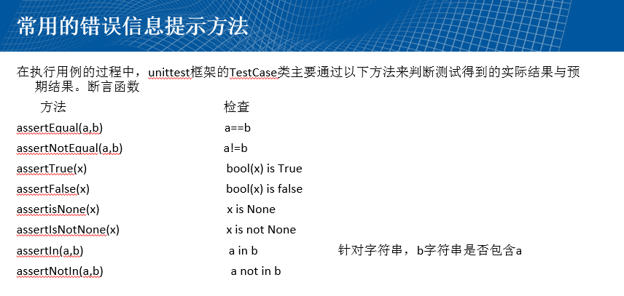

**import** unittest  
**class** Test(unittest.TestCase):  
 **def** setUp(self):  
 self.num=int(input(**"Enter a number:\n"**))  
 **def** testccc(self)://必须以test开头，不然执行不出来  
 self.assertEqual(self.num,13,msg=**'你的输入有误'**)  
**if** __name__==**"__main__"**:  
 unittest.main()

a12_3.py

**from** selenium **import** webdriver  
**import** unittest  
**import** time  
  
**class** MyTe(unittest.TestCase):  
 **def** setUp(self):  
 self.driver=webdriver.Firefox()  
 time.sleep(1)  
 self.base_url=**"http://www.baidu.com"  
 def** testbaidu(self):  
 dri=self.driver  
 dri.get(self.base_url)  
 dri.find_element_by_id(**"kw"**).clear()  
 dri.find_element_by_id(**"kw"**).send_keys(**"unittest"**)  
 dri.find_element_by_id(**"su"**).click()  
 time.sleep(1)  
 ti=dri.title  
 self.assertEqual(ti,**"unittest_百度搜索"**)  
 **def** tearDown(self):  
 self.driver.close()  
**if** __name__==**"__main__"**:  
 unittest.main()

a12_3_1.py

**from** selenium **import** webdriver  
**import** time  
**import** unittest  
**class** MyT(unittest.TestCase):  
 **def** setUp(self):  
 self.driver=webdriver.Firefox()  
 self.base_url=**"http://www.so.com"  
 def** testA(self):  
 d=self.driver  
 d.get(self.base_url)  
 time.sleep(1)  
 d.find_element_by_id(**"input"**).clear()  
 d.find_element_by_id(**"input"**).send_keys(**"webdriver"**)  
 d.find_element_by_id(**"search-button"**).click()  
 time.sleep(1)  
 t=d.title  
 self.assertEqual(t,**"webdriver_360搜索"**,msg=**'错误'**)  
 **def** tearDown(self):  
 self.driver.close()  
**if** __name__==**"__main__"**:  
 unittest.main()

12-33.py

**import** time  
**import** a12_3  
**import** a12_3_1  
**import** HTMLTestRunner  
**import** unittest  
  
csj=unittest.TestSuite()  
csj.addTest(a12_3.MyTe(**"testbaidu"**))  
csj.addTest(a12_3_1.MyT(**"testA"**))  
  
**if** __name__==**"__main__"**:  
 n=time.strftime(**"%Y-%m-%d %H-%M-%S"**)  
 filen=n+**"result.html"** f=open(filen,**"wb"**)  
 ru1=HTMLTestRunner.HTMLTestRunner(  
 stream=f,  
 title=**'测试报告呀'**,  
 description=**'具体情况下'**,  
 )  
 ru1.run(csj)

注意：HTMLTestRunner.pyss需要放在python.exe同路径下（或者lib目录中）

 result.html在D：\python路径下。