**Local repository creation**

**step1:**

**mount the iso image of that installed version(redhat-7.9) into to this path /mnt of the server.**

**$ mount *dev*/sr0 /mnt**



**Step2:**

**Create a directory for store that iso image repository in this directory.**

**$ mkdir /var/local-repository**

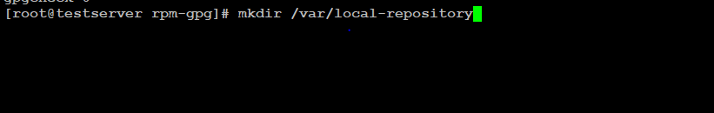

**step3:**

**Copy iso image package from /*mnt*\* to /var/local-repository**

**$ cp -rvf *mnt*\* /var/local-repository**

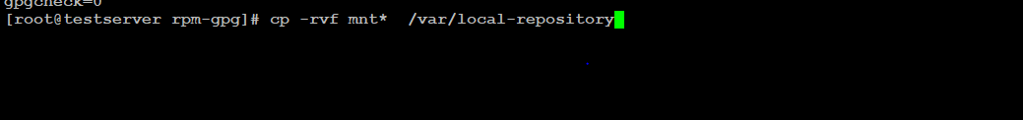

**Step4:**

**Now create the Local repository in this path /etc/yum.repos.d/local.repo**

**$ vim /etc/yum.repos.d/local.repo**

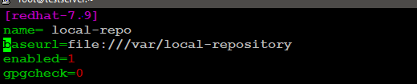

**Step5: cleaning and repolist list the yum**

**$ yum clean all**

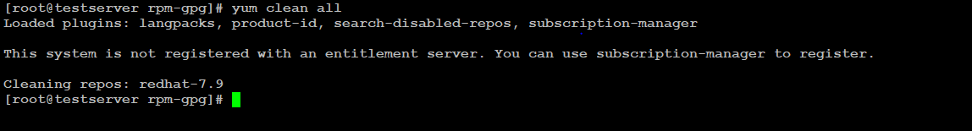

**$ yum repolist all**

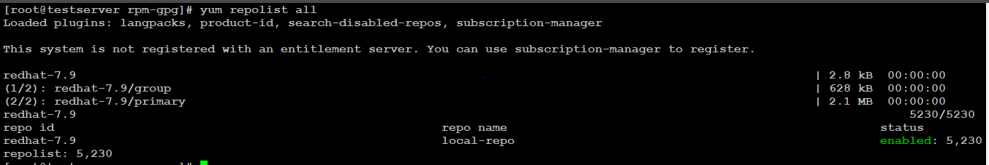

**Step6:**

**Now try to install the packages**

**$ yum install httpd**

