# **Set Static IP Address and Configure Network in Linux:**

**Step1:**

**Configure networking on your system. Unlike desktop machines where you can use dynamic IP addresses, on a server infrastructure, you will need to setup a static IP address (at least in most cases).**

**For the purpose of this tutorial, we will use the following Internet Protocol version 4 (IPv4) details:**

**IP address: 172.16.1.90**

**Netmask: 255.255.255.128**

**Hostname: testserver.example.com**

**Domain name: example.com**

**Gateway: 172.16.1.1**

**DNS Server 1: 8.8.8.8**

**DNS Server 2: 4.4.4.4**

**Step2:**

**To configure static IP address in RHEL / CentOS / Fedora, you will need to edit:**

**Where in the above "ifcfg-enp0s25" answers to your network interface enp0s25. If your interface is named “eth1" then the file that you will need to edit is "ifcfg-eth1".**

**Note: Make sure to open the file corresponding to your network interface. You can find your network interface name with ifconfig -a .**

**# vim /etc/sysconfig/network-scripts/ifcfg-enp0s25**



**You will only need to edit the following settings in configuration file:**

1. **DNS1 and DNS2**
2. **GATEWAY**
3. **HOSTNAME**
4. **NETMASK**
5. **IPADDR**
6. **BOOTPROTO**
7. **ONBOOT**

**Other settings should have already been predefined.**

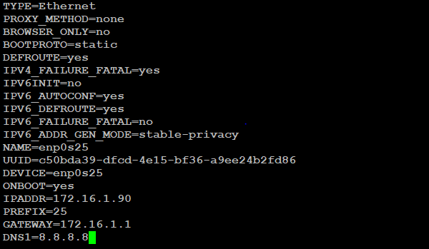

**Step3:**

**Next edit resolve.conf  file by opening it with a text editor such as nano or vi**

**# vim /etc/resolv.conf**



**Step4:**

**Once you have made your changes restart the networking with**

**# systemctl start network**



**Step5:**

**Now check the IP Address of the server**

**# ifconfig -a**

