Introduction to linear regression
Flora Green
Summary
Linear regression is a statistical model which uses one or more variables to predict the behaviour of another. It is widely used in fields such as business, economics and social sciences.
Before reading this guide, it is strongly recommended that you read [Guide: Introduction to straight lines] and Guide: Expected value, variance, standard deviation.

What is linear regression?
One of the key purposes of statistics is the understanding of data, which often involves considering the relationships between variables. Typically, this information is split into two categories: ‘the thing which is observed’ and ‘the thing(s) which affect this observation’, and a statistician collects information in both categories to build a full picture of the scenario. Then, the statistician tries to explain how and why a certain outcome is reached - which is incredibly useful for predicting which outcome may be reached in the future!
For instance, if the seaside branch of Cantor’s Confectionery had $150$ ice cream sales in one day, and only $30$ in another, they may wish to understand what it was that motivated this change, so that they can have the appropriate number of ice creams in stock. It could be that one of these days was a warm, sunny, summer’s Saturday, while the other was a cold, rainy winter’s Monday. If you take a sample of the weather, season and day of the week and the corresponding number of ice cream sales across multiple days, you can build a model which allows you to predict the number of ice cream sales on a particular day.
One of the models which describes the relationship between variables is known as linear regression. Linear regression finds a line of best fit for your data (known as a regression line) which can be used to predict outcomes - like the number of ice cream sales.
This guide will introduce you to linear regression. It will explain how to apply a simple linear regression model to a sample of data by finding the regression line. The guide will also explore the practical applications of linear regression, including in the construction of confidence intervals which explains the uncertainty about how closely your sample matches the real-world scenario, and in testing hypotheses about whether some factors impact the overall outcome.

Simple linear regression
Roughly speaking, variables in statistics fall into two kinds:
- things which you can see, measure, or control
- things which are impacted by the above kind of variables.
These are called explanatory and response variables respectively:
 Explanatory and response variables, statistical model
There are two types of variable used in statistical modelling.
The first is an explanatory variable; an independent variable controlled by the user to try and explain the behaviour of the model. These are typically variables that you can observe or measure.
The second is a response variable; a dependent variable which changes as any explanatory variables change.
A statistical model uses one or more explanatory variables to attempt to describe the behaviour of a response variable.

You can add or subtract as many explanatory variables as you like in your statistical model.
 Definition of linear regression, simple linear regression
A linear regression model is a statistical model that attempts to find a line of best fit through your data, by representing your response variable as a linear expression (no squared terms) involving one or more explanatory variables.
Simple linear regression is a linear regression model used when there is only one explanatory variable $x$. The regression line predicts the value of the response variable, which is written as $E\left(Y\right)$.

 Tip
For more on expected values, please see Guide: Expected value, variance, standard deviation. For more about explanatory and response variables, please see Overview: Statistical notation.

To find the equation of the regression line for a population of data, you will need to find the $y$-intercept of the line, which will be written as $α$, and its gradient, which will be described as $β$. For more about the equation of a straight line, please read [Guide: Introduction to straight lines].
The equation of the regression line is given by:
$$E\left(Y\right)=α+βx$$
In practice, it is impractical to work with an entire population of data; what if there were millions of samples? Instead, statisticians analyze samples of the population. This means that you will need to obtain estimates for the values of $α$ and $β$ from your sample of data. These will be called by $\hat{α}$ and $\hat{β}$.
 Tip
$\hat{α}$ and $\hat{β}$ are known as unbiased estimators of the population regression parameters $α$ and $β$. Here, ‘unbiased’ means that the expected value of $\hat{α}$ is the same as $α$ (similar for $\hat{β}$ and $β$).
For more about biased estimators, please read [Guide: Biased and unbiased estimators].

 | Example 1  The seaside branch of Cantor’s Confectionery wants to statistically model the relationship between temperature ($x$) and ice cream sales ($Y$). To do this, they track the number of ice cream sales in a $10$ day period alongside the peak temperature that day.  Day number Peak temperature (°C) Number of sales  1 22 150  2 20 100  3 19 110  4 21 210  5 24 260  6 25 280  7 27 310  8 26 350  9 28 360  10 25 270  You can define $Y$ to be the random variable describing the number of sales, associated with the explanatory variable $x$ (temperature). Then, you can plot the graph of the simple linear regression model:  $$E\left(Y\right)=α+βx$$
The graphs below illustrate how changing the values of the regression parameters affects how closely the simple linear regression model fits the observed data.
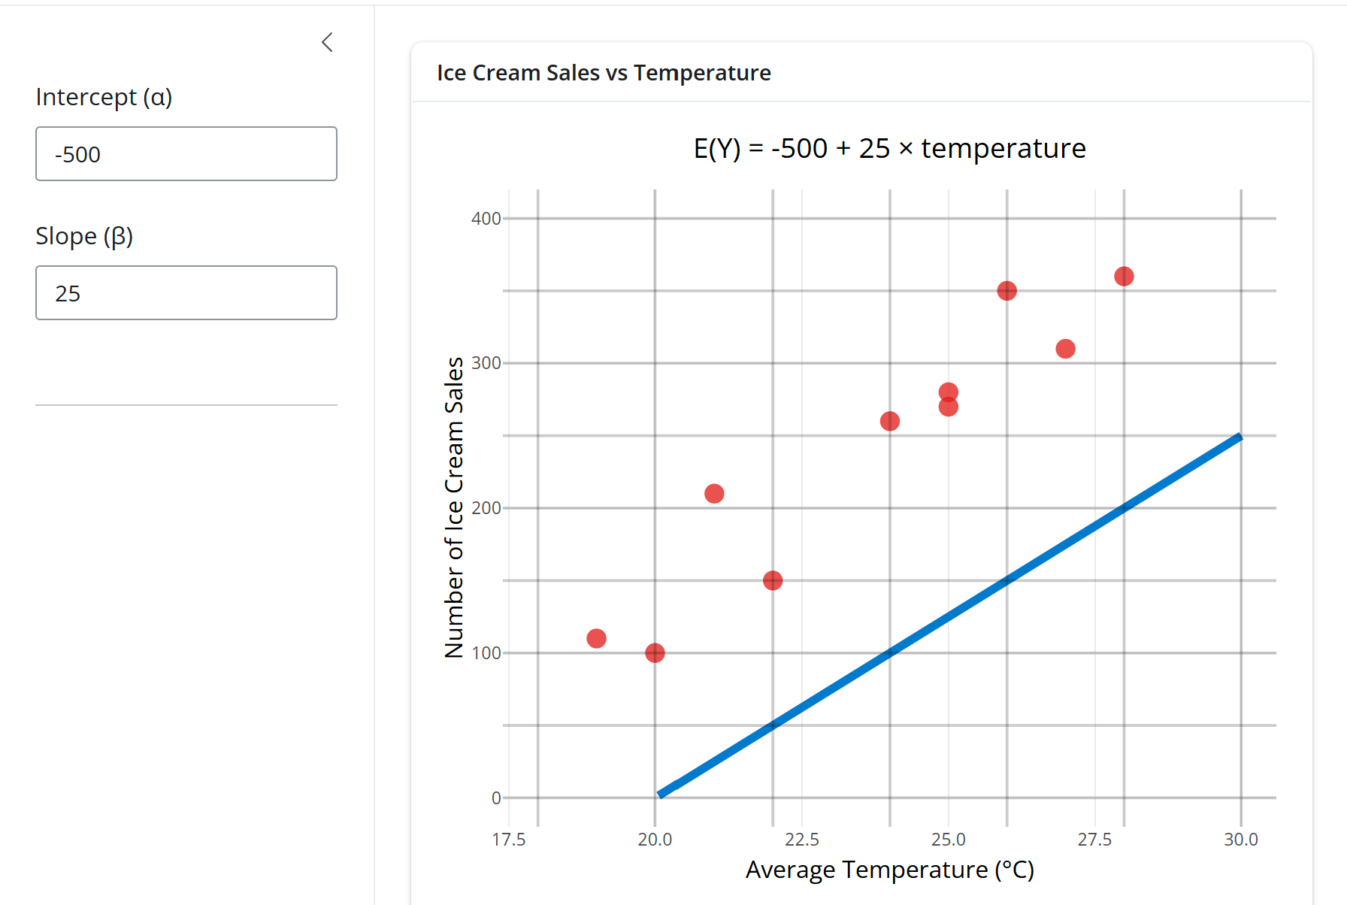
A simple linear regression model for ice cream sales vs. temperature, with parameters $α=−500$ and $β=25$
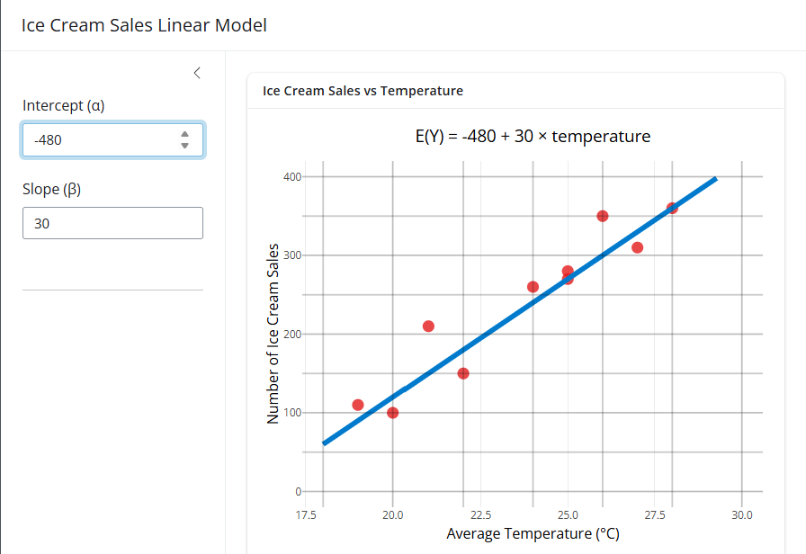
A simple linear regression model for ice cream sales vs. temperature, with parameters $α=−480$ and $β=30$
You can see that the line in Figure 2 is much closer to the data points than the line in Figure 1, meaning the equation in Figure 2 is a better fitted linear model.
 Tip
There are always a positive whole number $n$ many observations in any sample of data. (You could also write $n∈N$ to say this.)
If you have a whole number $i$ such that $1≤i≤n$, the $i$^{th} data point on the graph of your data is given by $\left(x_{i},y_{i}\right)$ and its corresponding estimated value is given by:
$$E\left(Y_{i}\right)=α+βx_{i}$$

Least squares estimation

Residuals
In practice, it is not always possible to plot the data points on a set of axes and manually tweak the values of the regression parameters until they appear to match the data - especially when you are working with a large sample of data. In addition, this is not a very scientific method for working anything out.
A quantitative method is a far more practical, and also far more correct, way to compute the regression parameters $α$ and $β$. You can use residuals in the method of least squares estimation to find the optimal regression line for your data.
 | Definition of residuals  The residual describes the difference between the observed value $y_{i}$ and the estimated value $E\left(Y_{i}\right)$.  Each residual is denoted $e_{i}$, where $i$ is a whole number such that $1≤i≤n$, where $n$ is your number of observations.  So, using the equation for $E\left(Y_{i}\right)$, you can define the residuals by:  $$e_{i}=y_{i}−E\left(Y_{i}\right)=y_{i}−\left(α+βx_{i}\right)$$

 Tip
When plotted on a graph, the residual can be viewed as the vertical difference between the line of best fit and the plotted data point. However, the difference may be positive or negative, which means that the residuals may be positive or negative.

Method of least squares
Ideally, you want $E\left(Y_{i}\right)$ to be as close to your observed data as it possibly can be, so you want the difference between your observed data and the data estimated by the model to be as small as possible. This is made more difficult because these differences could be negative; adding all of the differences together would then misrepresent how close the data points are to the regression lines. You can get around this by squaring the residuals; this makes every quantity positive while still retaining a sense of size.
To find the values of the regression parameters which achieve this closeness, you can use the method of least squares (or least squares estimation).
 | Method of least squares  Taking the sum of each $e_{i}^{2}$, you can define  $$S\left(α,β\right)=\sum_{i=1}^{n}{e_{i}^{2}}=\sum_{i=1}^{n}{{\left(y_{i}−\left(α+βx_{i}\right)\right)}^{2}}$$  The method of least squares minimizes this quantity $S\left(α,β\right)$ to find estimates (sometimes known as point estimates) for the regression parameters $\hat{α}$ and $\hat{β}$. These estimates generate a line of best fit where the average difference between the observed data and that estimated by the model is as small as possible.

Finding estimates of the regression parameters
To find estimates for the regression parameters, the following terminology is used:
- $\overset{‾}{x}$ and $\overset{‾}{y}$ are the sample means of $x$ and $y$.
- The sum of the squared differences between each observation $x_{i}$ and the sample mean $\overset{‾}{x}$ is given by:
$$SS_{XX}=\sum_{i=1}^{n}{{\left(x_{i}−\overset{‾}{x}\right)}^{2}}$$
- The sum of the differences between each observation $x_{i}$ and the sample mean $\overset{‾}{x}$, multiplied by the differences between each observation $y_{i}$ and the sample mean $\overset{‾}{y}$ is described by:
$$SS_{XY}=\sum_{i=1}^{n}{\left(x_{i}−\overset{‾}{x}\right)}\left(y_{i}−\overset{‾}{y}\right)$$
(For more detail about these terms, please read Overview: Statistical notation.)
The least squares estimate for the regression parameter $β$ is defined as:
$$\hat{β}=\frac{SS_{XY}}{SS_{XX}}=\frac{\sum_{i=1}^{n}{\left(x_{i}−\overset{‾}{x}\right)}\left(y_{i}−\overset{‾}{y}\right)}{\sum_{i=1}^{n}{{\left(x_{i}−\overset{‾}{x}\right)}^{2}}}$$
The least squares estimate for the regression parameter $α$ is defined as:
$$\hat{α}=\overset{‾}{y}−\hat{β}\overset{‾}{x}$$
For proofs of these results, please read [Proof sheet: Deriving estimates for regression parameters].
 Important
When working with large sums of squares, you could use programming languages (such as R or Python, or even Microsoft Excel) to save time manually typing each value into a calculator!

 Tip
Another way of doing this method is by using calculus. You can differentiate $S\left(α,β\right)$ with respect to the parameters $α$ and $β$ and set these equal to $0$ to find the point at which there is no change in the value of the parameters. These are the estimates for the parameters. For more about derivatives, please read Guide: Introduction to differentiation.

 | Example 2  The graphs below demonstrate how changing the values of the regression parameters affects how close the estimated values $E\left(Y_{i}\right)$ are to the observed values $Y_{i}$. You can see that the residuals are the vertical differences between the observed and expected values.
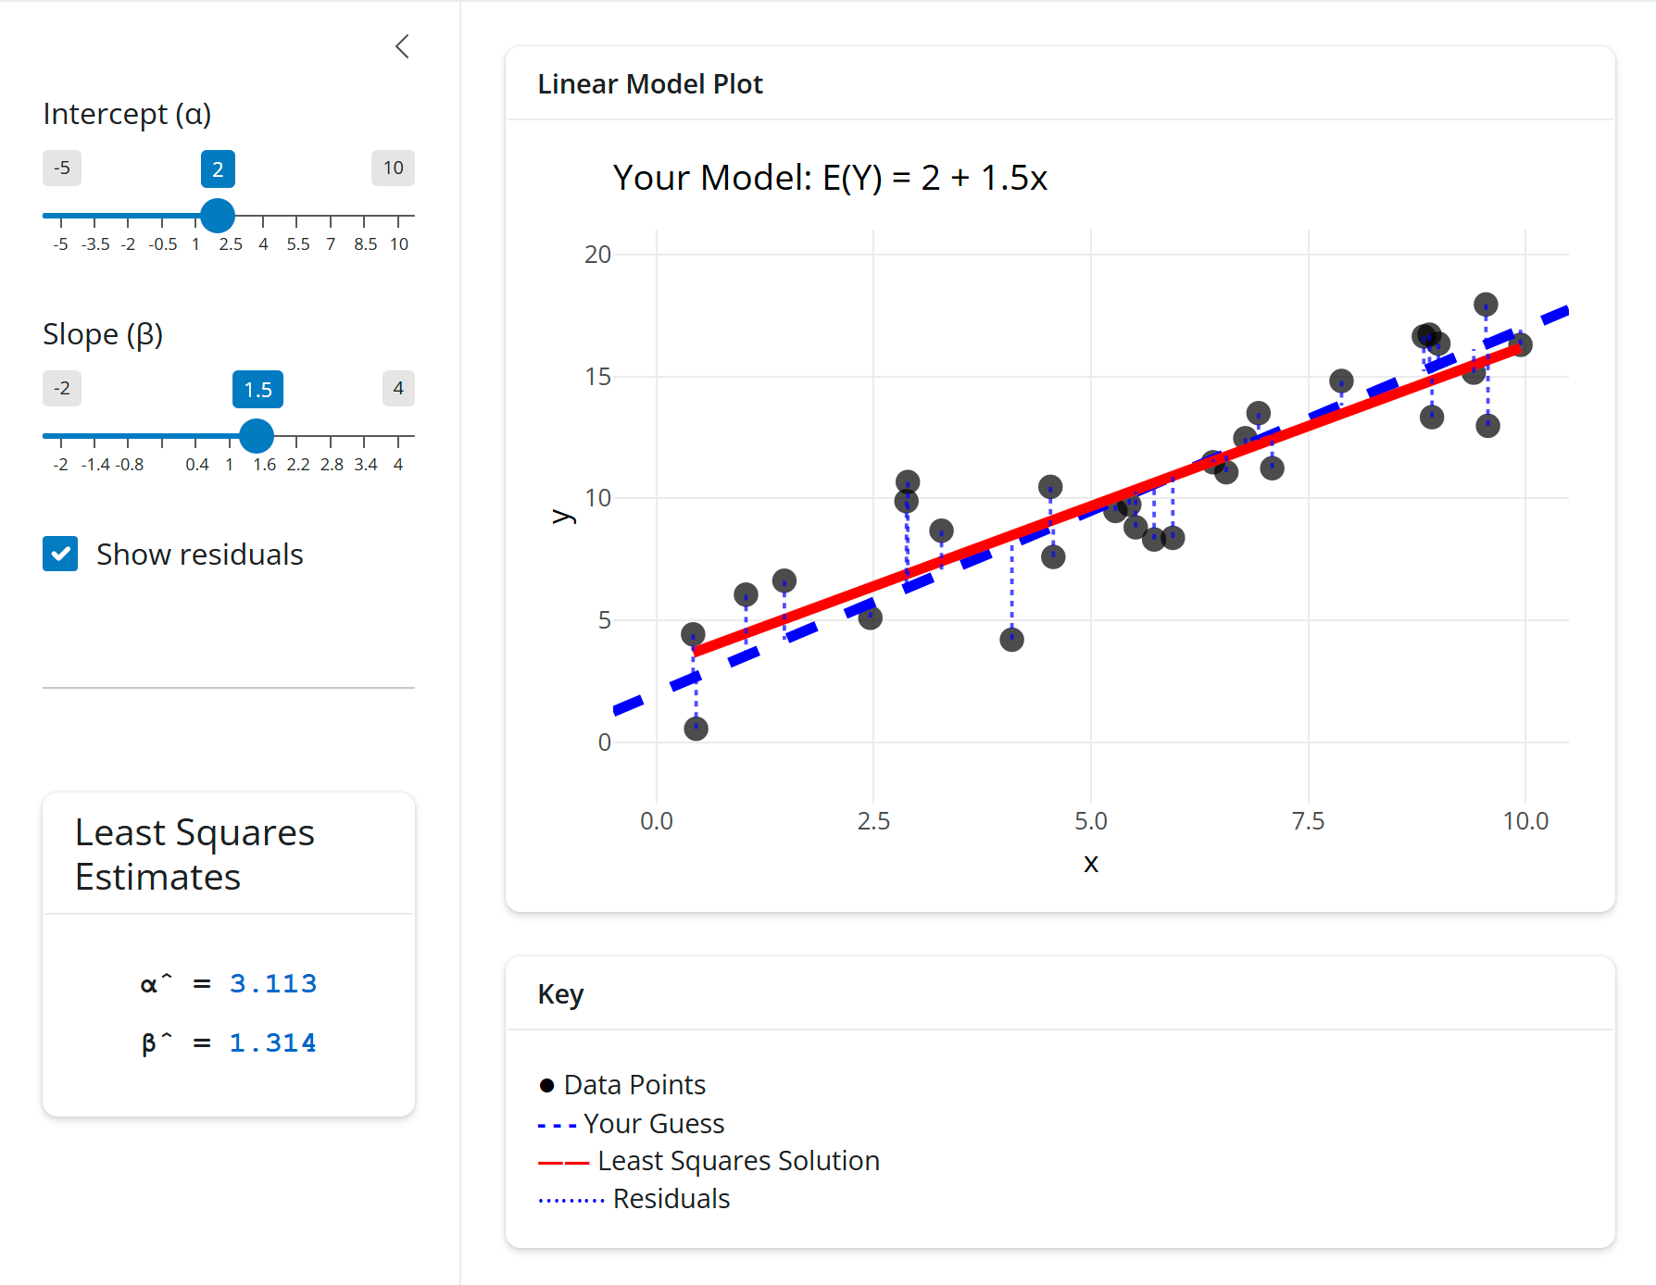
A regression line with parameters $α=2$ and $β=1.5$ plotted alongside the regression line with parameters $\hat{α}$ and $\hat{β}$.
You can see that the regression line which uses the least squares estimates fits the data the closest.
Now, here’s how to use least squares to find the example above.
 | Example 3  In Example 1, you saw the following data from Cantor’s Confectionery.  Day number Peak temperature (°C) Number of sales  1 22 150  2 20 100  3 19 110  4 21 210  5 24 260  6 25 280  7 27 310  8 26 350  9 28 360  10 25 270  You defined temperature as the explanatory variable $x$ and the number of ice cream sales as the response variable $Y$. You also saw how changing the values of the regression parameters $α$ and $β$ affected how closely the simple linear regression model $E\left(Y\right)=α+βx$ fitted the observed data.  Now, let’s use least squares estimation to estimate the values $\hat{α}$ and $\hat{β}$ which best fit the data.  You can see that there are $n=10$ entries in the table. You can use the definition of sample means (as seen in Overview: Statistical notation) to obtain values of $\overset{‾}{x}$ and $\overset{‾}{y}$. Here  $$\begin{matrix}\overset{‾}{x} & =\frac{1}{n}\sum_{i=1}^{n}{x_{i}}=\frac{1}{10}\sum_{i=1}^{10}{x_{i}}=23.7 \\ \overset{‾}{y} & =\frac{1}{n}\sum_{i=1}^{n}{y_{i}}=\frac{1}{10}\sum_{i=1}^{10}{y_{i}}=240\end{matrix}$$  Now, you can use these sample means to calculate $SS_{XX}$ and $SS_{XY}$:  $$\begin{matrix}SS_{XY} & =\sum_{i=1}^{n}{\left(x_{i}−\overset{‾}{x}\right)}\left(y_{i}−\overset{‾}{y}\right)=2460 \\ SS_{XX} & =\sum_{i=1}^{n}{{\left(x_{i}−\overset{‾}{x}\right)}^{2}}=84.1\end{matrix}$$  Finally, using these results, you can find estimates for the regression parameters.  $$\hat{β}=\frac{SS_{XY}}{SS_{XX}}=\frac{2460}{84.1}≈29.25089$$  $$\hat{α}=\overset{‾}{y}−\hat{β}\overset{‾}{x}=240−29.25⋅23.7=−453.2461$$

Further considerations

As you saw earlier, the observations $Y_{1},…,Y_{n}$ are random variables and can therefore be assumed to follow a distribution. Since the observations are functions of the regression parameters $α,β$, the least squares estimates $S\left(α,β\right)$ for the regression parameters are also random variables. For more information about this, please see [Guide: Maximum likelihood estimation].
Since the estimates are random variables, you can assume that they follow a probability distribution. For more information about the types of probability distributions which your data could follow, please read Overview: Probability distributions.
 Important
Before you can assume that your data follows a particular distribution, you must check whether your data aligns with the assumptions which underpin this distribution.

It is useful for your regression parameters to follow probability distributions because it allows you to construct confidence intervals and test hypotheses about them. Constructing confidence intervals for the regression parameters enables you to construct a plausible range of values, within which it is likely that your estimation lies. This recognizes the uncertainty as to how closely your sample matches the real-life scenario. For more information about confidence intervals, please read Guide: Confidence intervals.
To learn how to apply these ideas to data which follows a normal distribution, please read [Guide: Normal linear regression.]
Testing hypotheses is particularly useful when there are multiple explanatory variables, because you can test whether some of them are equal to zero - and if so, they can be discounted. This reduces the complexity of the linear regression model, meaning it is more transferable to new data.
For more on this, please read [Guide: Introduction to Multiple Linear Regression].

Quick check problems
- Which of these is the equation of a linear regression model?
- $E\left(Y\right)=α+βx_{i}$
- $\hat{α}=\overset{‾}{y}−\hat{β}\overset{‾}{x}$
- $\hat{β}=\frac{SS_{XY}}{SS_{XX}}$
- What is the name of the linear regression model which has one explanatory variable?
- Are the following statements true or false?
- $e_{i}$ is used to describe a residual.
- To use linear regression, your data must be normally distributed.
- The regression parameter $α$ can be equal to zero.

Further reading
For more questions on the subject, please go to Questions: Introduction to linear regression.
To learn about normal linear regression, please read [Guide: Normal linear regression].
To extend linear regression to encompass multiple explanatory variables, please read [Guide: Multiple linear regression].

Version history
v1.0: initial version created 12/25 by Flora Green as part of a University of St Andrews VIP project.
This work is licensed under CC BY-NC-SA 4.0.

