Answers: Trigonometry (degrees)
Dzhemma Ruseva, Ellie Gurini, Ciara Cormican
Summary
Answers to the questions on trigonometry, using degrees to measure angles.
These are the answers to Questions: Trigonometry (degrees).
Please attempt the questions before reading these answers!

Q1
You are given the triangle below.
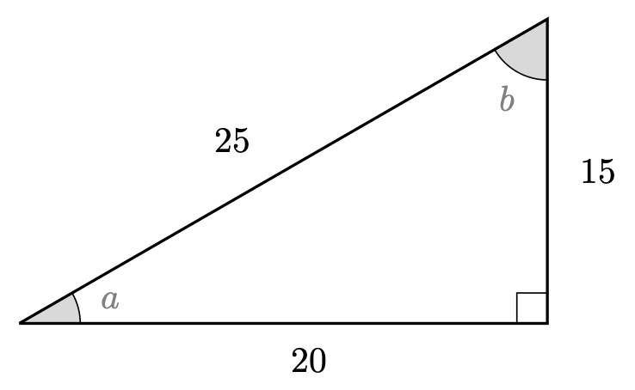
Q1. Triangle
Here,
- $cos(a)=\frac{4}{5}$
- $sin(a)=\frac{3}{5}$
- $tan(a)=\frac{3}{4}$
- $cos(b)=\frac{3}{5}$
- $sin(b)=\frac{4}{5}$
- $tan(b)=\frac{4}{3}$

Q2
Using the triangle below, solve the following equations.
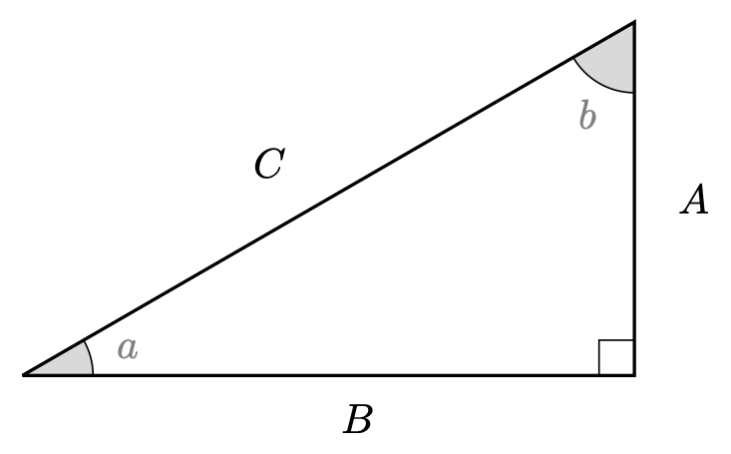
Q2. Triangle
2.1. $C=12$
2.2. $A=2$
2.3. $A=1.812$ (to three decimal places)
2.4. $A=\sqrt{6}$
2.5. $A=8$
2.6. $B=\frac{8}{\sqrt{3}}$.

Q3
3.1. $cos(30)=\frac{\sqrt{3}}{2}$
3.2. $tan(30)=\frac{1}{\sqrt{3}}=\frac{\sqrt{3}}{3}$
3.3. $csc(45)=1$
3.4. $cot(30)−sin(60)=\sqrt{3}−\frac{\sqrt{3}}{2}=\frac{\sqrt{3}}{2}$
3.5. $sin(90)+cos(180)=1+(−1)=0$
3.6. $tan(30)−cot(30)=\frac{1}{\sqrt{3}}−\sqrt{3}$
3.7. $cos(0)sin(90)=1⋅1=1$
3.8. $cos(30)sec(30)−sin(45)csc(45)=1−1=0$
3.9. $cot(90)=0$

Version history and licensing
v1.0: initial version created 08/23 by Dzhemma Ruseva, Ellie Gurini, Ciara Cormican as part of a University of St Andrews STEP project.
- v1.1: edited 05/24 by tdhc, and split into versions for both degrees and radians.
This work is licensed under CC BY-NC-SA 4.0.

