Factsheet: Gamma distribution
Michelle Arnetta and Tom Coleman
Summary
A factsheet for the gamma distribution.
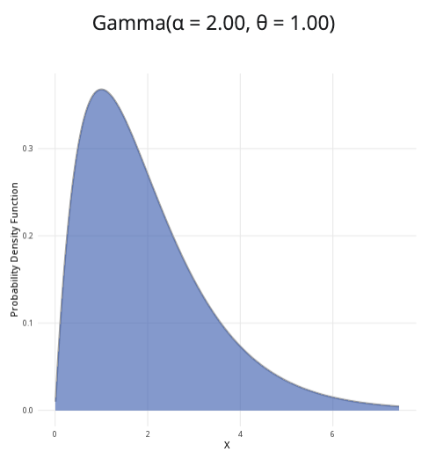
An example of the gamma distribution with $α=2$ and $θ=1$.
Where to use: The gamma distribution generalizes the exponential distribution, allowing for greater or lesser variance. It is used to model positive continuous random variables that have skewed distributions.
Notation: $X∼\text{Gamma}(α,θ)$ or $X∼\text{Gam}(α,θ)$
Parameters: Two real numbers $α$ and $θ$, which are related to the mean $μ$ and variance $σ^{2}$:
- $α=\frac{μ^{2}}{σ^{2}}$ (shape parameter)
- $θ=\frac{σ^{2}}{μ}$ (scale parameter)
Quantity | Value | Notes
Mean | $E(X)=αθ$
Variance | $V(X)=αθ^{2}$
PDF | $P(X=x)=\frac{x^{α−1}exp\left(−\frac{x}{θ}\right)}{Γ(α)θ^{α}}$ | $Γ(x)$ the gamma function of $x$
CDF | $P(X≤x)=\frac{\text{Gam}\left(α,\frac{x}{θ}\right)}{Γ(α)}$ | $\text{Gam}(α,θ)$ is the PDF of the gamma distribution
Example: You collect historical data on the time to failure of a machine from Cantor’s Confectionery. The mean is 83 days and the variance is 50.3. You can then use this to estimate the shape and scale parameters of the gamma distribution:
- $α=\frac{{83}^{2}}{50.3}=136.958250497≈137$
- $θ=\frac{50.3}{83}=0.60602409638≈0.61$
The distribution can be expressed as $X∼\text{Gam}(137,0.61)$, where the shape parameter is 137 and the scale parameter is 0.61.

Further reading
This interactive element appears in Overview: Probability distributions. Please click this link to go to the guide.

Version history
v1.0: initial version created 04/25 by tdhc and Michelle Arnetta as part of a University of St Andrews VIP project.
- v1.1: moved to factsheet form and populated with material from Overview: Probability distributions by tdhc.
- v1.2: deprecated shinylive apps replaced 09/26 by tdhc.
This work is licensed under CC BY-NC-SA 4.0.

