Factsheet: Normal distribution
Michelle Arnetta and Tom Coleman
Summary
A factsheet for the normal distribution $N(μ,σ^{2})$.
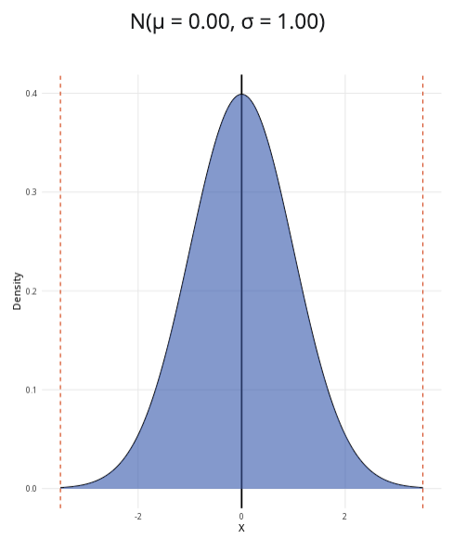
An example of the normal distribution with $μ=0$ and $σ=1$.
Where to use: The normal distribution can be used to model continuous random variables, which can include any positive or negative real values. The use of this distribution is often justified by the Central Limit Theorem: as the sample size increases, the distribution of sample means will resemble a normal distribution more and more closely.
Notation: $X∼\text{Normal}(μ,σ^{2})$ or $X∼N(μ,σ^{2})$
Parameters: Two real numbers $μ$ and $σ^{2}$.
- $μ$ is the centre of the distribution (the mean/expected value).
- $σ^{2}$ is the measure of how the distribution is spread (the variance).
Quantity | Value | Notes
Mean | $E(X)=μ$
Variance | $V(X)=σ^{2}$
PDF | $P(X=x)=\frac{1}{\sqrt{2πσ^{2}}}exp\left(−\frac{(x−μ)^{2}}{2σ^{2}}\right)$ | $exp(y)=e^{y}$
CDF | $P(X≤x)=\frac{1}{2}\left[1+\text{erf}\left(\frac{x−μ}{σ\sqrt{2}}\right)\right]$ | $\text{erf}(x)$ is the error function of $x$
Example: The lengths of chocolate bars produced by Cantor’s Confectionery follow a normal distribution with a mean of $5.6$ inches and a variance of $1.44$. This can be expressed as $X∼N(5.6,1.44)$, meaning the data is normally distributed, centered at $5.6$ with standard deviation $\sqrt{1.44}=1.2$.

Further reading
This interactive element appears in Guide: PMFs, PDFs, CDFs and Overview: Probability distributions. Please click the relevant links to go to the guides.

Version history
v1.0: initial version created 04/25 by tdhc and Michelle Arnetta as part of a University of St Andrews VIP project.
- v1.1: moved to factsheet form and populated with material from Overview: Probability distributions by tdhc.
- v1.2: graph transferred from R Shinylive to html by tdhc in 06/26.
This work is licensed under CC BY-NC-SA 4.0.

