Properties of integration
Tom Coleman
Summary
As the reverse process of differentiation, integration is a key area of mathematics. It has uses in almost all places that requires calculus, such as in the sciences, social sciences, and particularly in statistics. This guide introduces properties of both definite and indefinite integration.
Before reading this guide, it is highly recommended that you read Guide: Introduction to integration.

What is integration?
You have seen in Guide: Introduction to integration that integral calculus performs two roles: one, it is the reverse process of differentiation that provides the antiderivative of a function (via indefinite integration), and can be used to determine areas under curves (amongst other helpful applications, via definite integration). These two branches of integral calculus are connected by the Fundamental Theorem of Calculus, which says that finding definite integrals can be done using antiderivatives. Finding antiderivatives is therefore the key skill in integration
Much like the way that differentiation has properties and rules, so does integration - both definite and indefinite. This guide will introduce you to a selection of properties for both definite and indefinite integration, and how these can be used to enhance your skills in finding antiderivatives.
For reference and use throughout the guide, the table of antiderivatives from Guide: Introduction to integration is reproduced below:
Function $f(x)$ | Antiderivative $∫f(x) \text{d}x$ | Notes
$a$ | $ax+C$ | $a$ real
$ax^{n}$ | $\frac{ax^{(n+1)}}{n+1}+C$ | $a$ real, $n≠−1$
$ax^{−1}$ | $aln|x|+C$ | $a$ real
$ae^{kx}$ | $\frac{1}{k}ae^{kx}+C$ | $a,k$ real
$acos(kx)$ | $\frac{1}{k}asin(kx)+C$ | $a,k$ real
$asin(kx)$ | $−\frac{1}{k}acos(kx)+C$ | $a,k$ real

Properties of indefinite integrals
 Properties of indefinite integrals
Let $\int_{a}^{b}{f}(x) dx$ be a definite integral. Then the following properties hold:
- (constant rule for integration) If $k$ is some constant, then:
$$∫kf(x) dx=k∫f(x) dx$$
- More specifically, if $k=−1$, then
$$∫−f(x) dx=−\int_{a}^{b}{f}(x) dx.$$
- (sum rule for integration) For a function $g(x)$, then:
$$∫f(x)+g(x) dx=∫f(x) dx+∫g(x) dx$$
- that is, the antiderivative of a sum of functions is the sum of the antiderivatives.
- (difference rule for integration) For a function $g(x)$, then:
$$∫f(x)−g(x) dx=∫f(x) dx−∫g(x) dx$$
- that is, the antiderivative of the difference of two functions is the sum of the antiderivatives.

Here’s an example of these properties in action.
Example 1

Example 2

 Tip
Much like differentiating with respect to $x$, the sum rule and scaling rule says that indefinite integration is a linear operator.

 Important
Importantly, there are no general properties for finding the antiderivatives of the multiplication, division, or composition of two functions. That means that in general
$$∫f(x)g(x) \text{d}x≠∫f(x) \text{d}x⋅∫g(x) \text{d}x$$
and
$$∫\frac{f(x)}{g(x)} \text{d}x≠\frac{∫f(x) \text{d}x}{∫g(x) \text{d}x}$$
This is because integration is the reverse process of differentiation, and you know that differentiation does not work this way! In fact, you are able to reverse some of the rules of differentiation:
- The reverse process for the chain rule for differentiation (see Guide: The chain rule is known as integration by substitution; see [Guide: Integration by substitution] for more.
- A process to reverse the product rule for differentiation (see Guide: The product rule is known as integration by parts; see [Guide: Integration by parts] for more.

Properties of definite integrals
Properties of definite integrals
Let $\int_{a}^{b}{f}(x) dx$ be a definite integral. Then the following properties hold:
- (constant rule for integration) If $k$ is some constant, then:
$$\int_{a}^{b}{k}f(x) dx=k\int_{a}^{b}{f}(x) dx$$
- (sum rule for integration) For a function $g(x)$:
$$\int_{a}^{b}{f}(x)+g(x) dx=\int_{a}^{b}{f}(x) dx+\int_{a}^{b}{g}(x) dx$$
- (difference rule for integration) For a function $g(x)$ where the definite integral exists on the interval $[a,b]$:
$$\int_{a}^{b}{f}(x)−g(x) dx=\int_{a}^{b}{f}(x) dx−\int_{a}^{b}{g}(x) dx$$
The final four properties examine what happens when you modify the limits of integration.
- For $c$ such that $a<c<b$, then:
$$\int_{a}^{b}{f}(x) dx=\int_{a}^{c}{f(x)} dx+\int_{c}^{b}{f(x)} dx$$
- If $f(x)≤g(x)$ for all $x$ between $a$ and $b$, then:
$$\int_{a}^{b}{f}(x) dx≤\int_{a}^{b}{g}(x) dx$$
- If $a$ is some real number, then:
$$\int_{a}^{a}{f(x)} dx=0$$
- Finally if $a<b$, then:
$$\int_{a}^{b}{f}(x) dx=−\int_{b}^{a}{f(x)} dx$$

Even and odd functions
Let $f(x)$ be a function, and suppose that $a$ is a positive real number.
- If $f(x)$ is an odd function, then
$$\int_{−a}^{a}{f(x)} dx=0.$$
- If $f(x)$ is an even function, then
$$\int_{−a}^{a}{f(x)} dx=2\int_{0}^{a}{f(x)} dx.$$
:::

Definite integrals of piecewise functions

Definite integrals with infinite limits
Important
- The definite integral doesn’t change its value if you change the name of the variable throughout. For instance
$$\int_{a}^{b}{f}(x) \text{d}x=\int_{a}^{b}{f}(t) \text{d}t=\int_{a}^{b}{f}(θ) \text{d}θ$$
- and many more.
- It is important to remember that in every integral, the integrand $f(x)$ and $\text{d}x$ are multiplied together.
- In every definite integral you write, you should include every one of these pieces of notation.
- The answer to a definite integral is always a number, and not an expression involving a variable.
- The numerical answer represents the signed area bounded by the curve $f(x)$, the $x$-axis, and the two lines $x=a$ and $x=b$. That means that portions of the area above the $x$-axis contribute positively to the answer, and portions of the area below the $x$-axis contribute negatively to the answer.
  - This means that the definite integral is only equal to the area ‘under’ the curve when the outputs of the function $f(x)$ are always positive (above the $x$-axis) between the limits $x=a$ and $x=b$. This is the case in Example 1.

The figure below shows a representation of a definite integral. Here, the value of the integral $A$ corresponds to the area shaded in blue, as the function is always above the $x$-axis.
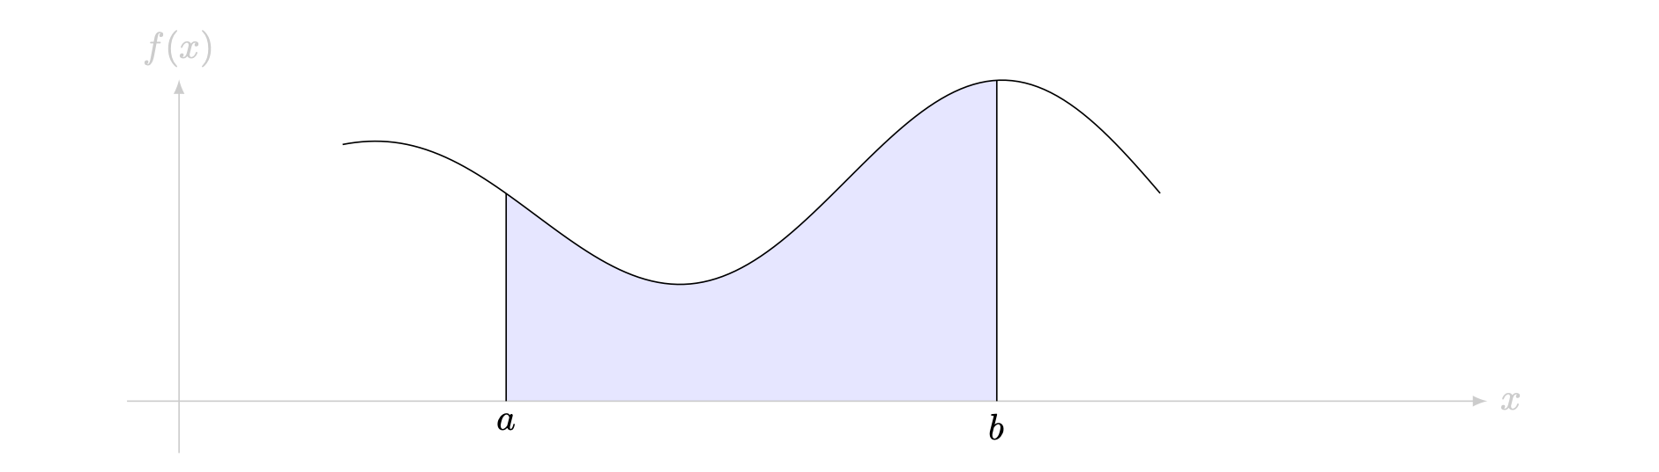
Figure 1: A representation of a definite integral. The area of the shaded region is equal to the integral $\int_{a}^{b}{f}(x) dx$.
You can work out the value of definite integrals using geometry if the curve is sufficiently well-behaved - a straight line or a circular arc.
Example 1
- Consider the area bounded by $f(x)=2$, the $x$-axis, and the lines $x=1$ and $x=3$.
The distance between the two bounds is $2$, and the distance between the lines $y=0$ and $y=f(x)$ is also $2$, so this area describes a square with side length $2$. The area of this region is $A=2⋅2=4$. You can use the idea of the definite integral to say that
$$\int_{1}^{3}{2} dx=4.$$
- You are given the area bounded by $f(x)=x$, the $x$-axis, and the lines $x=0$ and $x=3$.
As the shaded region is a triangle with base and height both $3$, the area is $A=(3⋅3)/2=9/2$. You can use the idea of a definite integral to say that
$$\int_{0}^{2}{x} dx=2.$$

Important
Both examples here involve functions which take positive outputs, and so the definite integral is actually equal to the area. It is worth reminding yourself at this point that the answer is the signed area bounded by the curve, the limits, and the $y$-axis. Here’s another figure which demonstrates this.

The figure below shows a representation of a definite integral. Here, the value of the integral $A$ corresponds to the area shaded in blue, as the function is always above the $x$-axis.
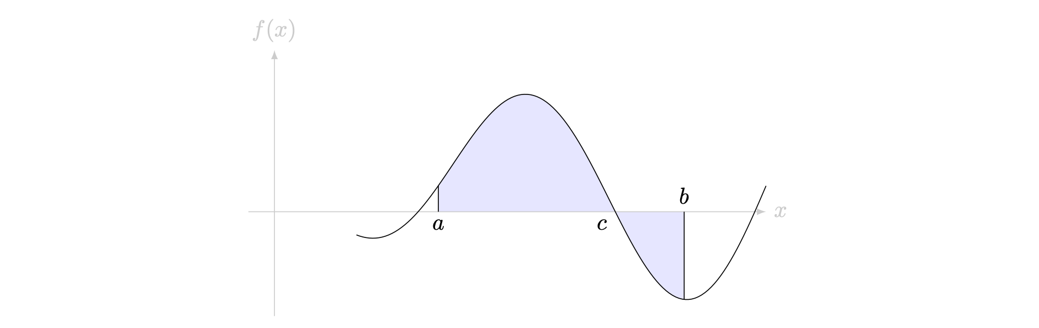
Figure 2: A representation of a definite integral. The integral $\int_{a}^{b}{f}(x) dx$ is equal to the bounded area above the curve minus the bounded area below the curve.

Indefinite integrals and antiderivatives
Evaluating areas gets more complicated if your curve is not a straight line. For instance, how would you work out the area bounded by $f(x)=x^{2}$, the limits $x=0$ and $x=1$ and the $x$-axis? In other words, what is the value of the definite integral of $f(x)=x^{2}$ between $0$ and $1$ with respect to $x$? You can work this out by finding the antiderivative.
Finding the derivative $f^{′}(x)$ of a function $f(x)$ is well defined; see Guide: Introduction to differentiation and the derivative for more. The question of finding the antiderivative is as follows: given a function $f(x)$, is there a function $F(x)$ such that $F^{′}(x)=f(x)$? If this happens, then $F(x)$ is the antiderivative of $f(x)$.
It turns out that antiderivatives are very closely related to integration. To find the antiderivative $F(x)$ of $f(x)$, you can find the indefinite integral of $f(x)$ with respect to $x$; in other words
$$F(x)=∫f(x) \text{d}x.$$
This means that indefinite integration is the reverse process of differentiation: to undo differentiation, do an indefinite integral; to undo an indefinite integral, find the derivative.

The constant of integration
You can ask yourself; is the antiderivative $F(x)$ of a function $f(x)$ unique? The answer here is no, it isn’t. Here’s an example to illustrate this process.

Quick check problems
- Answer the following questions true or false:
- The indefinite integral can be used to find the area under a curve.
- The answer to a definite integral is always a number.
- If $f(x)=a$, then the antiderivative of $f(x)=ax$.
- Indefinite integrals have limits.
- Differentiation is the reverse process of integration.
- The power of $x$ in the antiderivative of $f(x)=\frac{1}{x^{4}}$ is $−3$.
- Find the antiderivative of the following functions with respect to $x$.
- $f(x)=3x^{7}$
- $f(x)=4cos(3x)$
- $f(x)=e^{−8x}$

Further reading
For more practice on integration, see [Worked examples: Integration]. [For more questions on the subject, please go to Questions: Introduction to integration.]
For more about properties of integration, please see [Guide: Properties of integration].
For more about the theory of definite integration, including a formal definition and how to find a definite integral from first principles, please see [Guide: Definite integrals]. For more about why the Fundamental Theorem of Calculus works, please see [Proof sheet: Fundamental Theorem of Calculus]
For more about techniques of integration, please see [Guide: Integration by substitution], [Guide: Integration by parts], and [Guide: Trigonometry and integration].

Version history
v1.0: initial version created 08/25 by tdhc.
This work is licensed under CC BY-NC-SA 4.0.

