Answers: Introduction to complex numbers
Tom Coleman
Summary
Answers to questions relating to the guide on introduction to complex numbers.
These are the answers to Questions: Introduction to complex numbers.
Please attempt the questions before reading these answers!

Q1
Using complex numbers, find solutions to the following equations.
1.1. Here, $x=i$ and $x=−i$ are the two solutions.
1.2. Here, $x=3i$ and $x=−3i$ are the two solutions.
1.3. Here, $x=12i$ and $x=−12i$ are the two solutions.
1.4. Here, $x=1$ and $x=−1$ are the two solutions. (Real numbers are complex numbers too!)

Q2
For each of the complex numbers below, give their real and imaginary parts. (In this question, $a,b$ are real numbers.)
2.1. The real part of $z_{1}$ is $\text{Re}(z_{1})=2$ and the imaginary part of $z_{1}$ is $\text{Im}(z_{1})=3$.
2.2. The real part of $z_{2}$ is $\text{Re}(z_{2})=−23$ and the imaginary part of $z_{2}$ is $\text{Im}(z_{2})=32$.
2.3. The real part of $z_{3}$ is $\text{Re}(z_{3})=3$ and the imaginary part of $z_{3}$ is $\text{Im}(z_{3})=−3$.
2.4. The real part of $z_{4}$ is $\text{Re}(z_{4})=0$ and the imaginary part of $z_{4}$ is $\text{Im}(z_{4})=3$.
2.5. The real part of $z_{5}$ is $\text{Re}(z_{5})=−3$ and the imaginary part of $z_{5}$ is $\text{Im}(z_{5})=−2$.
2.6. The real part of $z_{6}$ is $\text{Re}(z_{6})=a$ and the imaginary part of $z_{6}$ is $\text{Im}(z_{6})=2b$.
2.7. The real part of $z_{7}$ is $\text{Re}(z_{7})=2$ and the imaginary part of $z_{7}$ is $\text{Im}(z_{7})=0$.
2.8. The real part of $z_{8}$ is $\text{Re}(z_{8})=3/2$ and the imaginary part of $z_{8}$ is $\text{Im}(z_{8})=2/3$.
2.9. The real part of $z_{9}$ is $\text{Re}(z_{9})=22$ and the imaginary part of $z_{9}$ is $\text{Im}(z_{9})=−33$.
2.10. The real part of $z_{10}$ is $\text{Re}(z_{10})=333$ and the imaginary part of $z_{10}$ is $\text{Im}(z_{10})=22$.
2.11. The real part of $z_{11}$ is $\text{Re}(z_{11})=−2$ and the imaginary part of $z_{11}$ is $\text{Im}(z_{11})=2$.
2.12. The real part of $z_{12}$ is $\text{Re}(z_{12})=−2$ and the imaginary part of $z_{11}$ is $\text{Im}(z_{11})=−3$.

Q3
The complex conjugate of $z_{1}=2+3i$ is ${\overset{‾}{z}}_{1}=2−3i$.
The complex conjugate of $z_{2}=−23+32i$ is ${\overset{‾}{z}}_{2}=−23−32i$.
The complex conjugate of $z_{3}=3−3i$ is ${\overset{‾}{z}}_{3}=3+3i$.
The complex conjugate of $z_{4}=3i$ is ${\overset{‾}{z}}_{4}=−3i$.
The complex conjugate of $z_{5}=−3−2i$ is ${\overset{‾}{z}}_{5}=−3+2i$.
The complex conjugate of $z_{6}=a+2bi$ is ${\overset{‾}{z}}_{6}=a−2bi$.
The complex conjugate of $z_{7}=2$ is ${\overset{‾}{z}}_{7}=2$.
The complex conjugate of $z_{8}=3/2+2i/3$ is ${\overset{‾}{z}}_{8}=3/2−2i/3$.
The complex conjugate of $z_{9}=22−33i$ is ${\overset{‾}{z}}_{9}=22+33i$.
The complex conjugate of $z_{10}=333+22i$ is ${\overset{‾}{z}}_{10}=333+22i$.
The complex conjugate of $z_{11}=2i−2$ is ${\overset{‾}{z}}_{11}=−2i−2$.
The complex conjugate of $z_{12}=−3i−2$ is ${\overset{‾}{z}}_{12}=3i−2$.

Q4
See Figure 1 for the Argand diagram. You can notice that the complex conjugates of the complex numbers can be obtained by reflecting the point in the real axis.
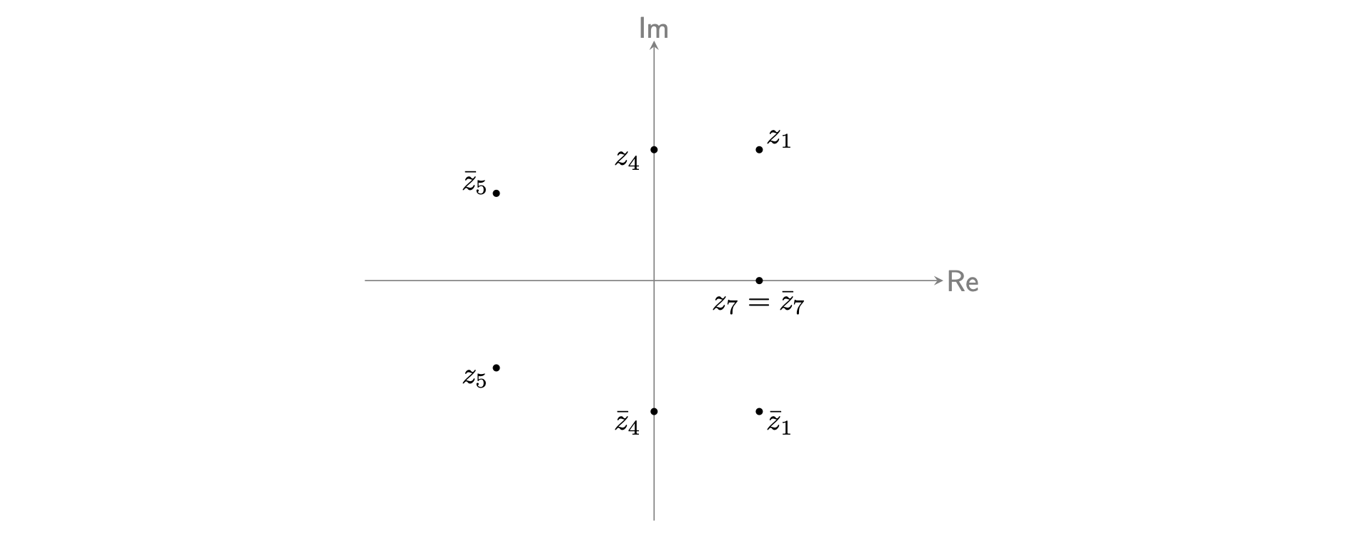
Figure 1: An Argand diagram with the seven complex numbers $z_{1},{\overset{‾}{z}}_{1},z_{4},{\overset{‾}{z}}_{4},$ in Example 5.

Version history and licensing
v1.0: initial version created 10/24 by tdhc.
This work is licensed under CC BY-NC-SA 4.0.

