Answers: Introduction to probability

Michelle Arnetta

Summary

Answers to questions relating to the guide on introduction to probability.

*These are the answers to* [*Questions: Introduction to probability.*](../questions/qs-introtoprobability.qmd)

**Please attempt the questions before reading these answers!**

## Q1

(Note: accept all simplified fractions, or probabilities represented in decimal and percentage forms)

**1.1.**

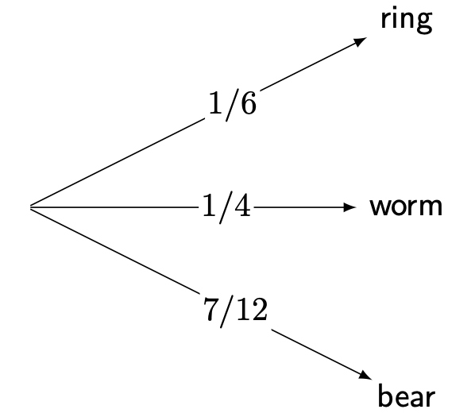

Answer to Q1.1(a)

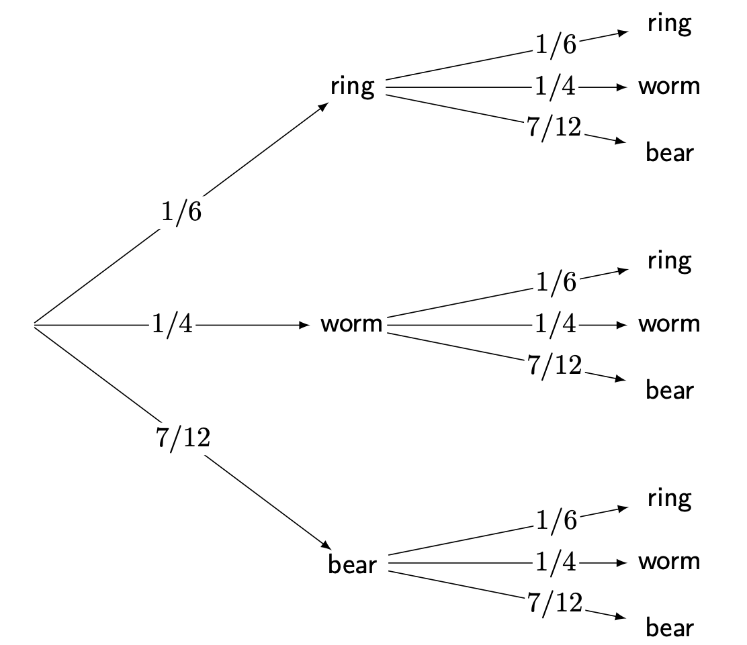

Answer to Q1.1(b)

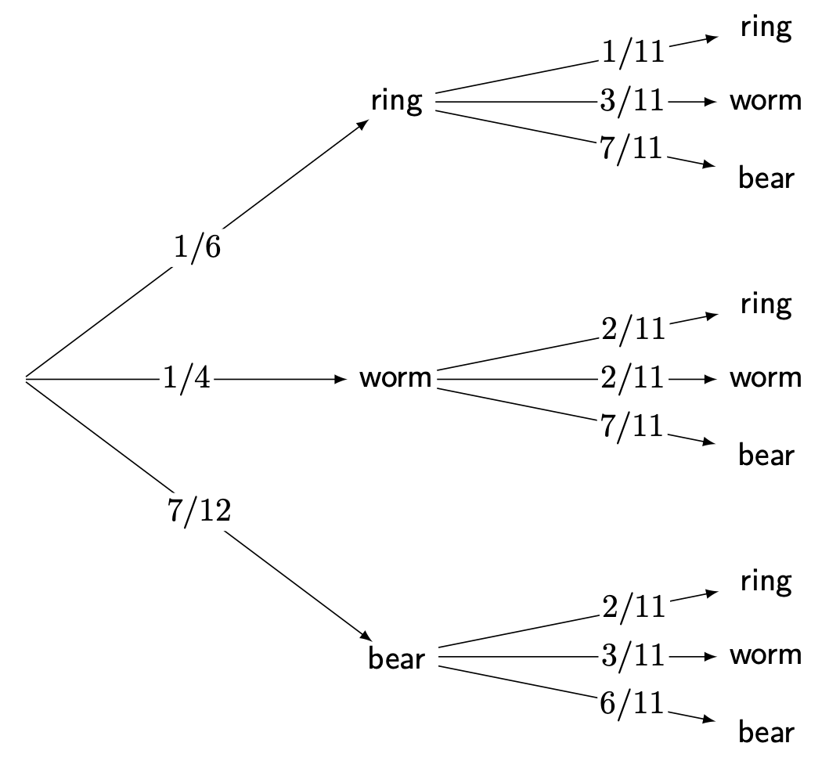

Answer to Q1.1(c)

**1.2.**

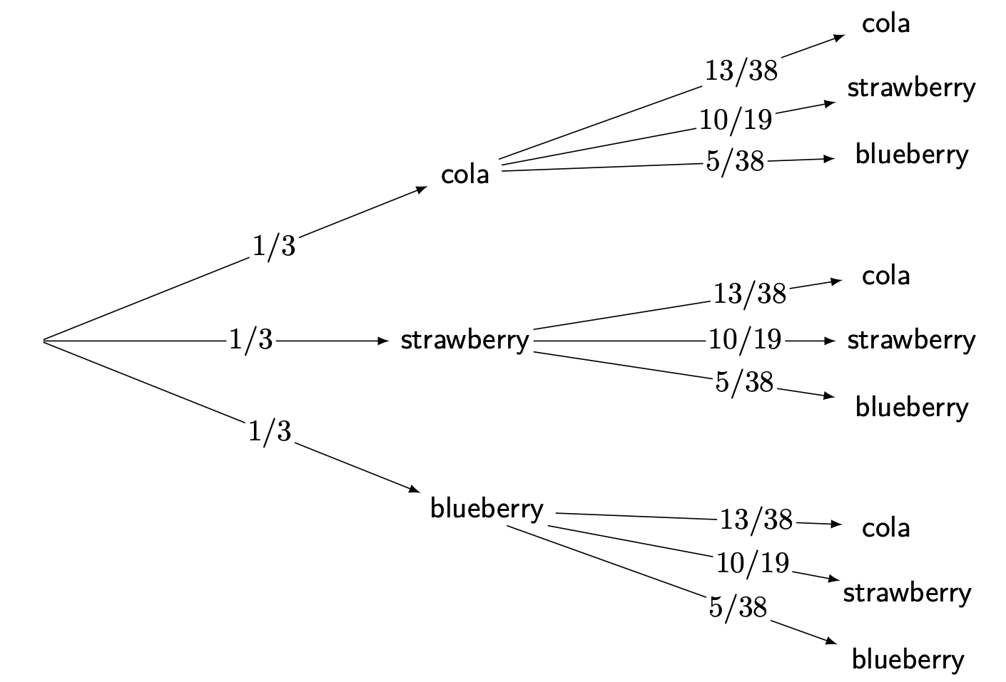

Answer to Q1.2

**1.3.**

* The events in Q1.1.(b) are independent.
* The events in Q1.1.(c) are dependent.
* The events in Q1.2. are independent.

## Q2

(Note: accept all simplified fractions, or probabilities represented in decimal and percentage forms)

**2.1.**

1. . Therefore, apply the complement rule to calculate the complement of , so .
2. The probability of drawing a gummy ring the first time is , and the probability of drawing a gummy ring the second time is also . Therefore, .
3. The probability of drawing a gummy bear the first time is , and the probability of drawing a gummy worm the second time is . Therefore, .

**2.2.** The probability of drawing a cola flavored jelly bean the first time is , and the probability of drawing a strawberry flavored jelly bean the second time is . Therefore, .

## Q3

**3.1.** This is an example of experimental probability.

**3.2.** The total number of spins is 60, and it lands on white 17 times. Therefore, , so by the complement rule, .

**3.3.** The spinner is unbiased (meaning the probability is uniform), so there are four possible colors that the spinner is equally likely to land on. Calculating the theoretical probability, .

**3.4.** As you spin the spinner more times, the experimental probabilities of each color will get closer to their theoretical probabilities.

## Q4

**4.1.** The sample space is , which contains 20 possible outcomes. The subset of the sample space with a value above 12 is , which contains 8 out of the 20 possible outcomes. Therefore, .

**4.2.** The possible outcomes of the 5-sided dice roll are . Adding 3 to each number, the sample space becomes . The sample space contains 5 possible outcomes, and the subset of the sample space that contains values 5 and above is , which contains 4 out of 5 possible outcomes. Therefore, where points of damage are dealt to the dragon.

**4.3.** Here is the sample space represented as a table:

|  | 1 | 2 | 3 | 4 |
| --- | --- | --- | --- | --- |
| **1** | (1,1) | (1,2) | (1,3) | (1,4) |
| **2** | (2,1) | (2,2) | (2,3) | (2,4) |
| **3** | (3,1) | (3,2) | (3,3) | (3,4) |
| **4** | (4,1) | (4,2) | (4,3) | (4,4) |

For convenience purposes, all outcomes that do not contain a 4 are then marked with an asterisk (although any way of marking or counting these outcomes are acceptable):

|  | 1 | 2 | 3 | 4 |
| --- | --- | --- | --- | --- |
| **1** | (1,1)* | (1,2)* | (1,3)* | (1,4) |
| **2** | (2,1)* | (2,2)* | (2,3)* | (2,4) |
| **3** | (3,1)* | (3,2)* | (3,3)* | (3,4) |
| **4** | (4,1) | (4,2) | (4,3) | (4,4) |

There are 16 total possible outcomes in the sample space, and there are 9 outcomes that do not contain a 4. Therefore, .

**4.4.** Here is the sample space represented as a table:

|  | 1 | 2 | 3 | 4 |
| --- | --- | --- | --- | --- |
| **1** | (1,1) | (1,2) | (1,3) | (1,4) |
| **2** | (2,1) | (2,2) | (2,3) | (2,4) |
| **3** | (3,1) | (3,2) | (3,3) | (3,4) |
| **4** | (4,1) | (4,2) | (4,3) | (4,4) |
| **5** | (5,1) | (5,2) | (5,3) | (5,4) |
| **6** | (6,1) | (6,2) | (6,3) | (6,4) |
| **7** | (7,1) | (7,2) | (7,3) | (7,4) |
| **8** | (8,1) | (8,2) | (8,3) | (8,4) |
| **9** | (9,1) | (9,2) | (9,3) | (9,4) |

The results of the two dice rolls can then be added together:

|  | 1 | 2 | 3 | 4 |
| --- | --- | --- | --- | --- |
| **1** | 2 | 3 | 4 | 5 |
| **2** | 3 | 4 | 5 | 6 |
| **3** | 4 | 5 | 6 | 7 |
| **4** | 5 | 6 | 7 | 8 |
| **5** | 6 | 7 | 8 | 9 |
| **6** | 7 | 8 | 9 | 10 |
| **7** | 8 | 9 | 10 | 11 |
| **8** | 9 | 10 | 11 | 12 |
| **9** | 10 | 11 | 12 | 13 |

For convenience purposes, all outcomes with skill levels that are greater than 9 are then marked with an asterisk (although any way of marking or counting these outcomes are acceptable):

|  | 1 | 2 | 3 | 4 |
| --- | --- | --- | --- | --- |
| **1** | 2 | 3 | 4 | 5 |
| **2** | 3 | 4 | 5 | 6 |
| **3** | 4 | 5 | 6 | 7 |
| **4** | 5 | 6 | 7 | 8 |
| **5** | 6 | 7 | 8 | 9 |
| **6** | 7 | 8 | 9 | 10* |
| **7** | 8 | 9 | 10* | 11* |
| **8** | 9 | 10* | 11* | 12* |
| **9** | 10* | 11* | 12* | 13* |

There are 36 total possible outcomes in the sample space, and there are 10 outcomes where the skill level exceeds 9 points. Therefore, where is the number of skill level points.

## Version history and licensing

v1.0: initial version created 04/25 by Michelle Arnetta as part of a University of St Andrews VIP project.

[This work is licensed under CC BY-NC-SA 4.0.](https://creativecommons.org/licenses/by-nc-sa/4.0/?ref=chooser-v1)