Factsheet: Beta distribution

Michelle Arnetta and Tom Coleman

Summary

A factsheet about the beta distribution.

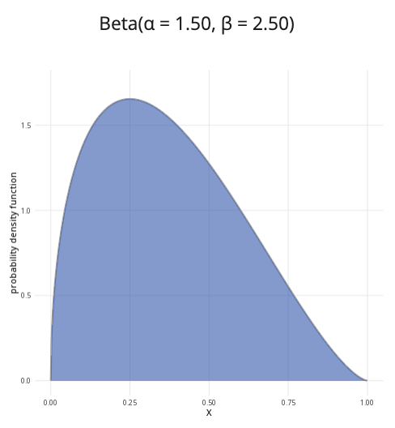

An example of the beta distribution with $α=1.5$ and $β=2.5$.

**Where to use:** The beta distribution is used to model the distribution of *probabilities* or proportions. Hence, the random variable $0≤X≤1$.

**Notation: $X∼\text{Beta}\left(α,β\right)$**

**Parameters:** Two positive real numbers $α,β$, which are shape parameters. These can be specified as follows in terms of $n$ and $k$ where $n$ is the number of Bernoulli trials and $k$ is the number of successes:

$α=k+1$

$β=n−k+1$

| Quantity | Value | Notes |
| --- | --- | --- |
| **Mean** | $E\left(X\right)=\frac{α}{α+β}$ |  |
| **Variance** | $V\left(X\right)=\frac{αβ}{{\left(α+β\right)}^{2}\left(α+β+1\right)}$ |  |
| **PDF** | $P\left(X=x\right)=\frac{x^{α−1}{\left(1−x\right)}^{β−1}}{\text{B}\left(α,β\right)}$ | $\text{B}\left(x,y\right)$ is the beta function |
| **CDF** | $P\left(X≤x\right)=I_{x}\left(α,β\right)$ | $I_{x}\left(a,b\right)$ is the regularized incomplete beta function |

**Example:** Cantor’s Confectionery is visited by 10 customers, and 6 of them purchase something from the store. Taking the buying customers as successes and the total visiting customers as number of trials, there would be 6 successes, allowing you to find the following parameters:

$α=6+1=7$

$β=10−6+1=5$

Then the distribution of the probabilities of a customer purchasing from Cantor’s Confectionery can be expressed as $X∼\text{Beta}\left(7,5\right)$, meaning the first shape parameter is 7 and the second shape parameter is 5.

# Further reading

[This interactive element appears in Overview: Probability distributions. Please click this link to go to the guide.](../overviews/o-distributions.qmd)

## Version history

v1.0: initial version created 04/25 by tdhc and Michelle Arnetta as part of a University of St Andrews VIP project.

* v1.1: moved to factsheet form and populated with material from [Overview: Probability distributions](../overviews/o-distributions.qmd) by tdhc.

[This work is licensed under CC BY-NC-SA 4.0.](https://creativecommons.org/licenses/by-nc-sa/4.0/?ref=chooser-v1)