Factsheet: Binomial distribution

Michelle Arnetta and Tom Coleman

Summary

A factsheet on the binomial distribution.

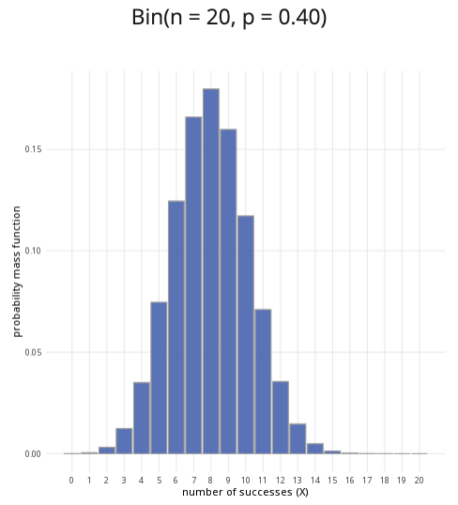

An example of the binomial distribution with $n=20$ and $p=0.4$.

**Where to use:** The binomial distribution is used when there are a fixed number of trials ($n$) and only two possible outcomes for each trial, representing $n$ many Bernoulli trials. Here, the random variable $X$ represents the number of successes.

**Notation: $X∼\text{Binomial}\left(n,p\right)$** or $X∼B\left(n,p\right)$.

**Parameters:** Two numbers $n,p$ where: - $n$ is an integer representing the number of trials, - $p$ is a real number representing the probability of success of a trial (where $0≤p≤1$).

| Quantity | Value | Notes |
| --- | --- | --- |
| **Mean** | $E\left(X\right)=np$ |  |
| **Variance** | $V\left(X\right)=np\left(1−p\right)$ |  |
| **PMF** | $P\left(X=x\right)=\frac{n!}{\left(n−x\right)!x!}p^{x}q^{\left(n−x\right)}$ |  |
| **CDF** | $P\left(X≤x\right)=I_{q}\left(n−⌊x⌋,1+⌊x⌋\right)$ | $I_{x}\left(a,b\right)$ regularized incomplete beta function, $⌊x⌋$ the floor function |

**Example:** You flip a coin $10$ times, and the probability of getting ‘heads’ is $0.5$. Taking ‘heads’ as a success, this can be expressed as $X∼B\left(10,0.5\right)$, meaning $10$ trials are conducted, where the probability of success in each trial is $0.5$.

# Further reading

This interactive element appears in [Guide: PMFs, PDFs, CDFs](../studyguides/pmfspdfscdfs.qmd) and [Overview: Probability distributions.](../overviews/o-distributions.qmd) Please click the relevant links to go to the guides.

## Version history

v1.0: initial version created 04/25 by tdhc and Michelle Arnetta as part of a University of St Andrews VIP project.

* v1.1: moved to factsheet form and populated with material from [Overview: Probability distributions](../overviews/o-distributions.qmd) by tdhc.

[This work is licensed under CC BY-NC-SA 4.0.](https://creativecommons.org/licenses/by-nc-sa/4.0/?ref=chooser-v1)