Factsheet: Chi-squared distribution

Michelle Arnetta and Tom Coleman

Summary

A factsheet for the $χ^{2}$ distribution.

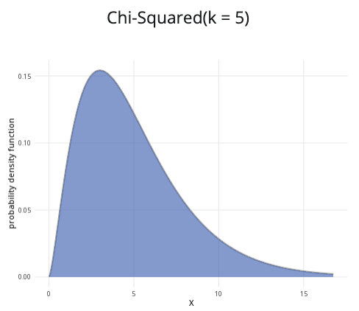

An example of the chi-squared distribution with $k=5$.

**Where to use:** The $χ^{2}$ distribution is used for hypothesis testing, such as for goodness of fit tests and tests for independence. (See [Guide: Introduction to hypothesis testing](../studyguides/hypothesistesting.qmd) for more.) It is a special case of the gamma distribution, as $χ^{2}\left(k\right)=\text{Gam}\left(\frac{k}{2},2\right)$.

**Notation: $X∼χ^{2}\left(k\right)$**

**Parameter:** The integer $k$ is the number of degrees of freedom in the sample.

| Quantity | Value | Notes |
| --- | --- | --- |
| **Mean** | $E\left(X\right)=k$ |  |
| **Variance** | $V\left(X\right)=2k$ |  |
| **PDF** | $P\left(X=x\right)=\frac{x^{\frac{k}{2}−1}exp\left(−\frac{x}{2}\right)}{2^{\frac{k}{2}}Γ\left(\frac{k}{2}\right)}$ | $Γ\left(x\right)$ is the gamma function |
| **CDF** | $P\left(X≤x\right)=\frac{1}{Γ\left(\frac{k}{2}\right)}\text{Gam}\left(\frac{k}{2},\frac{x}{2}\right)$ | $Γ\left(x\right)$ is the gamma function, $\text{Gam}\left(α,θ\right)$ is the PDF of the gamma distribution |

**Examples:**

* **Goodness of fit example:** You have a six-sided die with six possible outcomes: $1,2,3,4,5,$ and $6$. You calculate the expected frequencies of each outcome. Then you roll the die many times and record the observed frequencies of each outcome. Since there are 6 categories,
$$\text{degrees of freedom = number of categories}−1=6−1=5$$

* This can be expressed as $X∼χ^{2}\left(5\right)$, meaning the degrees of freedom is $5$.
* **Test for independence example:** You are investigating whether there is a correlation between two variables: candy colour and flavour. You have $5$ categories of colours and 3 categories of flavours. Calculating the degrees of freedom can be done with the formula:
$$\left(\text{categories of colours}−1\right)\left(\text{categories of flavours}−1\right)=\left(5−1\right)\left(3−1\right)=\left(4\right)\left(2\right)=8.$$

* You can model $X∼χ^{2}\left(8\right)$, meaning that there are $8$ degrees of freedom.

# Further reading

[This interactive element appears in Overview: Probability distributions. Please click this link to go to the guide.](../overviews/o-distributions.qmd)

## Version history

v1.0: initial version created 04/25 by tdhc and Michelle Arnetta as part of a University of St Andrews VIP project.

* v1.1: moved to factsheet form and populated with material from [Overview: Probability distributions](../overviews/o-distributions.qmd) by tdhc.

[This work is licensed under CC BY-NC-SA 4.0.](https://creativecommons.org/licenses/by-nc-sa/4.0/?ref=chooser-v1)