Factsheet: Continuous uniform distribution

Michelle Arnetta and Tom Coleman

Summary

A factsheet for the continuous uniform distribution.

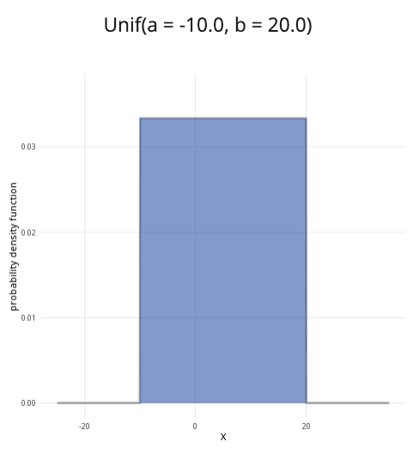

An example of the continuous uniform distribution with $a=−10$ and $b=20$.

**Where to use:** The continuous uniform distribution is used when all continuous values $x$ in the interval $a$ to $b$ are equally likely. The random variable $X$ represents the outcome.

**Notation: $X∼\text{Uniform}\left(a,b\right)$** or $X∼U\left(a,b\right)$.

**Parameters:** Two real numbers $a,b$, where

* $a$ is the minimum value of an outcome,
* $b$ is the maximum value of an outcome.

| Quantity | Value | Notes |
| --- | --- | --- |
| **Mean** | $E\left(X\right)=\frac{a+b}{2}$ |  |
| **Variance** | $V\left(X\right)=\frac{{\left(b−a\right)}^{2}}{12}$ |  |
| **PDF** | $P\left(X=x\right)=\left\{\begin{matrix}\frac{1}{b−a} & \text{if }a≤x≤b \\ 0 & \text{otherwise}\end{matrix}\right.$ |  |
| **CDF** | $P\left(X≤x\right)=\left\{\begin{matrix}0 & \text{if }x<a \\ \frac{x−a}{b−a} & \text{if }a≤x≤b \\ 1 & \text{if }x>b\end{matrix}\right.$ |  |

**Example:** A machine from Cantor’s Confectionery is programmed to chop long candy bars into pieces, each with a length between 30 millimetres to 50 millimetres. Due to variations in the machine, each continuous value between this interval is equally likely. This can be expressed as $X∼U\left(30,50\right)$. It means 30 is the minimum value and 50 is the maximum value, where all continuous values of $X$ for $30≤x≤50$ are equally likely.

# Further reading

This interactive element appears in [Overview: Probability distributions.](../overviews/o-distributions.qmd)

## Version history

v1.0: initial version created 08/25 by tdhc.

[This work is licensed under CC BY-NC-SA 4.0.](https://creativecommons.org/licenses/by-nc-sa/4.0/?ref=chooser-v1)