Factsheet: Discrete uniform distribution

Michelle Arnetta and Tom Coleman

Summary

A factsheet for the discrete uniform distribution.

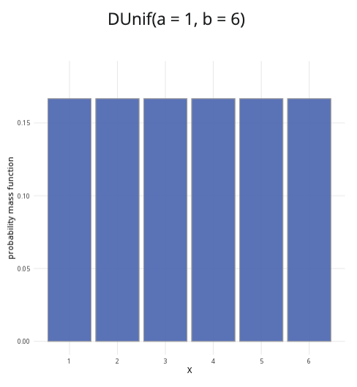

An example of the discrete uniform distribution with $a=1$ and $b=6$.

**Where to use:** The discrete uniform distribution is used when all integer outcomes $x$ in the interval $a$ to $b$ are equally likely. $X$ is a random variable for integer outcomes $x$ where for $a≤x≤b$, and the probability of each outcome $1/n$, where $n=b−a+1$.

**Notation: $X∼\text{Uniform}\left(a,b\right)$** or $X∼U\left(a,b\right)$

**Parameters:** The numbers $a,b$ are integers where

* $a$ is the minimum value of an outcome
* $b$ is the maximum value of an outcome

There are $n$ outcomes in total, with $n=b−a+1$.

| Quantity | Value | Notes |
| --- | --- | --- |
| **Mean** | $E\left(X\right)=\frac{a+b}{2}.$ |  |
| **Variance** | $V\left(X\right)=\frac{n^{2}−1}{12}.$ |  |
| **PMF** | $P\left(X=x\right)=\frac{1}{n}$ |  |
| **CDF** | $P\left(X≤x\right)=\left\{\begin{matrix}0 & \text{if }x≤a \\ \frac{⌊x⌋−a+1}{n} & \text{if }a<x<b \\ 1 & \text{if }x≥b\end{matrix}\right.$ | $⌊x⌋$ is the **floor function** |

**Example:** You roll a fair six-sided die, where all outcomes ( $1,2,3,4,5,$ and $6$) are equally likely. This can be expressed as $X∼U\left(1,6\right)$. It means $1$ is the minimum value and $6$ is the maximum value, where all discrete values of $X$ for $1≤x≤6$ are equally likely.

# Further reading

This interactive element appears in [Overview: Probability distributions.](../overviews/o-distributions.qmd)

## Version history

v1.0: initial version created 08/25 by tdhc.

[This work is licensed under CC BY-NC-SA 4.0.](https://creativecommons.org/licenses/by-nc-sa/4.0/?ref=chooser-v1)