Factsheet: Exponential distribution

Michelle Arnetta and Tom Coleman

Summary

A factsheet on the exponential distribution.

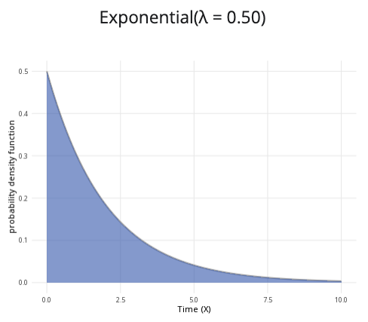

An example of the exponential distribution with $λ=0.5$.

**Where to use:** The exponential distribution is used when $X$ is the waiting time before a certain event occurs. It is similar to the geometric distribution, but the exponential distribution uses a continuous waiting time instead of the integer number of trials.

**Notation: $X∼\text{Exponential}\left(λ\right)$** or $X∼\text{Exp}\left(λ\right)$

**Parameter:** An integer $λ$, representing number of times an event occurs within a specific period of time.

| Quantity | Value | Notes |
| --- | --- | --- |
| **Mean** | $E\left(X\right)=\frac{1}{λ}$ |  |
| **Variance** | $V\left(X\right)=\frac{1}{λ^{2}}$ |  |
| **PDF** | $P\left(X=x\right)=λe^{−λx}$ |  |
| **CDF** | $P\left(X≤x\right)=1−e^{−λx}$ |  |

**Example:** Customers enter Cantor’s Confectionery at an average rate of 20 people per hour, and the time distance between each visit can be modelled by an exponential distribution. This can be expressed as $X∼\text{Exp}\left(20\right)$.

# Further reading

[This interactive element appears in Overview: Probability distributions. Please click this link to go to the guide.](../overviews/o-distributions.qmd)

## Version history

v1.0: initial version created 04/25 by tdhc and Michelle Arnetta as part of a University of St Andrews VIP project.

* v1.1: moved to factsheet form and populated with material from [Overview: Probability distributions](../overviews/o-distributions.qmd) by tdhc.

[This work is licensed under CC BY-NC-SA 4.0.](https://creativecommons.org/licenses/by-nc-sa/4.0/?ref=chooser-v1)