Factsheet: $F$-distribution

Michelle Arnetta and Tom Coleman

Summary

A factsheet for the $F$-distribution.

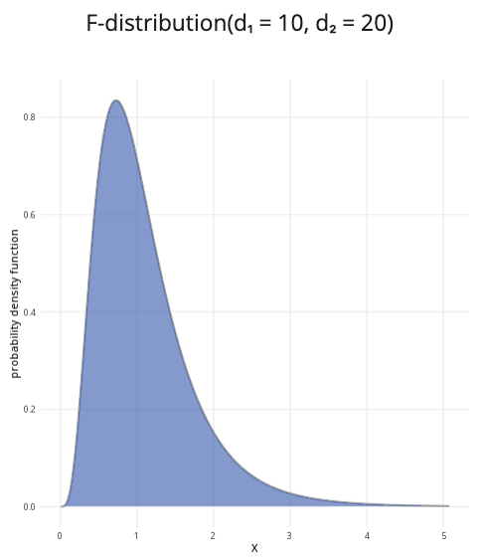

An example of the $F$-distribution with $d_{1}=10$ and $d_{2}=20$.

**Where to use:** The $F$-distribution is used for the ratio $\left(X/d_{1}\right)/\left(Y/d_{2}\right)$ of two independent random $χ^{2}$ variables $X∼χ^{2}\left(d_{1}\right)$ and $Y∼χ^{2}\left(d_{2}\right)$. It is commonly used as a reference distribution in hypothesis testing to compare two variances or more than two means, such as Analysis of Variance (ANOVA) tests.

**Notation: $X∼F\left(d_{1},d_{2}\right)$**

**Parameters:** Two integers $d_{1}$ and $d_{2}$, where - $d_{1}$ degrees of freedom for the random variable $X∼χ^{2}\left(d_{1}\right)$. - $d_{2}$ degrees of freedom for the random variable $Y∼χ^{2}\left(d_{2}\right)$.

| Quantity | Value | Notes |
| --- | --- | --- |
| **Mean** | $E\left(X\right)=\frac{d_{2}}{d_{2}−2}$ | $d_{2}>2$ |
| **Variance** | $V\left(X\right)=\frac{2d_{2}\left(d_{1}+d_{2}−2\right)}{d_{1}{\left(d_{2}−2\right)}^{2}\left(d_{2}−4\right)}$ |  |
| **PDF** | $P\left(X=x\right)=\frac{\sqrt{\frac{{\left(d_{1}x\right)}^{d_{1}}d_{2}^{d_{2}}}{{\left(d_{1}x+d_{2}\right)}^{d_{1}+d_{2}}}}}{x\text{B}\left(\frac{d_{1}}{2},\frac{d_{2}}{2}\right)}$ | $\text{B}\left(x,y\right)$ is the beta function |
| **CDF** | $P\left(X≤x\right)=I_{\frac{d_{1}x}{d_{1}x+d_{2}}}\left(\frac{d_{1}}{2},\frac{d_{2}}{2}\right)$ | $I_{x}\left(a,b\right)$ is the regularized incomplete beta function |

**Example:** You have three independent groups of data containing Cantor’s Confectionery chocolate bar lengths, and the total sample size is 90. From this, you would like to conduct an ANOVA test investigating if there is a statistically significant difference between the means of each group. You can find the degrees of freedom using the following methods:

$\text{numerator degrees of freedom = number of groups}−1=3−1=2$

$\text{denominator degrees of freedom = sample size - number of groups}=90−3=87$

The $F$ distribution, which will be used as a reference distribution for the ANOVA test, can be expressed as $X∼F\left(2,87\right)$, meaning the numerator degrees of freedom is $2$ and the denominator degrees of freedom is $87$.

# Further reading

[This interactive element appears in Overview: Probability distributions. Please click this link to go to the guide.](../overviews/o-distributions.qmd)

## Version history

v1.0: initial version created 04/25 by tdhc and Michelle Arnetta as part of a University of St Andrews VIP project.

* v1.1: moved to factsheet form and populated with material from [Overview: Probability distributions](../overviews/o-distributions.qmd) by tdhc.

[This work is licensed under CC BY-NC-SA 4.0.](https://creativecommons.org/licenses/by-nc-sa/4.0/?ref=chooser-v1)