Factsheet: Geometric distribution

Michelle Arnetta and Tom Coleman

Summary

A factsheet for the geometric distribution.

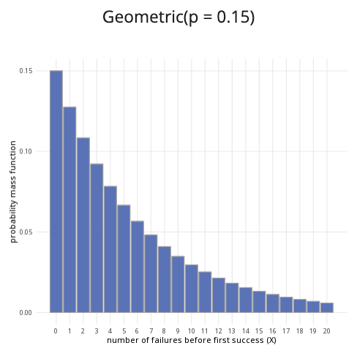

An example of the geometric distribution with $p=0.15$.

**Where to use:** The geometric distribution is used to count $X$, the number of Bernoulli trials until a successful outcome is reached.

**Notation: $X∼\text{Geometric}\left(p\right)$**

**Parameter: $p$** is the real number representing the probability of success in a single trial (where $0≤p≤1$).

| Quantity | Value | Notes |
| --- | --- | --- |
| **Mean** | $E\left(X\right)=\frac{1}{p}$ |  |
| **Variance** | $V\left(X\right)=\frac{1−p}{p^{2}}$ |  |
| **PMF** | $P\left(X=x\right)={\left(1−p\right)}^{k−1}p$ |  |
| **CDF** | $P\left(X≤x\right)=\left\{\begin{matrix}1−{\left(1−p\right)}^{x} & \text{if }x≥0 \\ 0 & \text{if }x<0\end{matrix}\right.$ |  |

**Example:** You flip a coin multiple times, and the probability of getting ‘heads’ is $0.5$. You decide to stop flipping the coin once you get a ‘heads’. Taking ‘heads’ as a success, this can be expressed as $X∼\text{Geometric}\left(0.5\right)$. It means the probability of success is $0.5$, and you will stop conducting trials after you reach a success.

# Further reading

[This interactive element appears in Overview: Probability distributions. Please click this link to go to the guide.](../overviews/o-distributions.qmd)

## Version history

v1.0: initial version created 04/25 by tdhc and Michelle Arnetta as part of a University of St Andrews VIP project.

* v1.1: moved to factsheet form and populated with material from [Overview: Probability distributions](../overviews/o-distributions.qmd) by tdhc.

[This work is licensed under CC BY-NC-SA 4.0.](https://creativecommons.org/licenses/by-nc-sa/4.0/?ref=chooser-v1)