Factsheet: Lognormal distribution

Michelle Arnetta and Tom Coleman

Summary

A factsheet for the lognormal distribution.

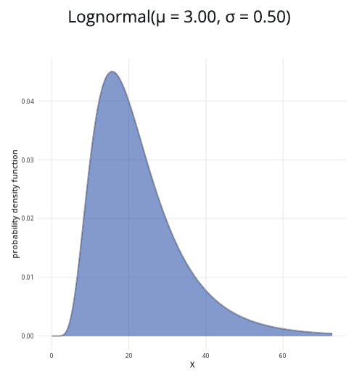

An example of the lognormal distribution with $μ=3$ and $σ=0.5$.

**Where to use:** The lognormal distribution is used to model continuous random variables with values that are both real and non-negative, wherein the logarithms of these variables follow a normal distribution. That is to say, if the random variable $X$ is lognormally distributed, then the random variable $Y=ln\left(X\right)$ is normally distributed (where $ln$ is the natural logarithm).

**Notation: $X∼\text{Lognormal}\left(μ,σ^{2}\right)$**

**Parameters:** As with the normal distribution, two numbers $μ$ and $σ^{2}$ where:

* $μ$ is the expected value of the normally distributed random variable $Y=ln\left(X\right)$,
* $σ^{2}$ is the variance of the normally distributed random variable $Y=ln\left(X\right)$.

| Quantity | Value | Notes |
| --- | --- | --- |
| **Mean** | $E\left(X\right)=exp\left(μ+\frac{σ^{2}}{2}\right)$ | $exp\left(y\right)=e^{y}$ |
| **Variance** | $V\left(X\right)=\left[exp\left(σ^{2}\right)−1\right]exp\left(2μ+σ^{2}\right)$ | $exp\left(y\right)=e^{y}$ |
| **PDF** | $P\left(X=x\right)=\frac{1}{xσ\sqrt{2π}}exp\left(−\frac{{\left(ln\left(x\right)−μ\right)}^{2}}{2σ^{2}}\right)$ | $exp\left(y\right)=e^{y}$ |
| **CDF** | $P\left(X≤x\right)=\frac{1}{2}\left[1+\text{erf}\left(\frac{ln\left(x\right)−μ}{σ\sqrt{2}}\right)\right]$ | $\text{erf}\left(x\right)$ is the error function of $x$ |

**Example:** The logarithms of Cantor’s Confectionery’s stock prices follow a normal distribution. The mean of the stock prices’ natural logarithms is $8.01$, whereas the variance of the stock prices’ natural logarithms is $3$. This can be expressed as $X∼\text{Lognormal}\left(8.01,3\right)$, meaning the logarithm of the location parameter is $8.01$ and the logarithm of scale parameter is $3$.

# Further reading

[This interactive element appears in Overview: Probability distributions. Please click this link to go to the guide.](../overviews/o-distributions.qmd)

## Version history

v1.0: initial version created 04/25 by tdhc and Michelle Arnetta as part of a University of St Andrews VIP project.

* v1.1: moved to factsheet form and populated with material from [Overview: Probability distributions](../overviews/o-distributions.qmd) by tdhc.

[This work is licensed under CC BY-NC-SA 4.0.](https://creativecommons.org/licenses/by-nc-sa/4.0/?ref=chooser-v1)