Factsheet: Normal distribution

Michelle Arnetta and Tom Coleman

Summary

A factsheet for the normal distribution $N\left(μ,σ^{2}\right)$.

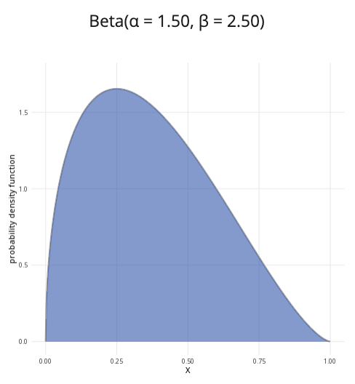

An example of the normal distribution with $μ=0$ and $σ=1$.

**Where to use:** The normal distribution is used to model continuous random variables, which can include any positive or negative real values. The use of this distribution is often justified by the Central Limit Theorem: as the sample size increases, the distribution of sample means will resemble a normal distribution more and more closely.

**Notation: $X∼\text{Normal}\left(μ,σ^{2}\right)$** or $X∼N\left(μ,σ^{2}\right)$

**Parameters:** Two real numbers $μ$ and $σ^{2}$.

* $μ$ is the centre of the distribution (the mean/expected value).
* $σ^{2}$ is the measure of how the distribution is spread (the variance).

| Quantity | Value | Notes |
| --- | --- | --- |
| **Mean** | $E\left(X\right)=μ$ |  |
| **Variance** | $V\left(X\right)=σ^{2}$ |  |
| **PDF** | $P\left(X=x\right)=\frac{1}{\sqrt{2πσ^{2}}}exp\left(−\frac{{\left(x−μ\right)}^{2}}{2σ^{2}}\right)$ | $exp\left(y\right)=e^{y}$ |
| **CDF** | $P\left(X≤x\right)=\frac{1}{2}\left[1+\text{erf}\left(\frac{x−μ}{σ\sqrt{2}}\right)\right]$ | $\text{erf}\left(x\right)$ is the error function of $x$ |

**Example:** The lengths of chocolate bars produced by Cantor’s Confectionery follow a normal distribution with a mean of $5.6$ inches and a variance of $1.44$. This can be expressed as $X∼N\left(5.6,1.44\right)$, meaning the data is normally distributed, centered at $5.6$ with standard deviation $\sqrt{1.44}=1.2$.

# Further reading

This interactive element appears in [Guide: PMFs, PDFs, CDFs](../studyguides/pmfspdfscdfs.qmd) and [Overview: Probability distributions.](../overviews/o-distributions.qmd) Please click the relevant links to go to the guides.

## Version history

v1.0: initial version created 04/25 by tdhc and Michelle Arnetta as part of a University of St Andrews VIP project.

* v1.1: moved to factsheet form and populated with material from [Overview: Probability distributions](../overviews/o-distributions.qmd) by tdhc.

[This work is licensed under CC BY-NC-SA 4.0.](https://creativecommons.org/licenses/by-nc-sa/4.0/?ref=chooser-v1)