Factsheet: Poisson distribution

Michelle Arnetta and Tom Coleman

Summary

A factsheet for the Poisson distribution.

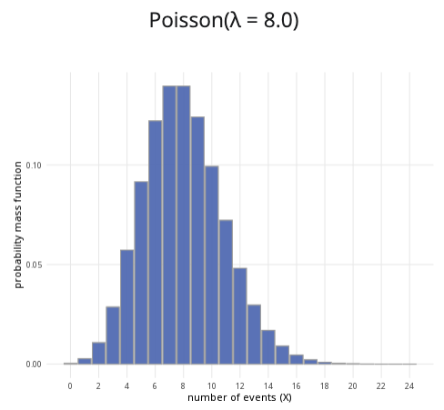

An example of the Poisson distribution with $λ=8$.

**Where to use:** The Poisson distribution is used when a specific event occurs at some rate $λ$, and you are counting $X$, the number of times this event occurs in some interval.

**Notation: $X∼\text{Poisson}\left(λ\right)$** or $X∼\text{Pois}\left(λ\right)$.

**Parameter: $λ$** is the integer number of times an event occurs within a specific period of time.

| Quantity | Value | Notes |
| --- | --- | --- |
| **Mean** | $E\left(X\right)=λ$ |  |
| **Variance** | $V\left(X\right)=λ$ |  |
| **PMF** | $P\left(X=x\right)=\frac{λ^{x}e^{−λ}}{x!}$ |  |
| **CDF** | $P\left(X≤x\right)=\sum_{i=1}^{⌊x⌋}{\frac{λ^{x}e^{−λ}}{x!}}$ | $⌊x⌋$ the floor function |

**Example:** Customers enter Cantor’s Confectionery at an average rate of 20 people per hour, and you want to see the likelihood that $X$ number of customers walks in. This can be expressed as $X∼\text{Pois}\left(20\right)$.

# Further reading

[This interactive element appears in Overview: Probability distributions. Please click this link to go to the guide.](../overviews/o-distributions.qmd)

## Version history

v1.0: initial version created 04/25 by tdhc and Michelle Arnetta as part of a University of St Andrews VIP project.

* v1.1: moved to factsheet form and populated with material from [Overview: Probability distributions](../overviews/o-distributions.qmd) by tdhc.

[This work is licensed under CC BY-NC-SA 4.0.](https://creativecommons.org/licenses/by-nc-sa/4.0/?ref=chooser-v1)