Questions: Trigonometry (radians)

Dzhemma Ruseva, Ellie Gurini, Ciara Cormican

Summary

A selection of questions on trigonometry, where angles are measured in degrees.

*Before attempting these questions, it is recommended that you read* [*Guide: Trigonometry (radians)*](../studyguides/trigonometry-radians.qmd)

## Q1

You are given the triangle below.

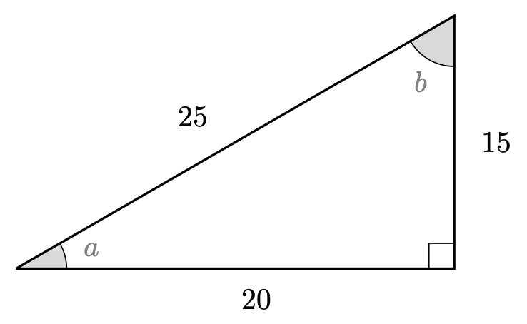

Q1. Triangle

Find $cos$, $sin$ and $tan$ of both $a$ and $b$.

## Q2

Using the triangle below, solve the following equations.

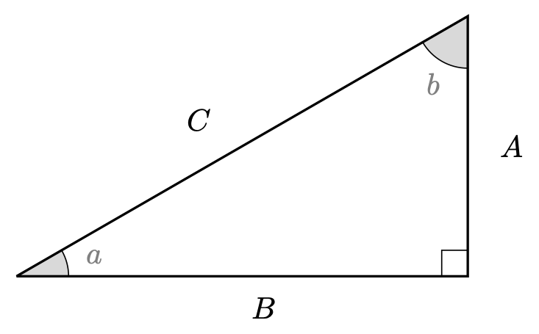

Q2. Triangle

2.1. If angle $a$ is $π/6$ and $B=6$, what length is $C$?

2.2. If angle $b$ is $π/4$ and $C=2\sqrt{2}$, what length is $A$?

2.3. If angle $a$ is $π/12$ and $C=7$, what length is $A$?

2.4. If angle $b$ is $π/6$ and $C=2\sqrt{2}$, what length is $A$?

2.5. If angle $a$ is $π/4$ and $B=8$, what length is $A$?

2.6. If angle $a$ is $π/3$ and $A=8$, what length is $B$?

## Q3

Without using a calculator if possible, give the values of the following expressions.

3.1. $cos\left(π/6\right)$

3.2. $tan\left(π/6\right)$

3.3. $csc\left(π/4\right)$

3.4. $cot\left(π/6\right)−sin\left(π/3\right)$

3.5. $sin\left(π/2\right)+cos\left(π\right)$

3.6. $tan\left(π/6\right)−cot\left(π/6\right)$

3.7. $cos\left(0\right)sin\left(π/2\right)$

3.8. $cos\left(π/6\right)sec\left(π/6\right)−sin\left(π/4\right)csc\left(π/4\right)$

3.9.

[After attempting the questions above, please click this link to find the answers.](../answers/as-trigonometry-radians.qmd)

## Version history and licensing

v1.0: initial version created 08/23 by Dzhemma Ruseva, Ellie Gurini, Ciara Cormican as part of a University of St Andrews STEP project.

* v1.1: edited 05/24 by tdhc, and split into versions for both degrees and radians.

[This work is licensed under CC BY-NC-SA 4.0.](https://creativecommons.org/licenses/by-nc-sa/4.0/?ref=chooser-v1)