Introduction to partial differentiation

Donald Campbell

Summary

Partial differentiation is a key technique used in calculus for dealing with functions of multiple variables. It focuses on how a function changes with respect to one variable while keeping others constant. It is widely used in physics, economics, and engineering to analyse systems involving multiple changing factors, such as in heat flow or optimization.

*Before reading this guide, it is recommended that you read* [*Guide: Introduction to differentiation and the derivative*](introtodifferentiation.qmd)*,* [*Guide: The chain rule*](chainrule.qmd)*,* [*Guide: The product rule*](productrule.qmd)*, and* [*Guide: The quotient rule*](quotientrule.qmd)*.*

# What is partial differentiation?

As explained in [Guide: Introduction to differentiation and the derivative](introtodifferentiation.qmd), a derivative measures how a function changes as its input changes. For example, if you have a function , the derivative describes the rate at which changes with respect to .

However, in many real-world examples, functions depend on more than one variable. For example, weather prediction involves functions that depend on pressure, humidity and time. In economics, profit might depend on both price and production level. The process of **partial differentiation** is essential if you want to understand the influence of each variable separately.

For a function that depends on two variables and , partial differentiation allows you to study the change in by considering the change in one variable at a time. If you choose to study the change in by considering the change in , you need to hold fixed. In this case, is treated as a constant as it doesn’t change during this process.

This guide explains the idea of partial differentiation and how it is different from standard single-variable differentiation. It will explain how to find partial derivatives, the concept of second-order partial derivatives, and how to partially differentiate a function with any finite number of variables.

# Definition of the partial derivative

Consider a surface (some bumpy terrain) shown in the 3D graph below. A surface can be defined as a function of and . This means that for any values of and , the function returns a value representing the height of the surface at the point .

A partial derivative measures how the surface changes in a single direction while keeping the other variable constant. To understand how the surface changes with respect to , fix a value of , say . The surface is a function of and , but when the surface reduces to a curve in the -plane. This shows how the height depends on alone when is fixed at .

The 3D graph illustrates the surface with a vertical plane slicing through it at a chosen value of . The points where the plane intersects the surface form a curve which is shown in yellow on the 3D graph. This curve is also shown separately on the -plane in the 2D graph.

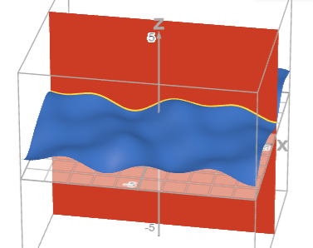

Plot of the surface (blue), the vertical plane, and the curve (yellow) at the intersection points of the surface and plane.

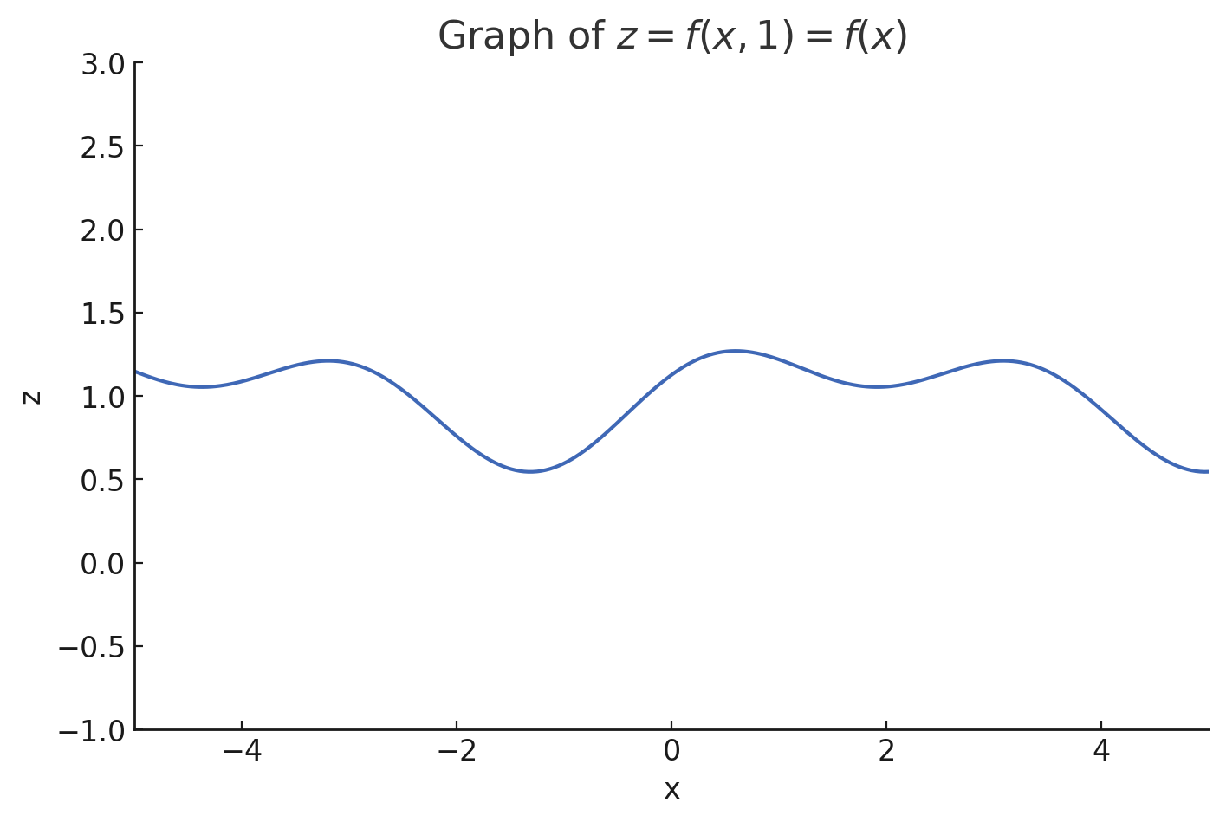

Plot of .

Imagine you are following a path across a bumpy terrain where you don’t change direction. As you go up and down the hills and valleys, you will trace out a curve that shows how the height changes along that path. The slope of this curve at any point tells you how steeply the surface is rising or falling in that direction. This is what the partial derivative measures.

As seen in [Guide: Introduction to differentiation and the derivative](introtodifferentiation.qmd), you can approximate the gradient of this function at a point by looking at how much the function’s value changes over a small step. By fixing and observing how the function changes with respect to , you’re treating the surface as a single-variable function. The slope of the curve at a point gives the partial derivative with respect to , evaluated at that value of .

|  |
| --- |
| Definition of the partial derivative |
| For a function , the **partial derivative with respect to** is written as  It is defined by the limit  This definition is similar to that of single-variable differentiation, with the key difference that  **is treated as a constant during the process**.  Similarly, the **partial derivative with respect to** is defined by the limit  When differentiating with respect to some variable, **all other variables are held fixed (they do not change) and they should be treated as you would normally treat constants**.  You may sometimes see the notation to mean the partial derivative of with respect to . |

|  |
| --- |
| Important |
| Partial derivatives are **always** written using a curly as opposed to a straight as in single-variable differentiation.  An important distinction is that if a function depends only on , then as there is no other variable to hold fixed. |

# Finding partial derivatives

To find a partial derivative, start by identifying the variable you want to differentiate with respect to. For example, if you want to find the partial derivative of with respect to , treat as the variable to differentiate with respect to.

The golden rule of partial differentiation is as follows:

|  |
| --- |
| Golden rule of partial differentiation |
| When differentiating with respect to some variable, **treat all other variables as constants**. |

If required, apply any rules of differentiation such as the sum/difference rule, chain rule, product rule or quotient rule. These rules from single-variable differentiation still apply to partial differentiation, but they must be applied with respect to the chosen variable only and (again) you must treat all other variables as constants. This can involve a lot of lengthy working, so take your time, especially when combining multiple rules.

For a reminder on how to apply these techniques, please see [Guide: Introduction to differentiation and the derivative](introtodifferentiation.qmd), [Guide: The chain rule](chainrule.qmd), [Guide: The product rule](productrule.qmd), and [Guide: The quotient rule](quotientrule.qmd).

|  |  |
| --- | --- |
|  | **Example 1**  Consider the function .  To find the partial derivative with respect to , first differentiate with respect to using the power rule to get . Importantly, the term is a constant with respect to so its partial derivative with respect to is . So:  To find the partial derivative with respect to , first differentiate with respect to using the power rule to get . Importantly, the term is a constant with respect to so its partial derivative with respect to is . |

|  |  |
| --- | --- |
|  | **Example 2**  Consider the function .  To find the partial derivative with respect to , first differentiate with respect to to get . Now differentiate with respect to to get . Once again, is treated as a constant.  To find the partial derivative with respect to , first differentiate with respect to to get . Now differentiate with respect to to get . Notice that in this case, is treated as a constant. |

|  |  |
| --- | --- |
|  | **Example 3**  Consider the function .  Start by finding the partial derivative with respect to . Notice that is a product of the two functions and . You need to use the product rule to differentiate the product with respect to . Then, you need to differentiate with respect to using the chain rule. Remember to treat as a constant.  Now find the partial derivative with respect to . Notice that is a product of the two functions and however only the second function is a function of . Therefore, this doesn’t require the product rule to differentiate as is treated as a constant. The second function still requires you to use the chain rule. |

# Higher-order partial derivatives

As with single-variable functions, you can take partial derivatives of partial derivatives to get **second-order partial derivatives**. For a function of two variables , there are **four** second-order partial derivatives, one for each combination of variables.

|  |
| --- |
| Second-order partial derivatives |
| Much like in differentiation in a single variable, second-order partial derivatives are the partial derivatives of first-order partial derivatives.  For a function of two variables and , the **pure second-order partial derivatives** are defined as:  To compute a pure second-order partial derivative, you need to differentiate a first-order partial derivative with respect to the same variable again.  For a function of two variables and , the **mixed second-order partial derivatives** are defined as:  To compute a mixed second-order partial derivative, you need to differentiate a first-order partial derivative with respect to a different variable. |

|  |
| --- |
| Warning |
| The order in which the subscript variables are written above is not a typo! For the two notation systems, there are different conventions for denoting the order in which differentiation occurs. |

Under certain conditions, the mixed second-order partial derivatives are equal. This is called *Schwarz’s Theorem*.

|  |
| --- |
| Schwarz’s theorem |
| If and are continuous and differentiable, then |

Please see [Guide: Introduction to continuity] and [Guide: Introduction to differentiability] for more detailed analyses of what makes functions continuous and differentiable.

|  |  |
| --- | --- |
|  | **Example 4**  Consider the function .  The first-order partial derivatives are given by  The second-order partial derivatives can be calculated from the first-order partial derivatives.  Notice that *Schwarz’s Theorem* holds as the first-order partial derivatives are continuous and differentiable and |

# Functions of more than two variables

Partial differentiation is not limited to functions of two variables. Many real-world problems involve functions of many more variables. For example, the temperature in a room might depend on position and time .

In general, if , you can compute the partial derivative of with respect to any one variable by treating all other variables as constants.

|  |
| --- |
| Definition of the partial derivative for functions of variables |
| For a function of variables, the **partial derivative with respect to** is denoted by  It is defined by the limit  This is a natural extension of the two-variable case from before. When differentiating with respect to , all other variables are held fixed. |

|  |  |
| --- | --- |
|  | **Example 5**  Consider the function .  As an example, to find the first-order partial derivative with respect to , you need to differentiate with respect to while holding , and constant.  The first-order partial derivatives are given by  You can also calculate various higher order partial derivatives for each variable by taking partial derivatives of these first-order partial derivatives. |

# Quick check problems

1. Consider the function . Determine whether the following statements are true or false.
2. The partial derivative with respect to is given by .
3. The partial derivative with respect to is given by .
4. Let . Which of the following best describes ?
5. Suppose . Find the mixed partial derivative .
6. Consider the function . Which rule(s) do you need to compute ?
7. If , find .

# Further reading

[For more questions on the subject, please go to Questions: Introduction to partial differentiation.](../questions/qs-introtopartialdifferentiation.qmd)

[For a way to differentiate functions of more than one variable, please see Guide: Multivariate chain rule.](multivariatechainrule.qmd)

## Version history

v1.0: initial version created 05/25 by Donald Campbell as part of a University of St Andrews VIP project.

[This work is licensed under CC BY-NC-SA 4.0.](https://creativecommons.org/licenses/by-nc-sa/4.0/?ref=chooser-v1)