Introduction to logarithms

Ritwik Anand

Summary

Using logarithms to help understand large numbers is a fundamental skill when working in mathematics. Understanding the laws of logarithms, working with the natural logarithm and learning how to change the base of a logarithm are key in mastering their functionality.

*Before reading this guide, it is recommended that you read* [*Guide: Laws of indices*](lawsofindices.qmd)*.*

# What are logarithms?

In the same way that subtraction ‘undoes’ addition, and division ‘undoes’ multiplication, you can think of the logarithm as the function that ‘undoes’ exponentiation. Logarithms are useful because they essentially let you work backwards through a calculation by undoing exponential effects. Furthermore, logarithms allow you to express large numbers in a convenient way, as well as model various phenomena as they occur in a logarithmic fashion. An example would be a hot object cooling down; this cools down logarithmically.

In this guide, you will learn the definition of a logarithm, the laws concerning logarithms, what the natural logarithm is and finally, how to change the base of a logarithm.

|  |
| --- |
| Definition of a logarithm |
| In its simplest form, a logarithm answers ‘How many of one number multiply together to make another number?’. This is what motivates the following definition:  If  then  where and . Here, is known as the *exponent*, is the *base* and is the *argument*. You would read the equation above as “logarithm of to the base is equal to ”. |

Note that the logarithm function can only evaluate **real, positive numbers**. Therefore, **you cannot compute the logarithm of a number that is less than or equal to** .

|  |  |
| --- | --- |
|  | **Example 1**  Suppose you are given the equation , and you need to find . You can rewrite the equation as , and from here, you can see that . |

|  |  |
| --- | --- |
|  | **Example 2**  Now consider the equation . Rewriting this, you can see that this is equal to . Therefore . |

Generally, if the base is not specified, it is assumed that the base is . For example, means that the logarithm of to the base is equal to .

|  |  |
| --- | --- |
|  | **Example 3**  Consider the equation from Example 1. This can be rewritten as , and the solution for is once again . |

That being said, it is good practice to always specify the base of the logarithm that you are using.

Following from the definition of a logarithm, you can make two key observations.

|  |
| --- |
| Inverse of a logarithm |
| The logarithm of an exponential where the base is equal to the base of the logarithm is equal to the exponent. |

|  |
| --- |
| Inverse of an exponent |
| Raising a logarithm of a number to its own base is equal to the number itself. |

The results above are equivalent to the definition of the logarithm, and are often used. You should remember these results!

# Laws of logarithms

Following on from the laws of indices, there are several rules of logarithms that allows you to expand, condense and solve logarithmic equations. For this section, assume that is a positive real number with .

|  |
| --- |
| Law 1: product rule |
| The logarithm of a product is the sum of the logarithms of the factors. |

|  |  |
| --- | --- |
|  | **Example 4**   1. . |

|  |
| --- |
| Law 2: quotient rule |
| The logarithm of a ratio of two numbers is equal to the logarithm of the **numerator** minus the logarithm of the **denominator**. |

|  |  |
| --- | --- |
|  | **Example 5**   1. . |

|  |
| --- |
| Law 3: power rule |
| The logarithm of an exponential number is the exponent multiplied with the logarithm of the base. |

|  |  |
| --- | --- |
|  | **Example 6**   1. Using the laws of indices, .   (You can compare 2. to Example 4 (2) above!) |

|  |
| --- |
| Law 4: zero rule |
| The logarithm of 1 to any base is **always** equal to 0.  This is true as  using the definition of the logarithm. |

|  |  |
| --- | --- |
|  | **Example 7** |

|  |
| --- |
| Law 5: identity rule |
| The logarithm of the argument, where the argument is equal to the base of the logarithm, is **always** equal to 1.  This is true as  for all positive real numbers and by also using the definition of the logarithm. |

|  |  |
| --- | --- |
|  | **Example 8**  For instance, and . |

# The natural logarithm

To learn about the natural logarithm, you first need to know of **Euler’s number**.

|  |
| --- |
| Euler’s number |
| **Euler’s number**, denoted *e*, is an irrational mathematical constant that is approximately equal to 2.718281828… |

Much like , the decimal representation of never repeats itself; it is an **irrational number**. Euler’s number appears naturally in various phenomena involving exponential growth and decay; as well as in important mathematical settings such as calculus and dealing with complex numbers. It is one of the most important mathematical constants yet discovered.

Now, the natural logarithm is a mathematical function used to study problems specifically involving exponential growth and decay. Unlike the logarithms you encountered above, this logarithm always has as its base.

|  |
| --- |
| The natural logarithm |
| The **natural logarithm**, often denoted , is . |

The natural logarithm shares the same domain as the logarithms above, namely that it only evaluates **positive, real** numbers. All of the laws from above apply to the natural logarithm as well.

|  |  |
| --- | --- |
|  | **Example 9**  Suppose you are given the equation and asked to find .  Using the definition of a natural logarithm, you can show that . Then, using the definition of a logarithm, you can conclude that . |

The natural logarithm is useful as it is the **inverse** of the exponential function . A graph of the natural logarithm, as well as its corresponding exponential curve, is shown in Figure 1.

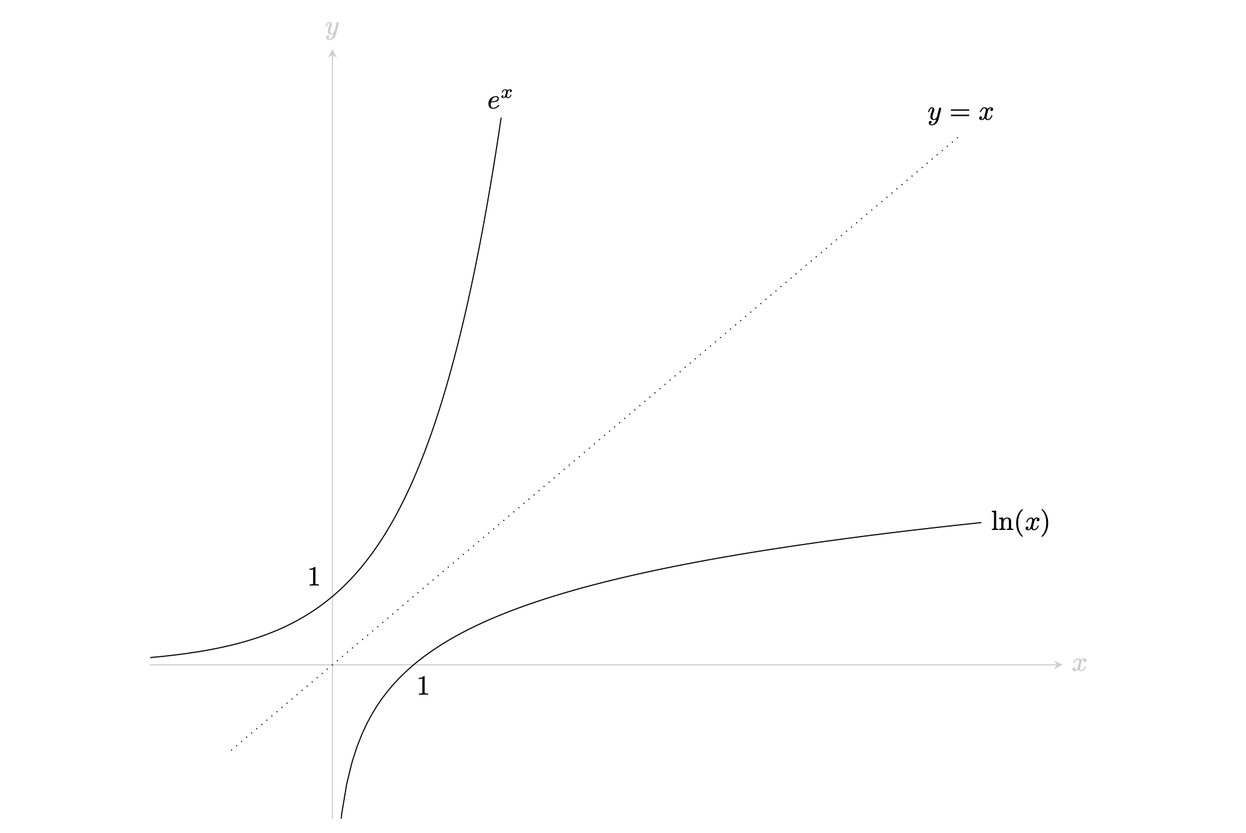

A graph that shows the natural logarithm , along with the curve. Each curve is a reflection of the other in the line , making them inverses of each other. Note that only takes positive values, and is undefined for .

|  |  |
| --- | --- |
|  | **Example 10**  Say that you’ve been given the equation , and you need to solve for . Taking the natural logarithm on both sides of the equation gives you  Now, using Law 3, you can write the equation as  From here, dividing both sides by results in  However, you know from the definition of the logarithm that . Finally, by the inverse of a logarithm rule.  Therefore, . |

# Changing bases of logarithms

Changing the base of a logarithm can be done for a variety of reasons. A few common reasons might be:

* **Familiarity**: Sometimes, changing the base of a logarithm can make calculations more familiar. For example, working with base logarithms is common in many areas of engineering, physics and chemistry, as they allow for simpler calculations by working with powers of .
* **Solving equations**: Changing the base of a logarithm can sometimes help make a calculation simpler. You could change the base in order to work in a base that suits the problem at hand better. An example would be wanting to work with the natural logarithm when working on problems involving Euler’s number.
* **Using calculators**: Some calculators may only allow logarithms of base or the natural logarithm to be computed. For this reason, it is important to know how to write out logarithms of any base into one that is required for use.

|  |
| --- |
| Change of base rule |
| Changing the base of any logarithm can be done by using the following formula  where   * is the argument (which cannot be negative) * is the original base, where . * is the new base, where and .   You can note that by multiplying by , you can recover an alternative formula for the change of base rule with as the argument:  Using either form of the change of base rule is allowed! |

|  |  |
| --- | --- |
|  | **Example 11**  You are asked to work out .  Using the change of base rule, and the fact that you can write to mean , you can write that:  Using the inverse of a logarithm rule, you can work out that . Therefore, the equation above simplifies to  Putting this into a calculator gives |

# Quick check problems

1. What is the value of ?
2. What is the value of ?
3. Determine whether the following can be evaluated:
4. ?
5. ?
6. ?
7. Let with . Rewrite as where and are constants. What are the values of and ?

# Further reading

[For more questions on the subject, please go to Questions: Introduction to logarithms.](../questions/qs-logarithms.qmd)

## Version history and licensing

v1.0: initial version created 08/23 by Ritwik Anand as part of a University of St Andrews STEP project.

* v1.1: edited 04/24 by tdhc.
* v1.2: addition of interactive Desmos figures 04/25 by tdhc.
* v1.3: slight modification of change of base rule 09/25 by tdhc.

[This work is licensed under CC BY-NC-SA 4.0.](https://creativecommons.org/licenses/by-nc-sa/4.0/?ref=chooser-v1)