Intro to ML

PS3 Report

Name: Timothy Horrell

ID: 4475990

Questions:

1. .
   1. Feature matrix size: (100, 3)

Label vector size: (100, 1)

* 1. .

**ps3-1-b.png**

* 1. .
  2. The figure appears to reach 0.9 at an input value of 2.

**ps3-1-c.png**

* 1. Cost J for the toy data set: 1.127
  2. Optimal Theta Parameters:

Theta0: -25.07

Theta1: 0.206

Theta2: 0.197

Cost at convergence: 0.207

* 1. .

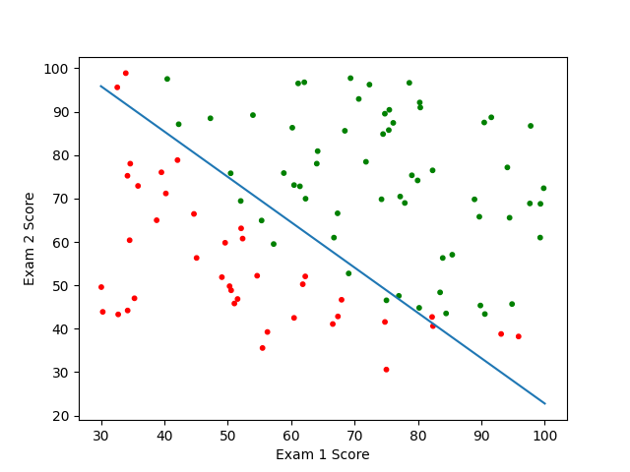

**ps3-1-f.png**

* 1. Accuracy = 80%
  2. Admission probability: 0.544

Admission Decision: yes

1. .
   1. Theta0: 2.19 x 10^5

Theta1: -7.76 x 10^2

Theta2: 1.06 x 10^1

* 1. Image Output:

**ps3-2-b.png**