MGH Sheep Protocol
Reach out to Brian before the study and make sure the dash monitor is free!!
Ask staff if MGH dash monitor can be used for monitoring ECG
Remember to book relevant materials on lab google calendars
Charge devices and free SD memory

Materials checklist:
Book relevant materials on google calendars
Computational cart:
- suture graft materials for access
- IVUS machine
- EM station
- EM emitter
- Mitra clip
- Anthony lab EM tracker stand
- PIM module
- USB splitter
- pullback device
- pullback device power chord
- pullback device USB cable
- dash monitor cable
- computer
- computer monitor facing out
- computer charger
- frame grabber
- optional: frame grabber for fluoro
- mouse
- keyboard
- supply boxes
- dash monitor
- camera
- camera stand
- iPhone stand
- tape
- marker for drawing on fluoro screen
- second cart for monitor (for now)
- lighter
- beaker
- scissors
- screwdriver
- supply boxes
- barbell weights
- guidewires consolidated in box sizes
- M6 wrench
- towel
- dryseal

supplies:
- printed protocol
- barbell weights
- IVUS + EM catheters
- steerable EM catheter
- steerable catheter
- computer monitor
- guiding catheters
- dryseal
- dilators
- hemostatic valve
- guidewires
- contrast agent
- saline
- stents
- puffing catheters
- surgical drapes
- ECG electrodes
- syringes for contrast agent injection
- check that there’s no other materials in protocol below that are referenced
- gore tex dacron graft

Room Setup:

Electronics setup:
- setup power strip
- Position EM tracker at level of pig’s abdomen (where we want tracking to be most accurate)
- Place a barbell on EM tracker stand
- Give warning to team and animal facility staff not to move EM tracker stand

Camera setup:
- Ensure iPhone is set to record at 60fps
- Ensure Nikon camera is set to 25 fps, long lens, place very up close on high stand [ ]
- Setup camera looking at fluoro screen and surgeon + fluoro + IVUS [ ]
- Ensure fluoro machine is in record mode / connect a frame grabber
- Station camera with view of operator, C-arm, ultrasound 3D display, ECG signal, pullback device, and possibly EM tracker stand
- station other camera / iPhone to record fluoro screen

Tool prep:

- Have mapping catheter and pullback catheter in easy to access positions [ ]
- Tape reference point on wire [ ]

Computer setup:
- Have deformation registration directory also open for troubleshooting
- ensure correct calibration file loaded for catheter [ ]
- ensure correct ML model loaded [ ]
- presave data directories on computer and load preop directories
- activate frame grabber, ensure aortascope working
- (optional) connect frame grabber to fluoro machine

Protocol (pig arrives):
Take pictures of every step

Capture ECG signal:
- ensure electrodes are on bony / flat parts of body ideally
- don’t need middle one, just LA RA LL RL
- LA and RA should be at the level of shoulder above arms – ask Jawad
- LL and RL should be above the hip
- Place 5th over the xiphoid (bottom of sternum)
- connect to dash monitor
- Pick any working lead if possible

Gaining access:

11Fr accepts the endoanchor catheter! - if the endoanchor IVUS breaks, just cut the the IVUS probe and use it as a normal cannulation catheter
Decide 0.018 catheter (12 Fr – very possibly 10Fr) or 0.035 catheter (16Fr) before procedure based on CT imaging – will not be able to navigate with mitra clip or use long sliding protective 12Fr sheath inside 16Fr in 12 Fr case – need to be in sheep or accept abdominal only
options:
1) femoral / iliac access (preferred 11 Fr)
- Identify common femoral artery from femoral vein – pulsatility, collapsibility, doppler pulsatile flow, turn probe 90 degrees to infer direction, femoral enlarges when you apply pressure to the abdomen, look at CT scan, look for below aortic and iliac bifurcation, be conscious of trifurcation vessels

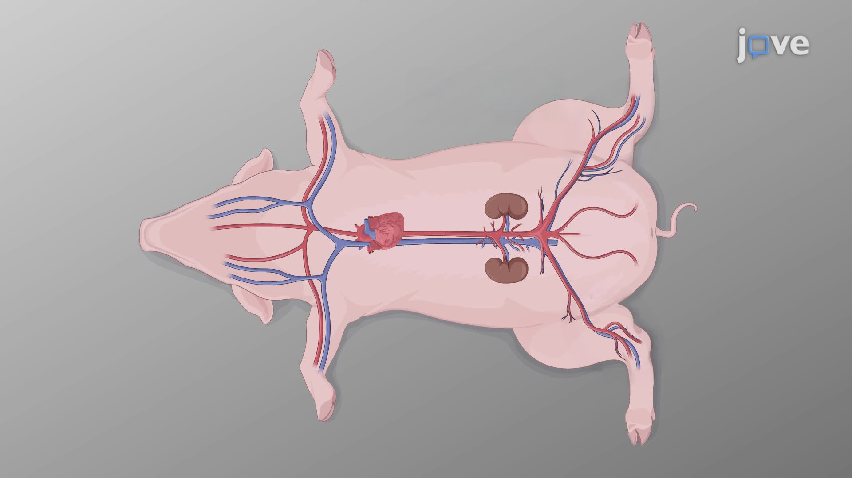

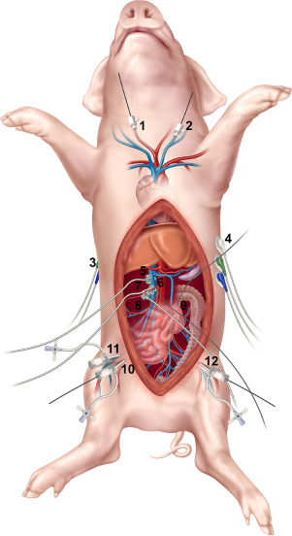

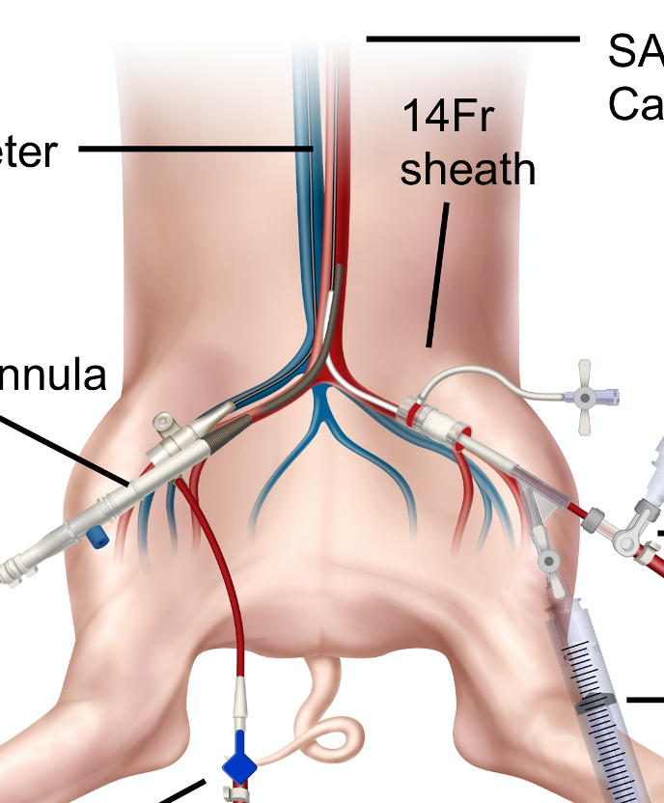

- Use fluoroscopic guidance puff on the contralateral limb and surgical tool placed on pig to identify common femoral artery
- Ideally vessel diameter is ~6.5mm
- Use vessel puncture kit at 45 degrees 18G needle 0.035 seldinger to gain femoral access
- Feed 0.014” wire in (compatible with steerable system)
- make a small 10mm skin incision
- Exchange puncture kit for dilator inside a sheath
- make sure sheath is bent around trifurcation so IVUS doesn’t have to
- Remove dilator
- suture sheath to skin
- Limb can become ischemic
2) Try the other femoral
3) sew graft onto iliac, ligate graft and tunnel to the groin
If its a 30-40kg, you’ll almost certainly need to open the abdominal cavity, cut through peritoneum and expose the iliacs. Otherwise you’ll need to tunnel a graft to the groin
Keep the ureters intact

4) cut down to distal abdominal aorta
- laporotomy – move intestines - be careful not to cut the ureters

Initializing IVUS:
- Feed in IVUS 0.018” over 0.014” wire
- Check initial imaging quality and tune gains as necessary
  - If vessel diameter too big at first glance, switch to 0.035” IVUS inside 16Fr only for rest of the study
- Even if sheep - push the catheter up to the base of the aortic arch, and do a quick pullback data collection of the abdominal aorta to ensure at least one dataset gets collected (do arch reg experiment later)

Navigating aortic arch – approach 1 (easy approach) – use precurved guiding catheter
- Feed a guiding catheter over the wire and navigate it up to the base of the aortic arch
- Using fluoroscopy as guidance, rotate the guiding catheter to point in the direction of the aortic arch and pass an 0.018” or 0.014” wire through until it reaches the base of the aortic root
  - inject a puff of contrast if aortic root direction is unclear, take a picture for paper
- Remove the guiding catheter
- Test to see if the IVUS catheter can be feed around the aortic arch with minimal force without entering the head branches

Navigating aortic arch – approach 2 (easy approach) – use Mitra Clip
- Push dryseal sheath up to base of aortic arch
- Deploy mitra clip from sheath and steer around arch, or feed wire out of mitra clip if you have to after point in right direction (take video of mitra clip navigation)
- Feed IVUS through and retract mitra clip
- Retract everything together during the pullback

Navigating aortic arch – approach 2 (if approach 1 doesn’t work) – use steerable catheter
- Remove IVUS 0.018”
- Feed 12 Fr sheath over 0.014” inside 16Fr sheath (or slide long 12 Fr sheath up and down)
- Navigate 0.014” wire around aortic arch
- Feed steerable catheter over 0.014” inside 12Fr
- Navigate steerable system around aortic arch by having it follow the wire
- Once the steerable system is at the aortic root, bend the 12Fr sheath around the arch by pushing it over the steerable system
- Once sheath is at aortic root, remove the steerable inner component
- Feed IVUS up through the sheath

If approach doesn’t work → commit to abdominal registration

Fluoro Positioning
- Position fluoro above kidneys based on CT scan and udder references (alert everyone in room not to move to prevent movement of EM field)
- Do a contrast injection with puffing catheter to verify you can visualize renals, SMA and celiac
- Ensure sheath is below aortic bifurcation or renals if possible
- Lock the table in place [ ]
- Position pullback device

Pullback (repeat for each dataset collection):
- Create an empty dataset folder for pullback data and load preop data into it
- If pullback device not working, just do manual but still gated pullback
- Flush catheter with saline after each experiment

- Assuming catheter at desired location from previous steps, clip IVUS catheter into pullback device
- Remind everyone in room not to touch EM tracker stand from this point onwards
- Start recording with (1) cameras in room, (2) screen recording, (3) click ‘start recording’ in aortascope, and (4) click start pullback device in that order
- Track IVUS on fluoro as you pullback

Performing registration (with contingency plans)
Remove IVUS catheter and guidewire if you think data was good
Workflow → gating, run bin0 and bin5, register bin 0, centerline caller, capture pulsatile
- 1. Just run registration again – or try viterbi
- 2. Replay data – conf class 2 threshold, tsdf voxel size, change ML model
- 3. Registration tuning – dbscan eps, downsampling CT mesh, allowable stretch factor visualize if needed / or change stretch threshold type, angle filter ransac, renal order swap injective mappings, bin / full selected for 4D reg
- 4. Map again (say nthng)- change the gain on the ultrasound machine, change to include arch or not (chopped param)
- 5. IVUS mapping only (say nthng) and record transform data (superimpose CT scan later) –
- Perform “aneurysm like” mapping, sweeping back over unseen portions without pullback device – this can still be gated without the pullback device, just make sure you go very slow and image most cross sections for decent amount of time
- Just map rubbish and hope centerline and orifices are ok – retrospectively look at IVUS segmentation

Side branch navigation:
- Test multiple surgeons, flush steerable catheter with saline after each experiment
- Remind staff in room not to touch EM tracker stand or table
- Check if wire is still decent quality / exchange at end of each run
- Be sure to save previous surgeon’s transform data (if using IVUS TSDF or deforming phantom)
- record with (1) cameras in room, (2) screen recording (!!!)
- Start above celiac artery and move from top down
- Start the clock - manipulated to be at 90 degrees to the side branch vessel for clear side viewperform shot of fluoroscopy to verify successful cannulation

Fluoro comparison at end!!
- (for one experiment) Take video of surgeon rotating C-arm to gain 90 degree view of vessel while trying to cannulate and injecting contrast at same time

Stent deployment – if approved on protocol in time
- (whenever CAC approved / ex vivo) on the last cannulated vessel, feed balloon stent (Medtronic Integrity) over cannulated wire and deploy under fluoro, recording fluoro screen as you navigate stent and deploy – inject a puff of contrast after if possible

