AWS Cloud Security Guardrails Platform — Phase 3 Plan
Nov 3, 2026 · @Truong
Phase 3 turns the static Phase 2 demo into a live, public website that shows real read-only scan results from a dedicated AWS demo account, with Rin answering from that evidence.
Status: Proposed plan
Purpose: Define the Phase 3 scope, system design, public-exposure rules, delivery stages, and release criteria.
Product posture: Single-organization, self-hosted platform with one public, sanitized demo surface. AWS-first, read-only toward every scanned account, deterministic results with optional AI explanation.
Lineage:
Phase | What it delivered | Status
Phase 1 | Read-only AWS Account & Access Configuration Auditor (14 rules, v1 report) | Complete
Phase 2 | Cloud security guardrails platform: IaC and policy scanning, PR gate, Gatekeeper, drift history, supply-chain checks, exceptions, AI analyst, read-only dashboard | Complete, except the AWS sandbox-apply criterion (local simulation per the 2026-11-02 approved deviation)
Phase 3 | Public live demo website | This plan

1. Executive Summary
Phase 2 is published today as a static GitHub Pages demo built on fixture data. Visitors see a snapshot, and Rin answers from canned content. Phase 3 replaces that snapshot with live results while keeping every Phase 1 and Phase 2 security boundary intact.
The public site will read scan results from a dedicated, intentionally misconfigured AWS demo account. A scheduled read-only scan runs against that account, results are redacted before publication, and the website reads only the redacted copy. Real organization data never reaches the public surface; it stays in the authenticated, self-hosted Phase 2 dashboard.
Rin becomes a live front end to the Phase 2 AI analyst. It answers only from redacted demo evidence, runs server-side, and is capped by per-session quotas and a hard monthly budget. Rin cannot change severity, pass or fail a scan, create exceptions, or call AWS. If the model is unavailable or the budget is reached, Rin falls back to fixture answers and the website keeps working.
Phase 3 adds no new scanning capability. Its value is a credible, reproducible, safely exposed demonstration of what Phase 2 already does.

2. Assumptions and Dependencies
This plan rests on two assumptions that the owner must confirm before Stage 1. If either is false, the affected stages change as noted.
Assumption | If false
A1. The Phase 2 read-only dashboard (Stage 4) runs against S3 snapshots and the DynamoDB index. | Stage 2 grows: the dashboard must be built before it can be exposed.
A2. Rin uses Amazon Bedrock, invoked through an IAM role. | Rin needs an external provider key stored in AWS Secrets Manager, plus a key-rotation runbook.
Phase 3 also depends on these Phase 2 components remaining unchanged:
- The versioned ScanRun and Finding contracts.
- The read-only AWS collectors and assumed-role model.
- The AI analyst restrictions in Phase 2 Section 9.2.
- PASS, FAIL, UNKNOWN, and ERROR result semantics.
Open questions:
- ☐ Confirm A1 and A2.
- ☐ Choose the public domain name, or keep a CloudFront default domain.
- ☐ Set the monthly budget cap for the demo account.

3. Product Objective and Success Story
Objective: Let any visitor see the platform detect, track, and explain real AWS misconfigurations live, without exposing organization data, granting write access, or creating an open-ended cost.
End-to-end demonstration:
- A visitor opens the public site over HTTPS. No sign-in is required.
- The dashboard shows the latest scheduled scan of the demo account, with its scan time and PASS, FAIL, UNKNOWN, or ERROR status.
- The visitor opens a finding and sees redacted evidence, the violated control, and the remediation guidance.
- The drift view shows new, resolved, persistent, and changed findings across recent scans.
- The visitor asks Rin why the finding matters. Rin answers from that finding's evidence and approved references, with citations.
- A repository change fixes one demo misconfiguration through the Phase 2 PR flow. After the next scan, the finding appears as resolved on the site.
- If Rin's quota or the budget is reached, the site shows a clear notice and Rin answers from fixtures. The scan results remain visible.

4. Scope and Boundaries

4.1 Included in Phase 3
- A dedicated AWS demo account in its own AWS Organizations OU, holding intentionally misconfigured resources defined in Terraform.
- Scheduled read-only scans of the demo account, reusing the Phase 2 scan worker and assumed-role model.
- A publication step that redacts each scan snapshot and writes it to a separate public-results store.
- A read-only public API that serves only redacted results.
- The public website on CloudFront, with TLS, security headers, and AWS WAF.
- Live Rin through the Phase 2 AI analyst, with quotas, a budget cap, and fixture fallback.
- Monitoring, budget alarms, and a documented kill switch that returns the site to static mode.
- A threat model, cost record, and reproducible evidence for every security claim.

4.2 Explicitly Out of Scope
- Showing organization or personal AWS account data on the public site.
- Visitor accounts, sign-up, or uploads of visitor files, IaC, or policies for scanning.
- Any write path from the website, API, or Rin to AWS, scan state, exceptions, or GitHub.
- Changes to Phase 2 gate logic, severity mapping, or scanner coverage.
- Multi-tenant SaaS, multi-cloud, or uptime commitments beyond best effort.

5. System Design

5.1 Logical Architecture
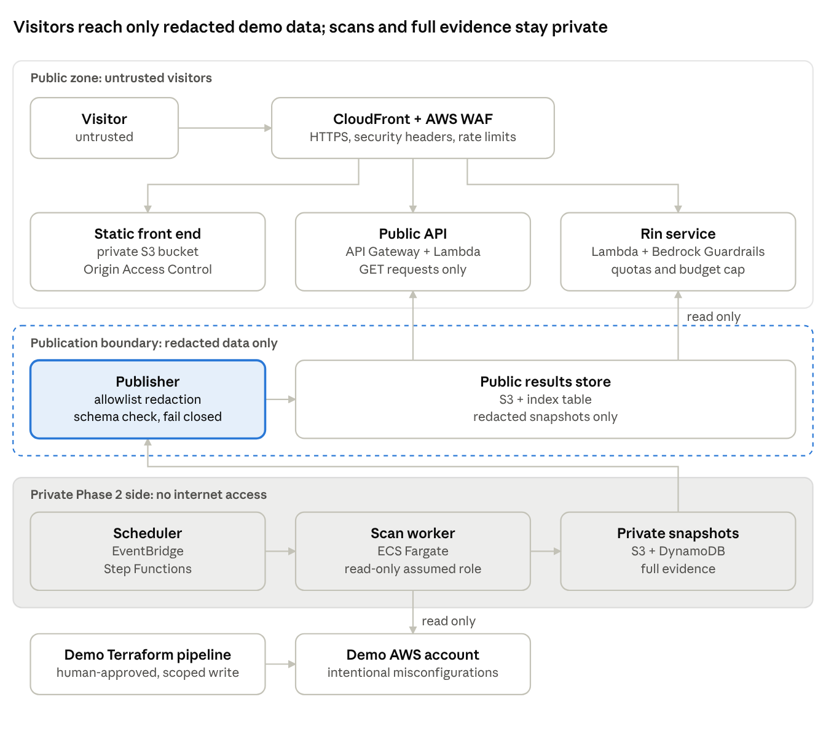
Phase 3 architecture · public zone, publication boundary, private Phase 2 side
The publisher is the only bridge between private and public data: it reads each completed scan, redacts it, and writes the result to a store that the public API and Rin can only read.

5.2 Execution Paths and Trust Boundaries
Visitor path: A visitor reaches CloudFront over HTTPS. CloudFront serves the static front end from a private S3 bucket through Origin Access Control and routes /api/* to API Gateway. AWS WAF sits in front of both. The visitor is untrusted and unauthenticated.
Public API path: API Gateway invokes a Lambda function with a role that can only read the public-results bucket and its index table. The role has no access to the Phase 2 snapshot store, the scan worker, or any target account. Only GET requests are routed.
Scan path: The Phase 2 EventBridge schedule, Step Functions, and ECS Fargate worker scan the demo account through a read-only assumed role. Results land in the private Phase 2 store, exactly as in Phase 2. Nothing in this path is reachable from the internet.
Publication path: After each completed scan, a publisher function reads the new private snapshot, applies the redaction contract (Section 6), validates the output against a public schema, and writes it to the public-results store. Publication fails closed: if redaction or validation fails, the previous public snapshot stays live and the failure is logged.
Rin path: A Rin Lambda accepts a question and a finding ID. It loads only the redacted public finding and the approved references, then calls Bedrock with Guardrails. Its role allows bedrock:InvokeModel on one model and read access to public results. It has no AWS-scanning, GitHub, or write permissions.
Demo-account change path: Misconfigurations in the demo account are created and fixed only by a separate, human-approved Terraform pipeline using GitHub OIDC on trusted workflows. The scanner, publisher, API, and Rin never hold these permissions.

5.3 Component Responsibilities
Component | Responsibility | AWS permissions
Front end | Render dashboard, findings, drift, and Rin chat | None (static assets)
Public API | Serve redacted scan runs, findings, and drift | Read public-results bucket and index
Publisher | Redact, validate, and publish each snapshot | Read private snapshots; write public results
Rin service | Answer questions from redacted evidence | Invoke one Bedrock model; read public results
Scan worker (Phase 2) | Collect and evaluate demo-account posture | Assume read-only role in demo account
Demo Terraform pipeline | Create and fix demo misconfigurations | Scoped write role in demo account only
Kill switch | Return the site to static fixture mode | Update CloudFront origin or feature flag

6. Public Data Exposure and Redaction Contract
The public site shows only fields on an explicit allowlist; every other field is dropped before publication. This is an allowlist, not a denylist, so a new field added to the Phase 2 contract stays private until someone approves it.

6.1 Field Rules
Field | Public treatment
Control ID, rule ID, scanner and policy-pack versions | Shown as is
Severity, result status, lifecycle and drift state | Shown as is
Scan time and scan run ID | Shown as is
Remediation guidance and approved references | Shown as is
AWS account ID | Replaced with a fixed label, such as demo-account
ARNs and resource IDs | Replaced with a stable pseudonym per resource, so drift still lines up across scans
Resource names and tags | Replaced with the same stable pseudonym, unless the name is on a published demo list
IP addresses, hostnames, and endpoints | Removed
IAM principal names, emails, and access key IDs | Removed
Raw API responses and full evidence blobs | Removed; a short, schema-checked evidence summary is shown instead
Exception owner and approver | Removed; the exception's existence and expiry date are shown

6.2 Contract Rules
- Pseudonyms use a keyed hash (HMAC) with a key held only by the publisher, so visitors cannot reverse them by guessing names.
- The public schema is versioned separately from the Phase 2 Finding contract.
- The publisher rejects any output that matches secret or identifier patterns, such as 12-digit account IDs, AKIA key prefixes, or ARNs.
- Redaction runs before data reaches Rin. Rin never sees unredacted evidence, even server-side.
- A redaction failure blocks publication. It never publishes partial or unredacted data.

7. Rin: Public AI Assistant Controls
Rin inherits every Phase 2 AI analyst restriction and adds controls for anonymous public traffic, where abuse and cost are the main risks.

7.1 Capabilities
- Explain a selected finding, its control, and its remediation, using that finding's redacted evidence.
- Answer general questions about the platform from an approved, versioned knowledge set (README, architecture, rule catalog).
- Cite the evidence fields and references used in every answer.
- Say when the evidence does not support an answer, instead of guessing.

7.2 Restrictions
- No tools: Rin cannot call AWS, GitHub, the scanner, or the public API beyond its read-only input.
- No effect on results: Rin cannot set severity, change status, create exceptions, or alter what the dashboard shows.
- Every visitor message, and every string inside evidence, is treated as untrusted input.
- Output is validated against a response schema and the allowed citation list; invalid output is replaced with a fixed fallback message.
- Bedrock Guardrails filter prompt attacks, off-topic requests, and sensitive data in both input and output.
- No conversation is stored beyond short-lived operational logs, and logs exclude message text by default.

7.3 Abuse and Cost Limits
The values below are starting defaults, tuned during Stage 3 from measured usage.
Control | Starting default
Questions per browser session | 10
Requests per IP address | WAF rate-based rule, 100 requests per 5 minutes across the API
Maximum question length | 500 characters
Maximum answer length | Fixed output-token cap per request
Global daily invocation cap | Set in Stage 3 from the monthly budget
Monthly budget | Owner-defined cap (open question in Section 2)
Model | One approved Bedrock model; changing it requires re-running the Rin evaluation suite

7.4 Fallback Behavior
Rin switches to fixture mode when the model errors, Guardrails block an answer, the daily cap or budget is reached, or the kill switch is on. Fixture mode returns prepared answers for demo findings and tells the visitor that live answers are paused. Scan results remain fully available.

8. Failure and Freshness Semantics
The website must never make a failed, partial, or stale scan look clean. It keeps the Phase 2 PASS, FAIL, UNKNOWN, and ERROR states and adds freshness to what visitors see.
Condition | What the website shows
Latest scan completed | Results, scan time, and overall status
Latest scan partial (AccessDenied, throttling, unsupported service) | Results with an "incomplete scan" banner and the affected services marked UNKNOWN or ERROR
Latest scan failed | The last good snapshot, labeled with its time, plus a "latest scan failed" banner
Snapshot older than two scan intervals | A "data is stale" banner with the last scan time
Publication blocked by redaction or schema failure | The last published snapshot, plus a "publication paused" banner
Public API unavailable | The static fixture snapshot, clearly labeled as sample data
Rin unavailable or over budget | Fixture answers with a "live answers paused" notice (Section 7.4)
Kill switch on | Full static mode, identical to the Phase 2 demo
Each banner state has a fixture and an automated UI test, so a regression cannot silently hide it.

9. Cost Model and Budget Controls
Phase 3 has a fixed, owner-approved monthly budget, and every variable cost has a hard stop. Before Stage 2, the owner records an AWS Pricing Calculator estimate in docs/costs.md; after launch, that file is updated monthly with actual spend from Cost Explorer.

9.1 Cost Drivers
Driver | Type | Control
AWS WAF web ACL and rules | Fixed monthly charge plus per-request charge | Keep the rule set small; review monthly
CloudFront, S3, API Gateway, Lambda | Per request and data transfer; low at demo traffic | WAF rate limits; caching of API responses between scans
Bedrock model invocations | Per token; the main variable cost | Session quota, daily cap, output-token cap, budget cutoff
Scheduled scans (Fargate, Step Functions) | Per run | Fixed schedule; scan only the demo account and its regions
Demo-account resources | Per resource | Use misconfigurations that cost little or nothing to keep (IAM, S3 policies, security groups); no idle compute or NAT gateways
CloudWatch logs and CloudTrail | Per GB ingested and stored | Short retention on the demo account

9.2 Budget Controls
- AWS Budgets alerts at 50%, 80%, and 100% of the monthly cap.
- At 100%, a budget action triggers the kill switch for Rin, and the site keeps serving cached results.
- A separate alert fires if the daily Bedrock invocation count exceeds its cap, catching abuse within hours instead of at month end.
- All demo resources carry a project=guardrails-phase3 cost-allocation tag.

10. Validation and Evaluation Plan
Every security claim on the public site is backed by a test or a checked-in artifact in docs/evidence/.
Boundary and permission tests
- IAM Access Analyzer and policy review confirm that the API, publisher, and Rin roles have no write access to AWS, scan state, or GitHub.
- Automated tests confirm that the public API rejects every method except GET and HEAD.
- A test confirms that the website and API cannot reach the private Phase 2 snapshot store.
- The Phase 2 regression suite still passes, and the scan worker still holds only read-only roles.
Redaction tests
- Fixture snapshots seeded with account IDs, ARNs, IPs, emails, and fake access keys must produce no matches in published output.
- Pseudonyms stay stable across two scans of the same resource, so drift still lines up.
- A new, unapproved field in the Phase 2 contract never appears in published output.
- A publisher failure leaves the previous public snapshot live.
Rin tests
- A prompt-injection suite covers direct visitor attacks and hostile strings planted in demo resource names and tags.
- Tests check for leakage of system prompts, unredacted data, and secrets.
- Fabrication tests confirm that answers cite only real evidence fields and approved references.
- Quota, daily cap, and budget cutoff each trigger fixture mode.
- A model outage leaves the dashboard and scan results unchanged.
Web and transport checks
- curl -I output shows that HTTP redirects to HTTPS and that the HSTS, CSP, X-Content-Type-Options, Referrer-Policy, and frame-ancestors headers are present.
- An external TLS and security-header scan result is saved with its date.
- The browser network log shows no third-party requests (analytics, fonts, CDNs) unless they are listed in the privacy note.
- Lighthouse and an accessibility check run on the dashboard, finding, and Rin pages.
Resilience checks
- A load test at several times expected traffic confirms that WAF rate limits engage and costs stay within budget.
- The kill switch is exercised end to end, and its recovery time is recorded.

11. Phase 3 Delivery Stages
Each stage ends at a gate; the next stage starts only when its exit criteria are met and the evidence is checked in.

Stage 1: Demo Account and Live Scans
Create the demo account in its own OU with a service control policy that blocks costly or risky services. Define the intentional misconfigurations in Terraform, deploy them through the human-approved pipeline, and point the Phase 2 scheduled scan at the account.
Exit criteria: Two consecutive scheduled scans complete; the drift view shows at least one new and one resolved finding after a reviewed Terraform change; the scan role is confirmed read-only.

Stage 2: Redaction, Publication, and Public API
Implement the public schema, the allowlist redaction with keyed pseudonyms, the fail-closed publisher, and the GET-only public API.
Exit criteria: All redaction tests in Section 10 pass; seeded secrets and identifiers never appear in published output; a forced publisher failure leaves the last good snapshot live.

Stage 3: Website Hosting and Live Rin
Move the front end to private S3 behind CloudFront with Origin Access Control, TLS, security headers, and WAF. Connect the dashboard to the public API, and connect Rin to Bedrock with Guardrails, quotas, caps, and fixture fallback.
Exit criteria: HTTP-to-HTTPS redirect and required headers are verified and saved; the Rin evaluation suite passes; quota, daily cap, and budget cutoff each trigger fixture mode; every failure banner in Section 8 renders correctly.

Stage 4: Harden, Document, and Launch
Update the threat model, write the operations runbook and kill-switch procedure, run the load and resilience checks, record the cost estimate and first actuals, and update the README and site.
Exit criteria: All release acceptance criteria in Section 12 are met; a reviewer who did not build the system can follow the runbook to switch the site to static mode and back.

12. Release Acceptance Criteria
Phase 3 is complete when all of the following are true:
- ☐ Phase 1 and Phase 2 read-only guarantees and regression results are unchanged.
- ☐ The public site shows live, scheduled scan results from the demo account only.
- ☐ Published data passes the redaction contract, and no organization data is reachable from the public surface.
- ☐ The website, API, publisher, and Rin hold no AWS write, scan-state write, or GitHub permissions.
- ☐ HTTPS is enforced, the required security headers are present, and WAF rate limits are active, with saved evidence.
- ☐ Rin is evidence-grounded, schema-validated, and quota-limited, and it falls back to fixtures on error or over budget.
- ☐ Failed, partial, stale, and blocked states are visible and never shown as clean.
- ☐ Budget alerts and the automatic Rin cutoff are tested, and actual monthly cost is recorded.
- ☐ The kill switch returns the site to static mode, and the procedure is documented.
- ☐ The README, threat model, and site state actual behavior, permissions, costs, and limitations.

13. Key Risks and Controls
Risk | Control
Real organization data leaks to the public site | Separate demo account; allowlist redaction; secret-pattern rejection; fail-closed publisher; no path from public roles to the private store
Denial of wallet through Rin or API spam | WAF rate limits; per-session quota; daily cap; output-token cap; budget action that cuts off Rin
Prompt injection through visitor input or planted resource names | Untrusted-input handling; Bedrock Guardrails; schema and citation validation; adversarial test suite; no tools for Rin
Rin fabricates evidence or fixes | Answers limited to redacted evidence and approved references; citation checks; fixed fallback on invalid output
Stale or failed scans look clean | Freshness and failure banners from Section 8, each with an automated UI test
Public roles gain write access over time | Least-privilege roles in Terraform; IAM Access Analyzer review at each release; permission tests in CI
Demo-account drift makes the story inconsistent | All demo resources in Terraform; changes only through the reviewed pipeline
Demo account becomes an attack target | SCP blocks costly services; no secrets or compute in the account; CloudTrail monitoring
Claims on the site exceed what is built | Every claim links to evidence in docs/evidence/; implemented and planned features labeled separately
Cost drifts above budget unnoticed | Budgets alerts at 50%, 80%, and 100%; monthly actuals in docs/costs.md

14. README and Portfolio Positioning
- Describe the site as "a live public demo of the Phase 2 platform, scanning a dedicated demo AWS account," not as a hosted product or a SaaS.
- Keep the phase history visible: Phase 1 auditor, Phase 2 platform, Phase 3 public demo. Label each stage's status honestly, including the Phase 2 sandbox-apply deviation.
- Put a short "Security and Limitations" section on the site itself, linking each claim to its evidence.
- Lead the README with the live link, a short demo GIF, the architecture diagram, and the security boundary. Move detailed tests and redaction rules to docs/.
- State that Rin is optional, rate-limited, and may be paused, so a paused Rin reads as a designed control rather than a broken feature.

15. Final Engineering Decision
Phase 3 is buildable with existing Phase 2 components plus four new parts: a demo account, a redacting publisher, a read-only public API, and a guarded Rin service. The strongest design keeps the public surface separate from organization data, keeps every public role read-only, and gives every variable cost a hard stop.
The result should be presented as a safely exposed, reproducible demonstration of a single-organization guardrails platform. That framing keeps the project ambitious, credible to security reviewers, and cheap to run.

