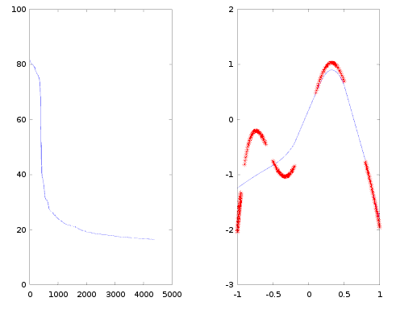

Eta adaptativo y chosen ones. Training ordenado .
15' quedó ya en 20.

clear; clf
trainingAmount = 200;
middleAmount = 15;
maxIt = 10000000;
calcAllFreq = trainingAmount;
ETol = 0.005;
gName = 'sigmodea';
[training, expected] = generateTrainingTPfunctionChosenOnes(trainingAmount);
training = [training, expected];

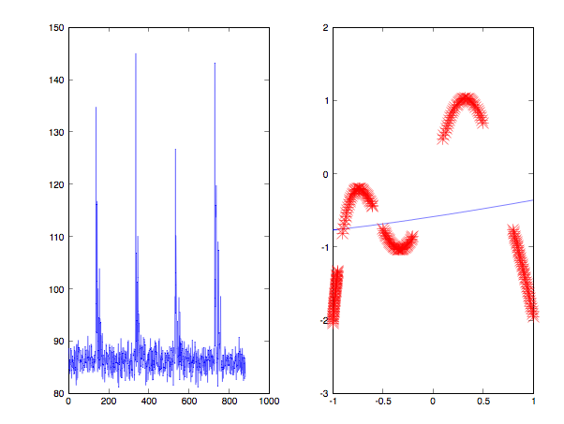

Eta adaptativo y chosen ones. Training se desordena en cada epoca.

clear; clf
trainingAmount = 200;
middleAmount = 15;
maxIt = 10000000;
calcAllFreq = trainingAmount;
ETol = 0.005;
gName = 'sigmodea';
[training, expected] = generateTrainingTPfunctionChosenOnes(trainingAmount);
training = [training, expected];

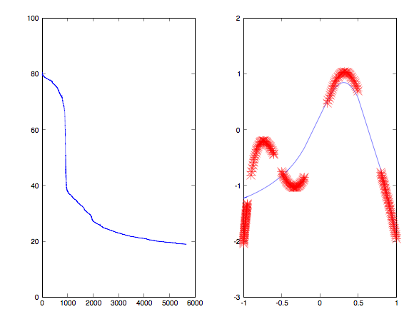

Eta adaptativo y chosen ones. Training se desordena una sola vez.

clear; clf
trainingAmount = 200;
middleAmount = 15;
maxIt = 10000000;
calcAllFreq = trainingAmount;
ETol = 0.005;
gName = 'sigmodea';
[training, expected] = generateTrainingTPfunctionChosenOnes(trainingAmount);
training = [training, expected];

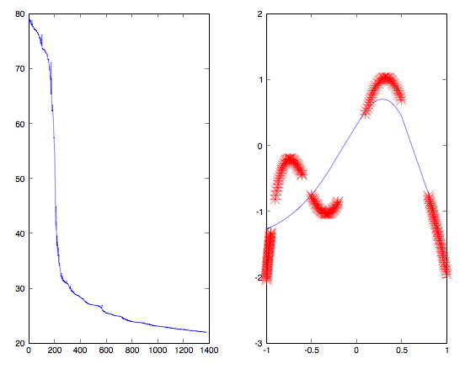

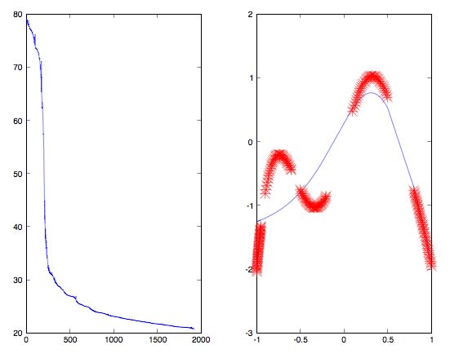

Eta adaptativo y chosen ones. Training se desordena una sola vez. Con control de saturacion con delta = 0.001 y rand()/10

clear; clf
trainingAmount = 200;
middleAmount = 15;
maxIt = 10000000;
calcAllFreq = trainingAmount;
ETol = 0.005;
gName = 'sigmodea';
[training, expected] = generateTrainingTPfunctionChosenOnes(trainingAmount);
training = [training, expected];

Dos capas sin eta adaptativo
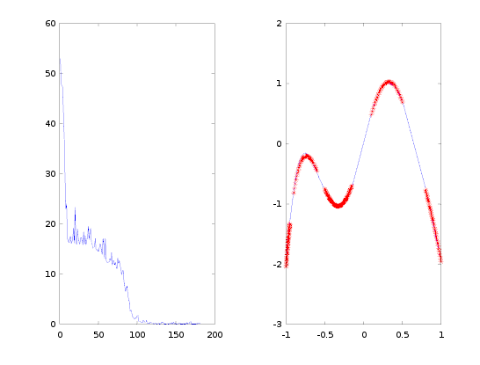

trainingAmount = 200;
middleAmount_1 = 6;
middleAmount_2 = 3;
maxIt = 10000000;
calcAllFreq = trainingAmount;
ETol = 0.005;
gName = 'sigmodea';
[training, expected] = generateTrainingTPfunctionChosenOnes(trainingAmount);
training = [training, expected]

% Start values
change_weight = 0.05;
E_best = -1;
decreaseCounter = 0;

Varia poco (no loco random como antes)

Todo igual pero inicialmente change_weight = 0,5
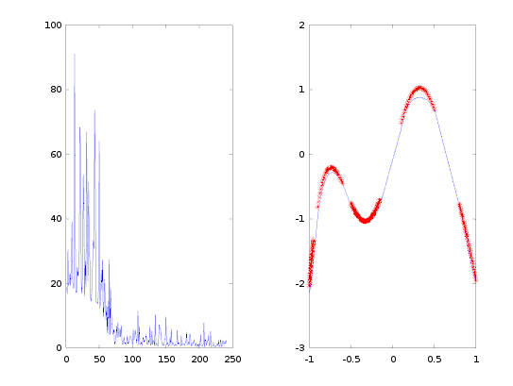

Dos capas con eta adaptativo
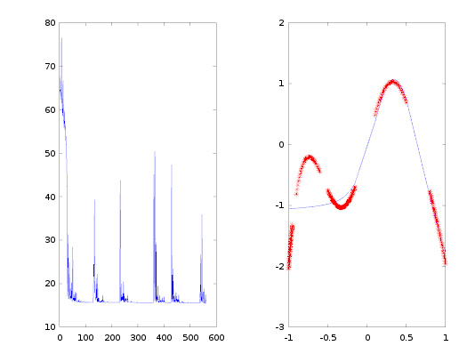
Mantuve todo los valores iguales de lo anterior solo descomenté el eta, que tiene 0,9 como beta y 0,2 como alpha.

0,95 = beta y 0,2 = alpha
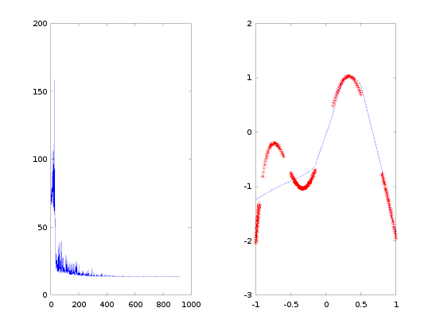

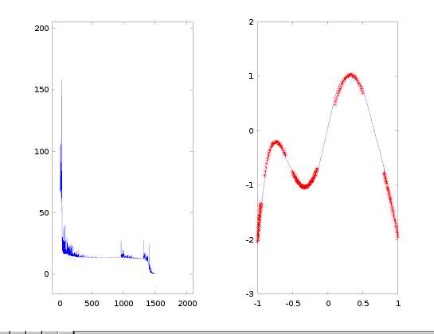

0.995 = beta y 0,001 = alpha
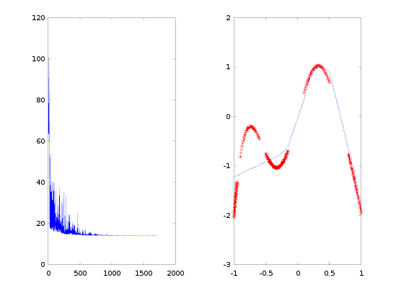

0,2 y 0,999
